Montessori Pointe Claire Summer Camp Programs: The best for everyone!

For all our children Montessori Pointe Claire summer camp is really the best place to be to have fun with your friends! Here’s what the summer program looks like:

Days will be well balanced with many activities and with the emphasis on outdoor fun. Our summer program is amazing with a fun “summertime twist” for everyone!

If you are not familiar with Montessori Pointe Claire, before registering, parents are invited to come for a tour of the facilities. Camp photos are accessible, and worth a look, both at the Montessori Pointe Claire Daycare Facebook site, and also the Montessori Pointe Claire Summer Camp Facebook site (for our 6 to 8 year olds).

- 1½ to 2½ years: Summertime “Toddler-Buddy” Program. This is a unique program designed to help our toddlers play interactively and learn how to make a friend and be a friend!

Our 1 ½ to 2 ½ years-old group requires very careful care in the summer. Activities take place indoors and out with the children’s teachers being vigilant in keeping everyone well hydrated and protected from too much sun. Our toddler playground is large and well shaded with trees and the ground surface is grass and special playground wood chips so that the environment is both pleasant and safe. There are no artificial surfaces that can overheat. This play area is for the use of our toddlers only, no older children use this space.

The summer “Toddler-Buddy” program is designed by our specialists to guide the children in developing their social skills. Children at this age are becoming aware of their interactions with other children, and with the correct guidance, the skills needed to “make friends” will flourish. Every day we will have a special activity that takes place outdoors (weather permitting) where the children will be encouraged to take the first steps in sharing and working together. Games can involve something as simple as collecting colourful balls that have been scattered around the playground and putting them in special bins. This type of activity teaches the child that it is fun and rewarding to work together towards a common goal (also if your “friend” is reaching to pick up the same ball as you, you need to figure out how to share!).

The summer is a fantastic time to try new activities. It’s relaxing to be outdoors in nature, and the more relaxed we are the better we learn.

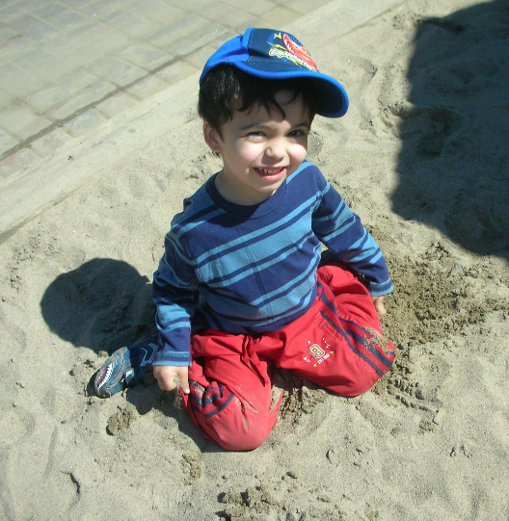
- 2½ to 3½ years: Pre-School Creativity Program: As children approach the amazing “3’s” they are at an age where they can start using and building their imagination.

Through crafts and creative play, we will have a summer that allows our brains to process how enjoyable the world is when we can start to “imagine”! Using their imagination helps children learn new vocabulary and helps in articulating feelings.

Humans enjoy creating. With the guidance of our teachers, we will “create” our own crafts, stories and games. Fostering creativity helps children develop mentally, socially, and emotionally. Creating art boosts young children's ability to analyze and problem-solve in myriad ways. As children manipulate a paintbrush, their fine motor skills improve. By counting pieces and colors, they learn the basics of math. When children experiment with materials, they dabble in science. Most important perhaps, when kids feel good while they are creating, art helps boost self-confidence. And children who feel able to experiment and to make mistakes feel free to invent new ways of thinking, which extends well beyond the craft room.

As much as possible our activities will be outdoors so we can benefit from the fresh air and summer sun. We will have outdoor painting, creative gym games, and good old fashioned fun with activities such as building sandcastles!

- 3½ to 4½ years: Sports-and-More Program. Start participating in sports! We are old enough to start learning some fun (non-competitive) outdoor games with our Physical Education specialists. We’ll have a variety of team games and introduction to sports activities every day.
By about 3 ½ years of age the child’s gross motor development as well as level of understanding of directions is at a level where the child can really start to enjoy organized games where he/she will act in a cooperative manner with friends. Children at this age start to develop their own outdoor games where they play all sorts of “make believe” activities with their friends. This play is encouraged and also well monitored by the teachers. At the same time the children love having their summer camp monitors guide them in some more organized games.

This age group is perfect to start introducing non-competitive sport activities. The children love using the sports equipment (balls, baseball bats, golf clubs, hockey sticks, etc.). It is really a fun challenge for them. The important part is that they need the help of adults to make these activities enjoyable as the children are just learning about cooperative play. This is the focus of the summer outdoor program for this age group. The children are given plenty of opportunity for free play, but there are also some organized games so that they can get involved in a different way with their friends, and at the same time start to develop the skills they will need later on should they decide to become involved in sports.

- 4½ to 5½ years: Let’s Get Outdoors! Program. Spend the day outdoors with all your friends and discover the fun of treasure hunts, crazy team games, picnics, gym games, sports activities, and park play at many of our local parks.
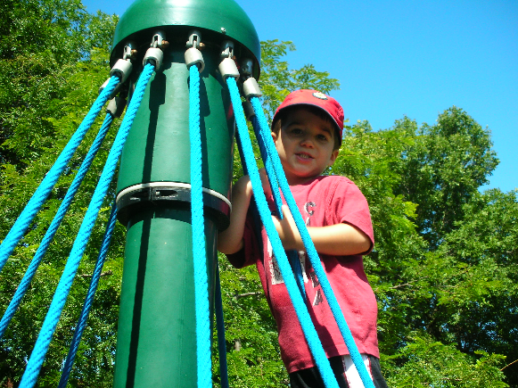
Our prekindergarten group is off to school next year and they are so happy to be together over the summer with their friends and share this time making life-lasting bonds. Our camp counsellors have a special summer program for this age group that encourages these friendships and is entirely different from the regular school year activities. The focus is on outdoor play. New games such as treasure hunts, as well as “crazy, fun” activities (try body painting, being your favourite animal for the day, and much more), make the summer so much fun!

The pre-K group is old enough for excursions to the local parks (within walking distance), and as much as possible activities will be held outdoors. There are so many different activities for this age group that it is difficult to list them all!

- 6 to 8 year-olds: Love-The-Sun Senior-Camper Program. Make new friends, come back and meet up with old friends, and have the best summer ever with our fun, experienced camp monitors! Activities are enjoyable, safe, and totally perfect for our 6 to 8 year olds.

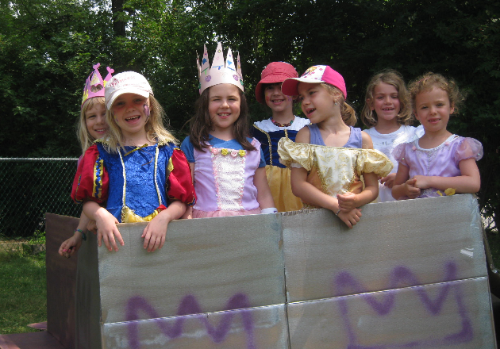
At Montessori Pointe Claire we take a maximum of 30 “Senior” campers who have their own space, their own program, and their own counsellors (ratio is 1:10). This program was initially developed as a fun and safe alternative to the “big” camps and it has become so popular that we fill up quickly and our campers keep returning! The activities are created by our counsellors to keep this group active. We promise that no one ever gets bored! Activities almost always take place outdoors. Our facilities provide more than ample green space to play games, have picnics and in general stay outdoors as much as we are comfortable doing. We have access to soccer fields, a baseball diamond, tennis courts, playgrounds for “bigger” kids, and a great outdoor splash/pool area at Viking Park across the street. We are always within a short walking distance from our building so it’s easy to go in and out as we please.

Our counsellors are mature and fantastic and are picked to work specifically with this age group. The counsellors are in charge of creating a summer program that will appeal to everyone in their group. Our counsellors are very capable of helping with special considerations for individual campers where necessary.

