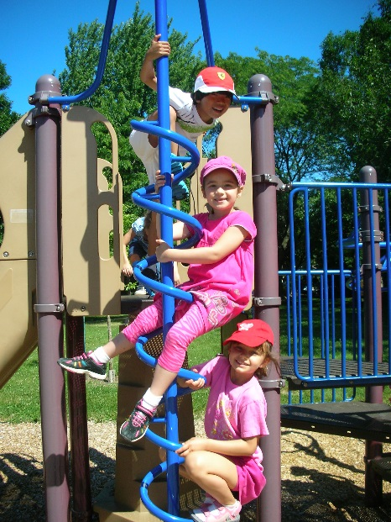Montessori Pointe Claire Summer Camp

Sample summer weekly calendar of activities and menu

|  |  |  |  |  |
| --- | --- | --- | --- | --- |
| **Monday** | **Tuesday** | **Wednesday** | **Thursday** | **Friday** |
| **Theme:**  Under the Sea | Craft: Tissue paper aquarium  Storytime: Whales and Dolphins  Yoga with Veronique: Best Kids Yoga ever! | Activity: Bake some “Sea Biscuits”  Outdoor “Fish” races!  Look at Lizards with Reptizoo – Learn about these fascinating animals | Storytime: Rainbow Fish  Game: Under the Sea musical chairs  Afternoon Karate class  With Meghan our amazing and fun Karate instructor | Pyjama day, wear your PJ’s to camp and have a yummy breakfast at camp:  Pancakes, scrambled eggs and fresh fruit  Craft: Starfish  Afternoon Sports games | Craft: a fish mask  Activity: The fishing game  Show: Magic with Todsky our favourite summer magician (with his magic fish!) |
| **Lunch Menu:**  *All our lunches are home cooked from fresh ingredients*  *Milk is served at lunch and at snack time* | *Potato and leek soup*  *Crispy crumbly baked fish (white fish)*  *Green and yellow beans*  *Apple slices* | *Garden salad*  *Cheddar cheese cubes*  *Chicken broccoli divan*  *Rice pilaf*  *Bananas* | *Hearty vegetable soup*  *Salmon patties*  *Mashed potatoes*  *Cooked carrots*  *Nectarines* | *Lentil soup*  *Vegetarian pizza*  *Corn*  *Watermelon* | *Greek salad*  *Spaghetti with meat sauce (or cheese sauce option)*  *Broccoli and cauliflower*  *Sliced fresh peaches* |

*Weekly calendars are given out every Monday of each week*

