Ballet with Nina
We have a new session starting for our ballet program with Nina Menon. Nina teaches ballet at Sheila Parkins Dance and Music Academy. Nina enjoys her little ballerinas at Montessori and is always happy to be starting a new session here.

Nina is a ballerina herself with many years of experience in dance. Nina joined the Royal Winnipeg Ballet after graduating from The Royal Conservatory of The Hague and The Royal Winnipeg Ballet Professional Division. As a member of the corps de ballet she danced numerous soloist roles. Nina has also choreographed several professional ballets and has coached for The Professional Division students and taught dance at The Royal Winnipeg Ballet’s General Division.

Ballet classes with Nina at Montessori will be held in the mornings on
Mondays for 8 classes.
Dates are: April 17, 24, May 1, 8, 15, 29, June 5, 12
Parents are invited to attend the class on Monday, June 12

There is no “uniform” for ballet but if the child wishes to dress with a “tutu” on ballet day (or bring one to put on) this is absolutely fine.

If you wish to register your child for ballet please fill in and return the form below. Cost for 8 classes is $65.00

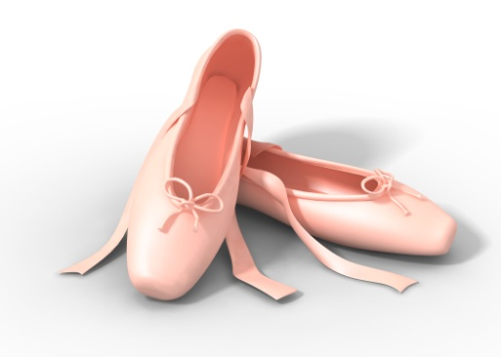
I wish to register my child (child’s name) __________________________________________________
in classroom number ____________
for Ballet classes with Nina (April to June 2017).
I enclose $65.00 _____cash _____cheque (made out to Montessori Pointe Claire)
Parent’s signature _______________________________________________________

