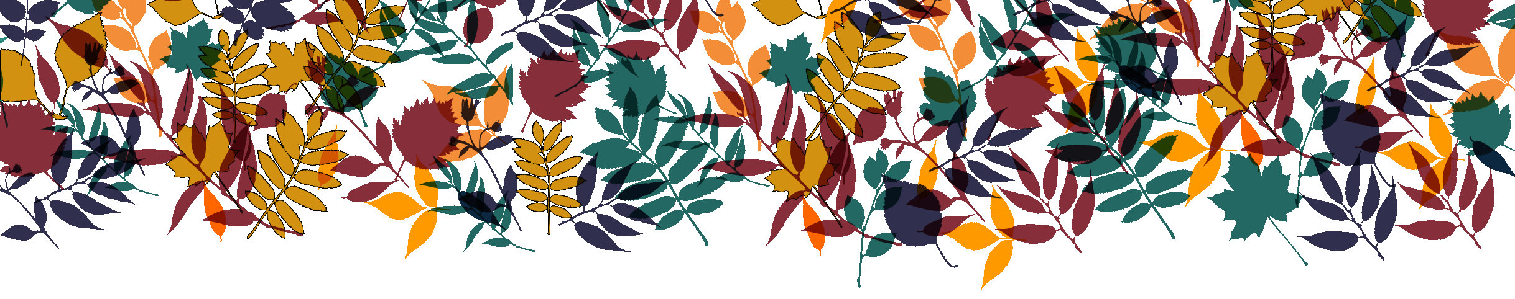
September 2017/septembre 2017
Classroom 3/Classe 3
MONDAY  LUNDI | TUESDAY  MARDI | WEDNESDAY  MERCREDI  IMPORTANT | THURSDAY  JEUDI | FRIDAY  VENDREDI
For the Meet the teacher evening
Please join us on Wednesday September 13th at 7:30PM

4 | 5 Theme: Learn about our new classroom  Explore our classroom game | 6 Learning new songs  in our classroom  Alana raconte:  « Bienvenue à l’école »  9:15AM: Yogi Doug “our  favourite fun yoga teacher” | 7  Estrellas de colores para el aula  (Étoiles colorées pour la classe) | 8  We will talk about what goes in our recycle bins  in our classroom
11 Theme: Teachers are fun!  Apprends le nom de tes professeurs. « Je m’appelle….! » | 12 Clap to our teachers  names in big circle  Samantha the Science Gal:  Fizzy Science is Fun! | 13  WE LOVE YOGA! ($5.00)  Jusanitos divertidos  (Drôles de papillons)  7:30PM Meet the teacher | 14  Colour an apple for our teachers  Un jeu de pommes amusant avec les professeurs | 15 Final day to bring Scholastic book orders  We will dance with  our teachers  Maya
18 Theme: A B C’ S  9:15AM: Concert “ABC  Come sing with me” with  Michael Woytiuk ($5.00)  Sign our ABC’s | 19  Let’s put our little hands to work for an ABC craft  Charlotte  Stella | 20 Alana raconte:  Les lettres  Samantha the Science Gal:  ‘’B’’ is for Bubbles  Music with Kimberley: Flute  FARM PYJAMA DAY | 21  Let’s colour the  first letter of our name  Ariana  Music with Kimberley: Flute | 22  Cartas con el abesedario  (Une lettre avec l’alphabet)
25  Theme: Visit the farm  Rencontre des animaux de la ferme (marionnettes) | 26  Let’s play with  our farm animals | 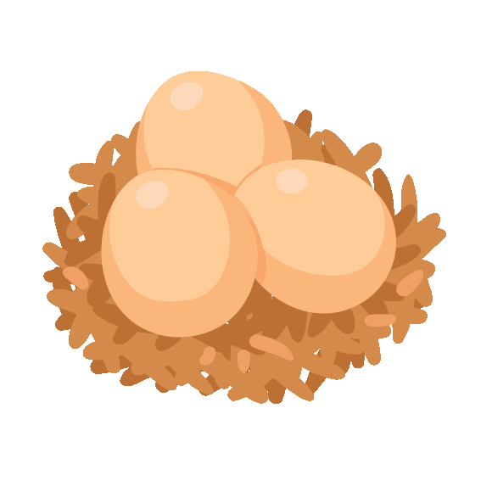27  “Farm” eggs for  breakfast  WEAR YOUR “ANIMAL” PJ’S  Let’s listen to our animal CD and pretend we are on the farm!  Music with Kimberley: Saxophone | 28  Alana raconte:  « La ferme »  Colorear animals de la granja  (Colore les animaux de la ferme)  Music with Kimberley: Saxophone | 29  Let’s sign the  ‘’Old McDonald’’ song  Samantha the Science Gal:  Dancing corn

