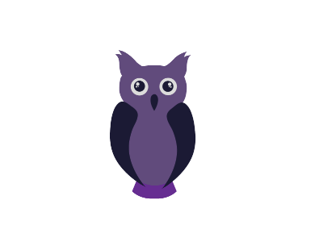
Classroom / Classe 1
October 2017/Octobre 2017
Español con Gabriela | MONDAY  LUNDI | TUESDAY  MARDI | WEDNESDAY  MERCREDI | THURSDAY  JEUDI | FRIDAY  VENDREDI
Árboles y manzanas Bricolage : des arbres et des pommes | 2 Theme: So many different trees!  Match the leaves game  with Emily | 3  Snacktime: Picnic at the parc  Melissa the Science Gal:  How old is a tree?  Regardons nos différents arbres (conifères et feuillus) | 4 AM Bricolage avec Jenny Lynn: L’arbre de l’automne ($12.00)  Citons nos arbres à fruits et leurs caractéristiques  Music with Kimberley: Guitar | 5  9:45AM Puppet show at Stewart Hall.  Gruffalo: A little mouse in the forest ($15)  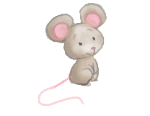  Craft with Sabrina: )  Colorful thankful turkey  Mini-Scientists  Music with Kimberley: Guitar  Everyone welcome!  WINE & CHEESE PARENT MEETING.  7:30PM | 6 Final day to bring  Scholastic book orders  Craft: A colorful tree  AM Wimgym
Búsqueda de texturas de otoño  On cherche les textures de l’automne | 9  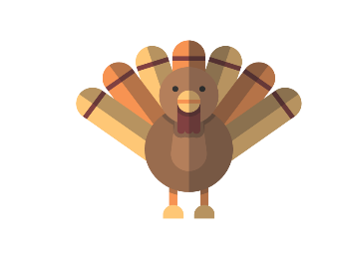  Vacance de l’Action de grâce  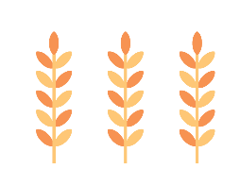  Thanksgiving day - Holiday | 10 Theme: The pleasures of Fall  9AM Apple picking at Verger Labonté ($24)  Show & tell with Sabrina  Let’s describe our apples | 11 Yummy homemade warm  apple cider served at snack  Made by chef Pina  Art: Collage de  feuilles d’automne  Music with Kimberley: Piano | 12 La chasse de  l’automne au parc  Melissa the Science Gal:  Why do Pine Cones  Mara-Jade  open?  Mini-Scientists  Music with Kimberley: Piano | 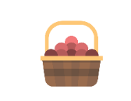  13  Cooking class with chef Pina : Fall harvest healthy granola bar  Craft: Yarn Pumpkin  AM Wimgym
Mensajes de amistad para nuestros amigos  Messages d’amitié | 16 Theme: I am kind!  We will learn how to live in harmony with ‘’The log hotel’’ story.  PM Ballet with Nina | 17  Bring a Teddy Bear  for a child in need  Compliment circle with Sabrina  PM Yoga with Caroline: kindness meditation | 18 Fais un dessin pour  donner à un(e) ami(e)  Melissa the Science Gal:  I am kind to the earth. Water pollution experiment  Music with Kimberley: Bongos  Wear your Halloween pj’s! | 19  Activity with Sabrina: Gift a friend with a kindness stone.  Mini-Scientists (Graduation)  Music with Kimberley: Bongos | 20  Chain of Kindness  with Sarah  AM Wimgym
Hacemos sombreros de brujas  On fait des chapeaux de sorcières | 23Theme: Halloween is coming!  Melissa the Science Gal:  Not so scary Skeleton!  Mummy craft with Emily  PM Ballet with Nina | 2410h30 Blair Marshall  Magic Halloween show  ($6.50)  Art: Une chauve-souris effrayante!  PM Yoga with Caroline: Halloween themed postures | Halloween  Pyjama Breakfast  Monster oatmeal  Sombrero de bruja  Chapeau de sorcière  Music with Kimberley: Harmonica | 26  Craft with Sabrina:  Let’s make a spider!  Music with Kimberley: Harmonica | 27  Spider web game with Sabrina  Play dough monster with Sarah  AM Wimgym
Las Sombras nocturnas de los animales!  Les ombres de nuit des animaux ! | 30 Theme: Nocturnal animals  9AM Excursion to the Ecomuseum to ‘’find’’ the nocturnal animals ($20.00)  Cercle avec Mme Hibou  PM Ballet with Nina | 31 Apporte ton costume!  PM: It’s Halloween!  Trick or Treat at school  Poción magica con Gabriella  Nocturnal animal game with Emily | 1  Table d’exploration portant sur les hiboux  Music with Kimberley: Accordion | 2  Nommons nos animaux nocturnes  Music with Kimberley: Accordion | 3  Melissa the Science Gal:  Let's pretend to be bats! (echolocation)  Raccoon mask craft with Sarah  AM Wimgym

