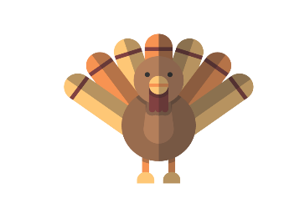
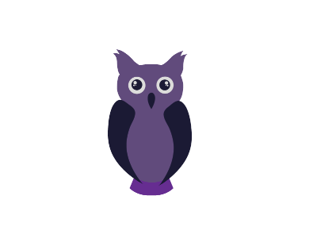
Classroom / Classe 3
October 2017/Octobre 2017
MONDAY  LUNDI | TUESDAY  MARDI | WEDNESDAY  MERCREDI | THURSDAY  JEUDI | FRIDAY  VENDREDI
2 Theme: So many different trees!  Bricolage avec des  feuilles d’automne | 3  Samantha the Science Gal:  How old is a tree?  Let’s place our apples  on an apple tree | 4  Alana raconte : les arbres  Music with Kimberley: Guitar  WINE & CHEESE PARENT MEETING. | 5  Tree Craft  Music with Kimberley: Guitar  7:30PM  Everyone welcome! | 6 Final day to bring  Scholastic book orders  Colorear arboles  Colorions les arbres  Manoé
9  Vacance de l’Action de grâce  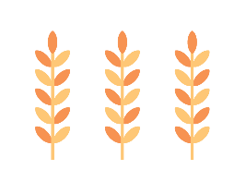  Thanksgiving day - Holiday | 10 Theme: The pleasures of Fall  Colour a fall leaf  Jiaxi | 11 Yummy homemade warm  apple cider served at snack  Made by chef Pina  Alana raconte : l’automne  James  Music with Kimberley: Piano | 12 Cansiones de l’Otoño  Des chansons de l’automne  Samantha the Science Gal:  Why do Pine Cones open?  Music with Kimberley: Piano | 13  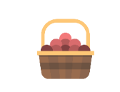  Cooking class with chef Pina : Fall harvest healthy granola bar  Let’s collect leaves in our yard
16 Theme: I am kind!  Hug a friend today!  Ella L | 17  Bring a Teddy Bear  for a child in need  Cartas de Corazon  Une letter venant du coeur  Wear your Halloween pj’s! | 18 Hey Little Ant : the story of a kind boy who didn’t step on an ant  Samantha the Science Gal:  I am kind to the earth.  Water pollution experiment  Victoria Ko.  Music with Kimberley: Bongos | 19  Projet: chaîne d’amitié  Music with Kimberley: Bongos | 20  Circle time: We will talk about things we can do to be kind
23Theme: Halloween is coming!  Samantha the Science Gal:  Not so scary Squeleton! | 24  9h45 Blair Marshall  Magic Halloween show  ($6.50)  Hacer Fantasmas  Imitons les fantômes | Halloween  Pyjama Breakfast  Monster oatmeal  Les chauves-souris en vol!  Music with Kimberley: Harmonica | 26 Halloween storytime:  The night before Halloween  Music with Kimberley: Harmonica | 27  We will carve  our pumpkin  Riley
30 Theme: Nocturnal animals  Circle time song:  Bats are sleeping  Angelina | 31 Bring your costume in a bag!  PM: It’s Halloween!  Trick or Treat at school  A bat craft | 1  Les chauves-souris en vol!  Music with Kimberley: Accordion | 2  Colorear búho  Dessinons un hibou  Music with Kimberley: Accordion | 3 Melissa the Science Gal:  Let's pretend to be bats!  (echolocation)  Circle time song: Bats are sleeping

