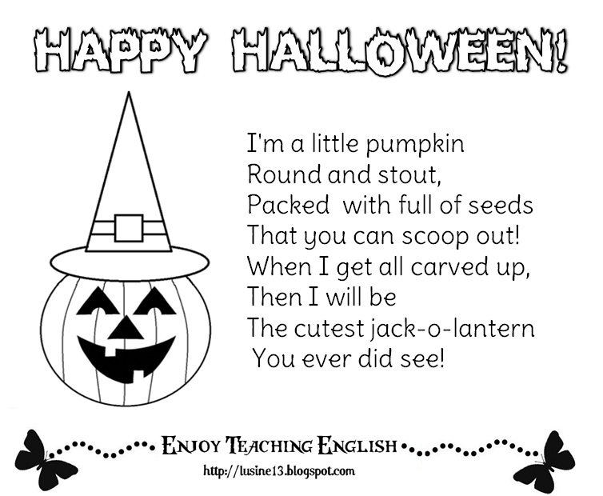  **OCTOBER 2017 NEWSLETTER**

**PARENT WINE AND CHEESE MEETINGS**

Our General Assembly meeting took place at 8:30pm on September 13th. Thank you to the parents who volunteered to be our “official parent committee” members. As promised we will have four or five very informative meetings during the course of the school year. All parents are invited to attend. You may come to one or to all of the meetings. The purpose of these meetings is to encourage the parents to come out and be part of Montessori Pointe Claire, to voice opinions and make suggestions as to what activities they would like the children to participate in, as well as to help us by giving us the “parents’ point of view” on life at Montessori. The meetings are always fun and a nice evening out for everyone. Meetings are actually “a fun night out” with wine and cheese and the parents of your child’s classmates and friends. There is an agenda prepared for each meeting. If you would like to have a special topic discussed at the meeting you are encouraged to call the office and have that topic added to our agenda.

Sing to the tune of “I’m a Little Teapot”

**The first parent “Wine and Cheese” meeting will be held on Thursday, October 5that 7:30 pm. (Meetings adjourn at 9:00pm)**

Agenda for our first meeting:

* 1. Upcoming events
  2. Herla (professeur de la prématernelle):  [les façons d'encourager être amis dans les enfants](https://www.google.ca/search?rlz=1C1CHBF_enCA724CA731&q=les+facons+d%27encourager+etre+amis+dans+les+enfants&spell=1&sa=X&ved=0ahUKEwi8trOGoLfWAhXE5IMKHY01D-MQBQglKAA)
  3. Tanya, Alana, Tina (Classroom 3 teachers): How to calm your child’s fears. What we do in class.
  4. Pascale (Science specialist): The importance of imaginary play in brain development
  5. *Share ideas:* What is your favourite home activity to do with your child
  6. Discussion

# SCHOOL PHOTOS

On Wednesday, October 11 and Thursday, October 12 the School Photographer from Kreative Memories Photography Studio will be at Montessori in the morning to take individual and class photos of the children. Classrooms 3 and 4 will have photos taken on the Thursday and classrooms 1 and 2 on the Wednesday. Your child may have his photo taken on the alternate day if necessary. Class photos will be taken on BOTH days for all four classrooms. You will be given a proofs of the photos and can order photos if you desire (there is absolutely no obligation).

**If your child does not normally attend on the photography day** you may bring him/her to the school for the pictures in the morning. It is preferable that you drop the child off around 8:30am and pick him/her up after the photography is over (we can call you) as the children seem to find it more relaxing to do the “photo shoot” with just their friends and teachers present ☺

**REPORT CARDS**

Your children will be receiving their first “report card” towards the end of October. This is a basic evaluation on how the child has adjusted to his/her new class, and how he/she is doing socially. A child development report will be given to you in February and an academic report in June. If you have questions or you would like to discuss your child’s report with his/her teacher, please call the office to arrange an interview.

**HALLOWEEN PARTY**

On Tuesday, October 31 we will be trick or treating at Montessori with the children. On that day children are invited to bring a costume in a plastic bag with the child’s name on the bag please. We will dress up in the afternoon. At afternoon snack time we will trick or treat inside the school. We will go to each of the classrooms, the office and the kitchen and receive treats in our halloween bags. If your child does not usually come on Monday, you may bring him on Monday afteroon but please check with your child’s teacher to find out the details!

**HALLOWEEN LAMPLIGHTER BOXES FOR THE MONTREAL CHILDRENS HOSPITAL**

This year again we will be handing out little “Lamplighters” boxes to the children for Halloween trick or treating. The money collected in these boxes goes to the Montreal Children’s Hospital Foundation. We realize that not all of you will be taking your child trick or treating door to door but you can still help fill the Lamplighters boxes with some loose change (most of us have a jar or two at home!) and bring it back in to Montessori. Please bring your Lamplighters boxes in by Friday, November 6th as they will be picked up by the Children’s Hospital.

**OUTDOOR PLAY and CHANGE OF CLOTHING**

Please make sure your child has the correct clothing to go play outdoors! Also please verify your child’s “change of clothes” that he/she keeps at school to make sure that you now have warmer clothing in the ziploc bag.

**FIRE DRILLS**

We will have two fire drills soon, the dates will be determined depending on the weather. (We will not hold a fire drill in bad weather as the children do have to go outside without putting on any extra clothing.) We will only be outdoors for a few minutes, not long enough for anyone to get cold ☺ The drills are designed so that the staff has practice assisting the children to leave the building and follows our evacuation procedure correctly, but also for the children to understand and become familiar with the sound of the fire bell (which is quite loud). Our experience with the drills is that the children are actually very cooperative but also that after the first trial, the second and third go extremely smoothly so this is a drill worth repeating. The main thing to convince the children is that during a fire drill they do not go into the cubbies to change into their outside shoes! Each of our classrooms has it’s own exit for a fire drill, so the children may also exit from a door which is not their usual one.

Although we feel very secure about being in a building which is not wood construction (cement block and steel) and with excellent smoke detectors that are hooked up to central security (should the fire alarm go off for real, the fire department would arrive in under three minutes), we still believe that fire drills are an important part of keeping everyone safe.

**THANK YOU EVERYONE**

BDH00001 Yogi Doug’s class in September raised $400 as a donation to the ALS Society of Canada, and we contributed another $100 from “Montessori” to make that a lovely amount of $500. This is a special donation made for our Office Manager Cindy and her daughter Brittany (who taught with us) for their walk for ALS. Thank you to everyone who participated!

##### NO NUTS PLEASE

PLEASE READ THE LABELS VERY CAREFULLY ON YOUR CHILD’S SNACK ITEMS. THERE ARE SEVERAL CHILDREN IN THE SCHOOL WITH VERY SEVERE, LIFE THREATENING NUT ALLERGIES. FOR THEIR SAFETY WE DO NOT ALLOW ANY NUTS OR NUT PRODUCTS TO BE BROUGHT INTO THE SCHOOL.

THANK YOU FOR YOUR COOPERATION.