Classroom / Classe 3
MONDAY  LUNDI | TUESDAY  MARDI | WEDNESDAY  MERCREDI | THURSDAY  JEUDI | FRIDAY  December 2017/Décembre 2017  VENDREDI
Bring your donations of food, clothing or toys for Share The Warmth charity |  |  |  | 1
4 Theme: What can I do with my hands?  We will learn to sign I love you with our hands | 5 Final day to bring  Scholastic book orders  Jugar con plastilina  Play with playdough | 6  I can create shapes with my hands!  Samantha the Science Gal : Fingerprints are unique!  Music with Kimberley: Bells | 7 Let’s catch a bubble  with our hands!  3:00PM  You are invited to our  Christmas party  & music concert | 83:00PM With my hands I can play Basketball with Sportball ($8.00)  Comptons sur nos  doigts avec Alana  For Parents: Klassy Kanvas Christmas gift sale
11  Theme: Santa Claus is on his way  9AM SPECTACLE “Le traineau du Père Noël”($8.00) | 12 Happy Hanukkah  activities with  Melissa!  Storytime :  The night before  Hanukkah | 13  L’heure du conte  avec Alana:  Petit arbre de Noël | 14  We will pin  the hat  on Santa!  Callie  Storytime:  Is it Hanukkah yet? | 15 Deadline Sep 2018  early registration  Pinguinos de Navidad  Christmas pinguins  Roman
18 Theme: Enjoying  the holiday season  9:15AM ‘’A Magical Musical Adventure’’ with pianist Michael Woytiuk ($5.00)  Wear your Christmas sweater!  Lianaa | 19  9:15AM Yogi Doug : Holiday Yoga  For the profit of the  Angel Hair for Kids foundation ($5.00)  We will create  reindeer food | 20  L’heure du conte avec Alana:  Père Noël  Sienna  Kwanzaa storytime  & coloring | 21  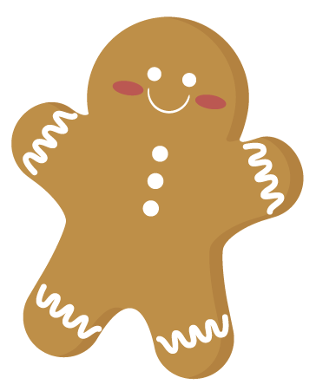  Cuisinons avec Pina: Biscuits de Noël  Christmas craft  with Adriana  Noah  Music with Kimberley: Bells | Come to school in your holiday PJ’s! Christmas waffle breakfast  Copos de papel  Paper snowflakes  Victoria G.
Closed for holidays December 25 to January 1.
The first day of school for the New Year is Tuesday January 2, 2018.

