Special Events for February 2018

1 Build A wooden “cabane”: A Craft Workshop with Florent (Classes 1, 2 and 4)
Where: At the school, in the library area or in the classroom.
What: It’s “architect” week and we have another great workshop taught by Florent Antona who is a professional woodworker and artist. The children will put together a wooden cabin to show them, in miniature, how we can build a house. This is a great opportunity for the child to explore building, to learn how to put something together in sequence, and to learn to follow precise instructions. If your child does not usually attend on Tuesdays, he/she is welcome to come to the workshop. The cost is $13.00.
When: Tuesday, February 6, in the morning

- Excursion to Rudy’s woodworking shop (Classrooms 1, 2 and 4 if toilet trained only)
Where: 110 Leacock, Pointe Claire, H9R 1L2, 514-695-5151 RudyErfle.com
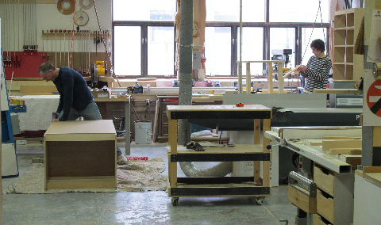
What: Let’s look at all the machines we need to build cabinets that go inside our home. We’ll see how pieces of wood get turned into furniture and cabinets. We will learn about the different materials that go into making cabinets. Each child will bring home his own mini peg rack. We have done this tour before and the children are amazed by the machines and all the things they will see in the shop. The shop is “closed down” for our tour so it’s perfectly safe. The woodworking shop is also very close to us, 4 minutes by bus. If your child does not normally attend on Wednesdays, please let the teachers know. We will need some parent volunteers for this trip so please sign up on the classroom door. Cost is$15.00 to cover transportation and materials. (PS Artemis’ husband Rudy and son Amile are the owners of the shop so we have a lovely personal connection here, and we know we will be very well looked after )
When: Wednesday, February 7, in the morning.

3 Pianist Michael Woytiuk presents a Piano Concert for children: “I Love Beats”
Where: At the school, in the library area or classroom.
What: It’s rhythm week at Montessori and Michael has a special piano concert planned for us, where we will have fun with music and stories that get us up and moving to the rhythm. Called “I Love Beats!” Michael uncovers all different kinds of beats, how they make you feel and where they can be found; beats that speed up and slow down, beats that make you want to waltz like Cinderella, beats that make you want to march in a parade, old beats, jazzy beats and more.
Michael performs several times a year at Montessori and his concerts are always a success with the children. If your child does not usually attend on Mondays he/she is welcome to at the time shown. The cost is $5.00. If you are leaving your child with us for the show, please remember to pick him/her up promptly once the performance is over.
When: Monday, February 19 Classroom 1: 10:45 am Classroom 2: 10:15 am
Classroom 3: 9:15 am Classroom 4: 9:45 am

- Children’s Ukulele Fun with Janice, Linnet and Artemis (The Ukuladies!)
Where: At the school, in the classroom or library
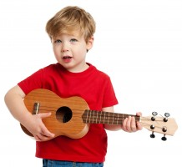
What: We have a special performance for the children this week. The up-and-coming musical instrument for teaching children in elementary schools is the Ukulele so it’s a great idea to introduce this instrument to the children. JanICe Donato is a local artist who exhibits with the Lakeshore Artists association (she does beautiful paintings and she is also the artist for all our murals at Montessori,). Janice is also an avid Ukulele player and is enthusiastic about sharing her love for this instrument with the children. Janice originally started playing the Ukulele when her mother was diagnosed with early onset Alzheimer’s. In an effort to communicate with her mother, Janice found being able to sing to her with the Ukulele brought both of them joy. Janice also entertained the seniors at the Residence Centre d’Hébergement Denis-Benjamin-Viger (where we are doing our Valentine cards for seniors this month), where her mother was a resident for some time.
At Montessori Janice will be accompanied by Linnet and Artemis who enjoy being a Ukulele trio (the Ukuladies!) and have some totally lively and fun children’s songs to perform for the children that they can sing and dance to. We are asking for a $4.00 donation for this concert which will be given to Alzheimer’s Canada in honour of Janice’s mother. If your child does not usually attend on Wednesdays, he/she is welcome to at the time shown. Cost is only the $4.00 donation to Alzheimer Society of Canada.
When: Wednesday, February 21 Classroom 1: 10:45 am Classroom 2: 10:15 am
Classroom 3: 9:15 am Classroom 4: 9:45 am

- Excursion to The Redpath Museum of McGill University (Classrooms 1 and 2 only)
Where: 859 Sherbrooke Ouest/West, Montréal, Qc H3A 0C4T: 514 398-4086 ext. 00549
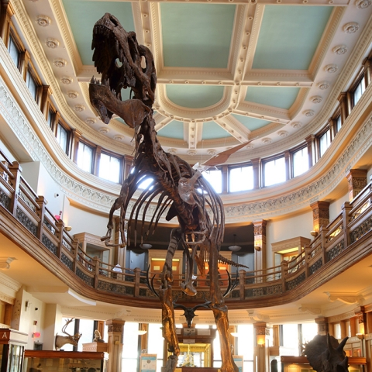
What: We will be going for a one hour guided tour (for pre-schoolers) of the Redpath museum. We will have fun exploring the collections and we will even do a “treasure hunt” to see what objects we can find. Here is a list of some of the amazing Exhibits and collections: (1)Life on Earth - Dinosaurs and prehistoric beasts, Creatures from the deep, Quebec's biodiversity,A letter from Charles Darwin, Shells from the Seven Seas
Not long for this world, Water is life, (2)Earthly Treasures - Minerals from Quebec, Geological garden, (3)World Cultures - Egyptian mummies.
Cost per child is $19.00. If you would like to accompany us on this trip as a parent volunteer, please sign up on the classroom door. If your child does not normally attend on Tuesdays, and you would like him to participate in this trip you can bring him/her to school at 9:00am and pick him/her up once we are back.
When: Monday, February 26 The bus leaves at 9:00am

6 An Art Workshop with Jenny-Lynn Manzo “All about humans” (Classrooms 1, 2 and 4 only)
Where: In the school library or classroom
What: We all love Jenny and her art classes! Here’s the synopsis of this workshop, which takes place during “All about humans” week.

Tout sur l’être humain - All about humans
Nous parlerons de l’homme de cro magnon et de la préhitoire au travers de la découverte des merveilleuses grottes de Lascaux en France. Les enfants vont créer une peinture épatante et originale d’une de leur main à la manière des hommes cro magnons…les premiers artistes de l’humanité!

We will talk about prehistoric life and cavemen through the discovery of the marvelous Lascaux caves in France. And the children will create an amazing and original prehistoric painting of one of their hand like the cavemen…the first artist of the humanity!
Jenny-Lynn Professeur d’art/ Art teacher
The cost of this great activity is $12.00
When: Tuesday, February 27, in the morning
____________________________________________________________________________________________
I give permission for my child to participate in the following:
1. Build A wooden “cabane”: A Workshop with Florent (Classes 1, 2 and 4 only) Yes  No  Cost: $ 13.00
2. Excursion to Rudy’s woodworking shop (Classrooms 1, 2 and 4 if toilet trained only) Yes  No  Cost: $ 15.00
3. Pianist Michael Woytiuk presents a Piano Concert for children: “I Love Beats” Yes  No  Cost: $ 5.00
4. Children’s Ukulele Fun with Janice, Linnet and Artemis (The Ukuladies!) Yes  No  Cost: $ 4.00
5. Excursion to The Redpath Museum (Classrooms 1 and 2 only) Yes  No  Cost: $ 19.00
6. An Art Workshop with Jenny “All about humans” (Classrooms 1, 2 and 4 only) Yes  No  Cost: $ 12.00

CHILD’S NAME ______________________________________________CLASSROOM NUMBER___________________
PARENT’S SIGNATURE________________________________________TOTAL SUBMITTED $___________________
IMPORTANT: PLEASE GIVE THIS FORM AND THE FEE TO THE TEACHER BY TUESDAY, FEBRUARY 6.
WE ASK THAT YOU RETURN THE PERMISSION FORM EVEN IF YOUR CHILD IS NOT ATTENDING THE EVENTS (INDICATING “NO”)Thank you.

