MONTESSORI POINTE CLAIRE SUMMER CAMP SCHEDULE
SENIOR CAMPERS - 6 TO 8 YEAR-OLD GROUP – SUMMER 2017
7:00-8:00 am  Early Drop Off: All groups are in room 3 | Supervised Free Play  An enjoyable time with the mixed age group! | Classroom toys, books, coloring activities are available |  |  | Child may bring a breakfast snack to eat during this time
8:00-9:30 am | Organized Outdoor Games/ Social activities/Crafts | Indoor activities organized by camp monitors ( If raining) |  |  | Emphasis is on games, physical activity and social time
9:30-9:45 am | Team bonding activities | Wash hands and prepare for snack |  |  | We have a special team cheer!
9:45-10:15 am | Snack Time: When possible at the park or in our picnic area | Eating snack indoors or outdoors is a fun time to relax |  |  | Snack is sent from home and must be nut-free please
Swimming lesson days:  July 4-15 and Aug 1-12  (for children registered) | Earlier snack 9:00-9:20am: Bus leaves for the Aquatic Centre at 9:30am | 10:15-11:15 am swimming lesson (half hour) plus free play in wading pool |  |  | 11:30 am bus returns to Montessori
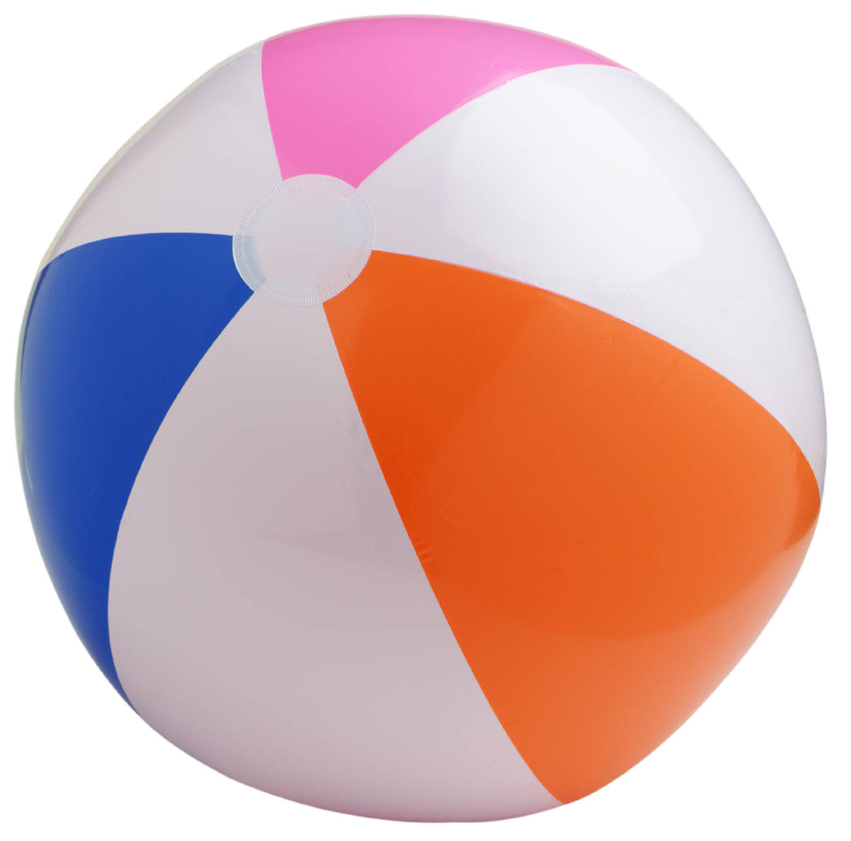  10:15-11:45 am | OUTDOOR PLAY TIME  In very hot weather outdoor play time will be shortened and we will continue our games indoors where it is air conditioned! | Walk to a nearby park  Free play and  organized activities  e.g. Treasure hunt  Red Rover, Red Rover  Simon Says  Hop Scotch |  |  | Free play on the playground is always an option but there are also many activities organized such as t-ball, parachute games, relay races, etc.
12:00pm-1:00 pm | Lunch: A full course home-cooked, hot meal is provided by our chef. | Includes washing up and helping to clean up your place after lunch |  |  | We can care for children with food allergies or food restrictions
1:00pm-2:00pm | Board games, coloring activities and classroom games (time to relax) | Our activities are geared to stimulate the child’s mind as well as help build friendships |  |  | Children are given many choices and are allowed freedom to choose activities
Every day: Activity with our specialists | Between 1:30 to 2:30pm  Yoga, Baking or cooking class, Outdoor Sports, Reptile visits with Reptizoo, The Science Gal, Games days, Spanish For Fun, Music shows, Theatre workshops, Gardening, Karate  Or on special days at 3:00pm we will have summer shows: Magic, Clown shows (see summer calendar for dates)
Afternoon snack time | Snack is eaten after our activity with our specialist
Afternoon activities | Outdoor Games/ Crafts/Sports
4:00-6:00 pm (approx)  Note: After 6pm there is a late fee of $1.00 per minute, payable to the teacher in charge | OUTDOOR PLAY TIME  (Indoors in case of rain: gym games, dress up, puppet play, board games and free play) |  | Outdoor free play and organized play with camp monitors | Ball games, racquet games, parachute games, “street” hockey, painting outdoors, water play on hot days, etc
We will be going on exciting excursions about once per week in the morning. Excursions will not conflict with swimming lessons or activities with our specialists. Parents will be asked to pay the cost of any entry fee.

