September 2017/septembre 2017
Classroom 2 / Classe 2
Español
con Andrea
 | MONDAY  LUNDI | TUESDAY  MARDI | WEDNESDAY  MERCREDI  IMPORTANT | THURSDAY  JEUDI | FRIDAY  VENDREDI
For the Meet the teacher evening
Please join us on Wednesday September 13th at 7:30PM

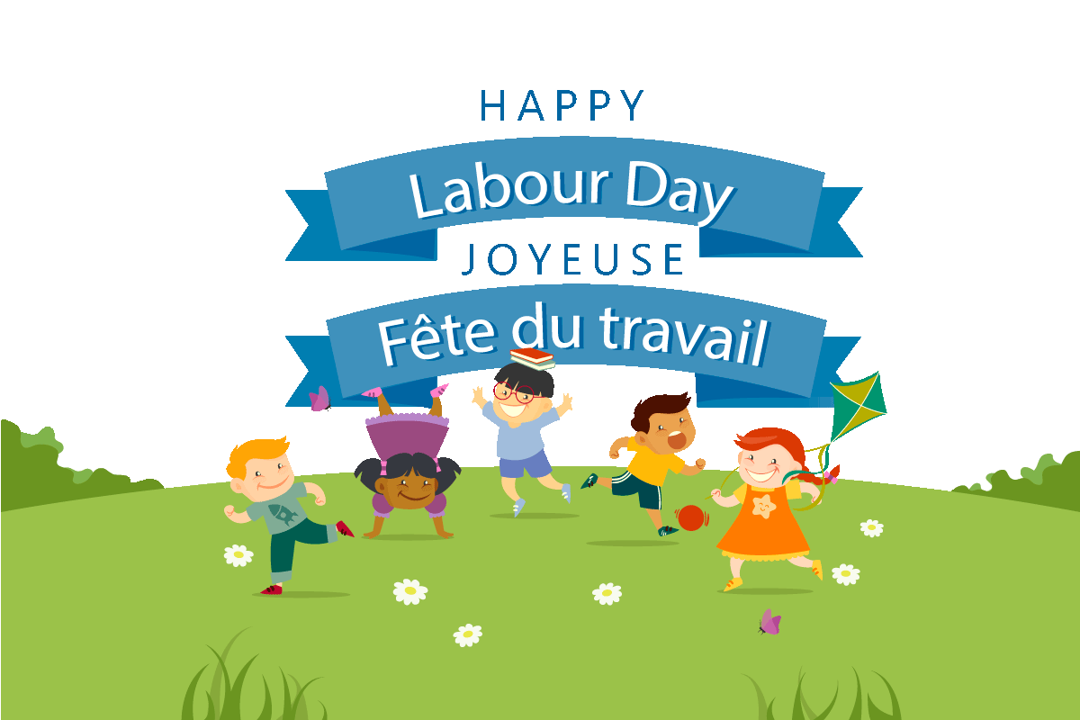Nos Conocemos: ¿Como te llamas?  Comment t’appelles-tu? | 4 | 5 Theme: Learn about our new classroom  Jeu pour apprendre à  se connaître  Jack W.  Noah | 6 Discussion: We will learn  ‘’ the rules ‘’ for classroom 2  Avery L.  10:15AM: Yogi Doug “our  favourite fun yoga teacher” | 7  Let’s make a  big painting for our classroom | 8  Choose your favorite game  in our classroom, and play it  with your friends
Mi nueva clase: Vocabulario de mi entorno proximo.  Vocabulaire de ce qui m’entoure. | 11 Theme: Teachers  are fun!  The teachers will have a  Hoola Hoop contest! | 12 Discussion :  Parlons à propos du prof!  Weekly Science:  Fizzy Science is Fun! | 13  WE LOVE YOGA! ($5.00)  Storytime:  7:30PM Meet the teacher  What teachers can’t do | 14  Jeu: Deviner c’est quel professeur  AM Mini-Scientists Program with Chelsea and Sarah | 15 Final day to bring Scholastic book orders  We’ll have a dance party  with our teachers
La canción del ABC & Pintamos  las letras.  L’alphabet en chanson et peinture. | 18 Theme: A B C’s  10:15AM: Concert “ABC  Come sing with me” with pianist  Michael Woytiuk ($5.00)  PM Ballet with Nina | 19 Bricolage avec  les lettres de  l’alphabet  Storytime :  Chicka Chicka Boom Boom | 20  Game: Guess what letter I am?  Weekly Science:  ‘’B’’ is for Bubbles  Music with Kimberley: Flute  FARM PYJAMA DAY | 21  Storytime: Winnie the Pooh  A to Zzzzzz  AM Mini-Scientists  Music with Kimberley: Flute | 22 Devine la première  lettre de ton nom  Tracing letters in the sand  AM Wimgym
Animales  de la granja : Vocabulario/ Artesanias.  Animaux de la ferme : vocabulaire et bricolage | 25  Theme: Visit the farm  Art: Make a cow  Storytime:  Harvest Party  PM Ballet with Nina | 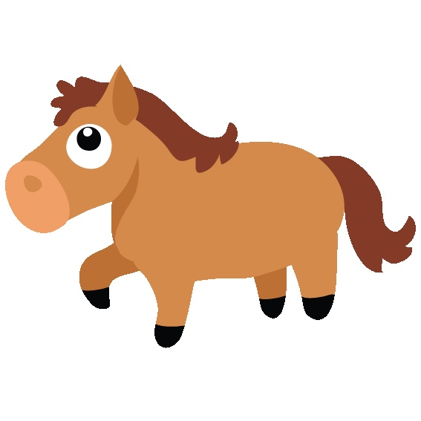  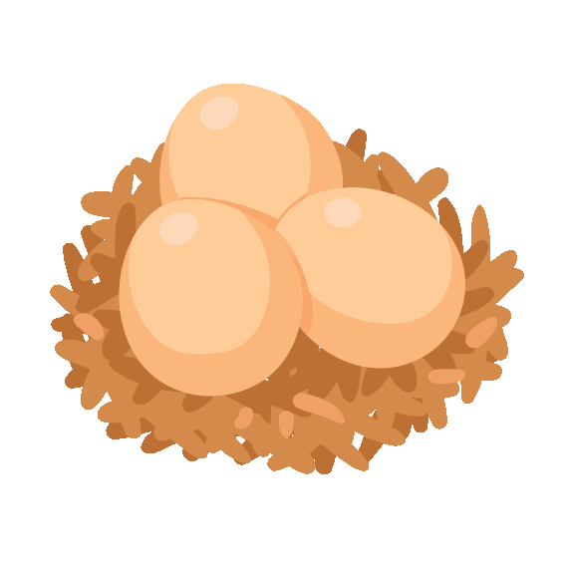26 8:45AM trip to Ferme du Domaine Quinchien with  pony rides ($20.00)  Storytime: My Farm Friends | 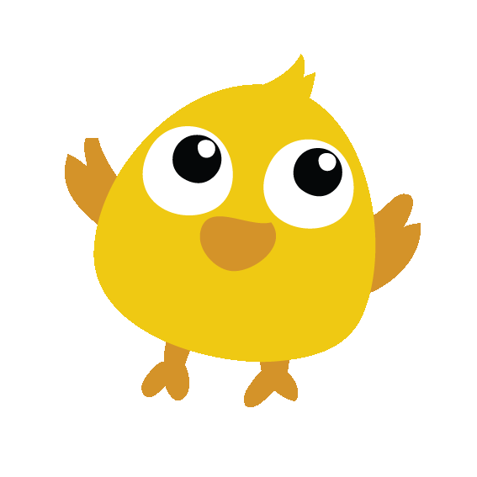27  “Farm” eggs for  breakfast  WEAR YOUR “ANIMAL” PJ’S  We’ll sing songs about the farm  Craft: Farm animals on a stick  Music with Kimberley: Saxophone | 28  Bricolage d’un mouton  AM Mini-Scientists Music with Kimberley: Saxophone | 29 Show & Tell : Bring a  picture of a farm animal  Weekly Science :  Dancing corn  Sonny  AM Wimgym

