November session!
Kid’s Karate with Sensei Meghan
Kodomo Karate
Meghan Greig (Sensei Meghan) is trained as an elementary school teacher and has been studying and teaching Karate for twenty years. Meghan teaches our very popular Karate program and we can guarantee that every child will LOVE Sensei Meghan’s classes. Sensei Meghan’s creativity (she uses fun themes to illustrate the Karate moves) and her skill and sensitivity in working with young children (all the children focus in Meaghan’s classes!) means that our Montessori Karate program is well worth attending. In Sensei Meghan’s words:

“Kodomo Karate is a special class customized for the preschool aged population. This program is a unique blend of traditional martial arts etiquette and technique, with age appropriate games and manipulatives designed to bring young children a love and appreciation for the world of martial arts.
What will your child gain from Kodomo Karate?
Each class begins with an activity called the “ski game”. “SKI” is the magic word in our karate classes. It means that students must stand absolutely still and quiet, waiting for the “sensei” to give instruction. In the ski game, students are asked to use their imaginations to pretend to be something loud and fast. This might be their favourite animal, or a gigantic T-Rex, or Lighting McQueen. All the while, students are listening for the word Ski. When they hear it, they race back to their spots, and stand at attention, completely silent. This is one example of the many activities and exercises designed to bring children from their natural state of high energy to one of calm and focus.
The end result?
Children who are masters of themselves. Able to have fun and be a child, while also capable of settling into quiet focus when necessary. This is only one amazing life skill that Kodomo Karate can introduce to your child. Add to that the confidence they will gain from feeling Strong both inside and out. And throw in some kicks, punches, and the ability to count to ten in Japanese! “

Classes will take place on Friday afternoons. Each class will be 30 minutes in length. There will be four classes total starting on Friday, November 3 and ending on Friday, November 24. The cost for the four classes is $40.00. To register please submit the form below by Wednesday, November 1.
Note: For classrooms 1 and 2 the classes will take place in the library. For classrooms 3 and 4, Karate classes will take place in classroom 4 (children not attending Karate will have a fun activity planned in room 3 for that half hour period).
____________________________________________________________________________________
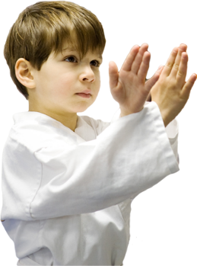
I wish to register my child for Karate classes with Sensei Meghan for the November 2017 session
Child’s name___________________________________________ Classroom ____________
I enclose $40.00 cash________or cheque_________ (made out to Montessori Pointe Claire)
Parent’s signature_________________________________________________

