Classroom / Classe 2
December 2017/Décembre 2017
Español con Andrea | MONDAY  LUNDI | TUESDAY  MARDI | WEDNESDAY  MERCREDI | THURSDAY  JEUDI | FRIDAY  VENDREDI
Bring your donations of food, clothing or toys for Share The Warmth charity |  |  |  |  | 1
Las profesión práctica  Hands-on professions | 4 Theme: What can I  do with my hands?  AM Michael’s mom will tell us about using her hands as a hairstylist  Layla | 5 Final day to bring  Scholastic book orders  Jeu: Mimons  avec nos mains | 6 8:20AM Excursion: I can juggle! ‘’Cirque et Boule de neige’’ at Stewart Hall  ($15.00)  We’ll sing songs  with our hands  Music with Kimberley: Bells! | 7  Adelaide’s mom is a veterinarian and she will talk about how she uses her hands to care for animals  Melissa the Science Gal : Fingerprints are unique! | 8 2:00 or 2:30PM With my hands I can play Basketball with Sportball ($8.00)  Viviane’s mom – a chiropractor – will tell us about  working with her hand  Oscar  Stringing activity  For Parents: Klassy Kanvas Christmas gift sale
Vocabulario de Navidad  Vocabulaire de Noël | 11 Theme: Santa  Claus is on his way  11AM SPECTACLE ‘’Le traineau du Père Noël’’($8.00)  Chanson: Petit papa Noël | 12 Happy Hanukkah  Activities with Melissa!  AM Atelier sur  la gestion des  matières  résiduelles | 13 Storytime :  The night before  Hanukkah  2:15PM  You are invited to our  Christmas party  & music concert | 14  Craft: Christmas stockings  Avery R. | 15 Deadline Sep 2018  early registration  8h20 Excursion to the “Railway Christmas Exhibition” at Exporail(27$)  Storytime : Is it Hanukkah yet?
Canción “Rodolfo el reno”. Decorados nuestro reno.  Chanson « Le renne au nez rouge ». Décorons notre renne. | 18 Theme: Enjoying  the holiday season  10:15AM ‘’A Magical Musical Adventure’’ with pianist Michael Woytiuk ($5.00)  Storytime:  A kwanzaa miracle  & Kwanzaa coloring | 19  10:15AM Yogi Doug : Holiday Yoga  For the profit of the  Angel Hair for Kids foundation ($5.00)  Bricolage:  Père Noël arrive! | 20  Show &tell:  Bring your favorite holiday story  Wear something red or a Christmas sweater today! | 21  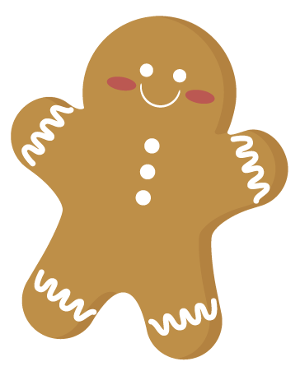  Cuisinons avec Pina: Biscuits de Noël  We’ll go caroling  in the school  Storytime: K is for Kwanzaa  Music with Kimberley: Bells! | Come to school in your holiday PJ’s! Christmas waffle breakfast  We’ll have a special  Christmas treat for  afternoon snack  Jake
Closed for holidays December 25 to January 1.
The first day of school for the New Year is Tuesday January 2, 2018.

