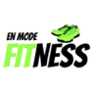
ZUMBA FOR CHILDREN
Zumba kids junior Program
With En Mode Fitness

By popular demand we have arranged a winter Zumba session available to all children in classrooms 1 and 2. Classes will be on Tuesday afternoons. Please fill in the form below and return as soon as possible in order to have your child join in! The cost for 6 classes is $60.00.
En Mode Fitness specializes in Zumba for young children. Kid friendly Zumba routines are so much fun as the children love the Zumba Fitness music, rhythms, and beats. Children will improve their gross motor skills by jumping, dancing, shaking, and swinging their hips, it’s the perfect recipe for fitness fun.
It’s a well-known fact that fitness is an essential part of children’s health. Zumba, which literally means “moving quickly and having fun” is the perfect way to incorporate exercise into kids’ lives in a fun, easy way with multiple personal and social benefits.

ZUMBA CLASSES WILL BE ON TUESDAYS FOR 30 MINUTES FOR SIX SESSIONS:
Jan 16, 23, 30
Feb 6, 13, 20
(Parents are invited to our last class)

Why children should do Zumba:
- Easy-to-follow moves that work on gross motor skills
- Improves fitness
- Improves coordination
- Great fun
- Increases self-confidence
- Boosts self-esteem
- Elevates mood
- Improves memory
- Instills a love of dance

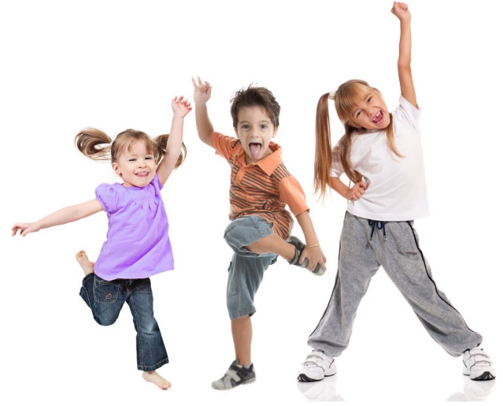
I would like to register my child (name)
__________________________________________
Classroom number______________ for Zumba classes (January/February 2018).
Attached is my cheque (made out to Montessori School) or cash for $60.00
Parent’s signature
_________________________________________

