SWIMMING REGISTRATION

LESSONS FROM MARCH TO JUNE

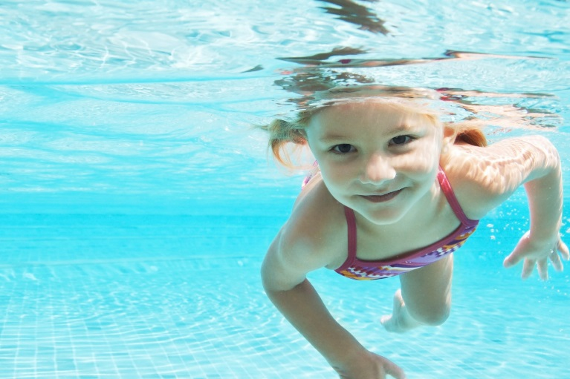

For children ages 3 to 5 (child must be completely toilet trained)

Swimming lessons are at the warm (indoor) pool at the Pointe Claire Aquatic Centre, corner of Douglas Shand and Maywood Roads. The children learn swimming techniques from certified instructors. Emphasis is on feeling comfortable in the water, learning to float, kick and learning basic swimming strokes. The children have a half-hour lesson at 10:00 or 10:30am and also play for approximately 20 minutes in the wading pool (extremely well supervised-with our teachers IN the water). The bus leaves the school at 9:15 a.m. Your child needs to arrive at school by 9:00am please.) Children are at all times supervised carefully by the teachers, the swimming instructors and lifeguards. This is a very enjoyable activity for young children. Places are limited (maximum of 5 children per instructor for lots of individual attention during the lessons).

***11 lessons, Tuesday mornings, March 27 to June 5.***

***Parents are invited to come to our last class on June 5th.***

The cost of this program includes transportation by school bus and additional supervision.

**TO REGISTER, PLEASE RETURN THE FORM BELOW.**

**Registration will be accepted on a first come-first serve basis.**

⇒⇒⇒⇒⇒⇒⇒⇒⇒⇒⇒⇒⇒⇒⇒⇒⇒⇒⇒⇒⇒⇒⇒⇒⇒⇒⇒⇒⇒⇒⇒⇒⇒⇒⇒⇒⇒⇒⇒⇒⇒⇒⇒⇒⇒⇒⇒

Please register my child for swimming lessons: Tuesday mornings March to June 2018 (11 classes)

In order to help us place your child in the correct level, please check one:

€ my child has already attended lessons at the Pointe Claire Aquatic Centre and is in colour level___________________

OR € my child does not yet know how to swim

€ my child can swim with a bubble/floaties

* my child can swim (2-3 meters) on his/her own

CHILD’S NAME___________________________________Date of birth_________________

Classroom number_____________

MCj03579930000%5b1%5d

Total amount submitted **$185.00** €cash €cheque (payable to Montessori Pointe Claire

and dated March 15, 2018)

Parent’s Signature­­­­­­­­­­­­­­­­­­­­­­­­_______________________________________Date__________________