Special Events for March 2018

1 Excursion to Stewart Hall Cultural Centre: Mozart's Flight of Fancy (Classrooms 1 and 2 only)
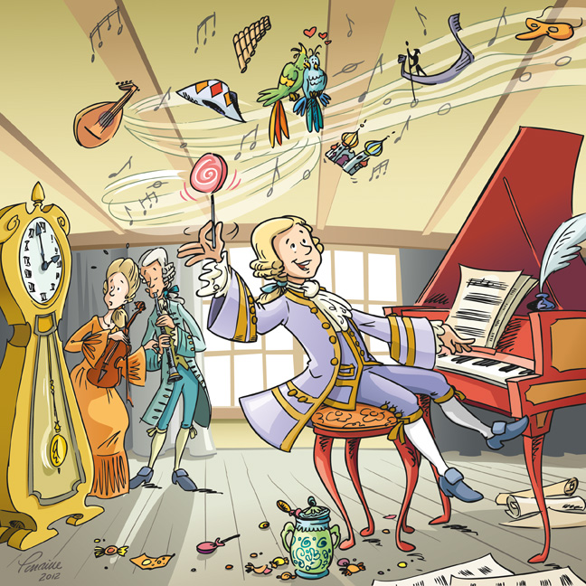
Where: 176 du Bord-du-lac Pointe-Claire 514-630-1220
What: Immersed in the world of the child prodigy Wolfgang Amadeus Mozart, children will discover his infinite sources of inspiration. One afternoon Mozart and his big sister, Maria Anna, find themselves home alone for an hour of free time! Excited by the freedom to run around and have fun without parental supervision, Mozart imagines various fantasy scenarios while his sister tries to bring him back down to earth. That’s when their good friend Anton shows up with a magnificent instrument: the clarinet! If your child does not usually attend on Tuesdays, he/she is welcome to attend this trip. Cost per child is $15.00.
When: Tuesday, March 6. The bus leaves at 9:45AM and we will be back at school for lunch

2 Sportball "Moving is brainy"
Where: In the child’s classroom
What: Sportball is a half hour of fun and learning with a physical education animator (“coach”). For the "What can I do with my brain?" week, the children will take part in developmentally appropriate exercises and fun and exciting cooperative play that will have their brains working! This is perfect to demonstrate to the child that we have a brain-body connection No matter what the sport or games are, we always look forward to our Sportball workshops. If your child does not usually attend on Fridays, he/she is welcome to come to the Sportball Workshop at the time shown below. The cost is $9.00. The web site for Sportball is www.sportball.ca
When: Friday, March 9 Classroom 1: 1:00pm or 1:30pm Classroom 3: 3:00pm
Classroom 2: 2:00pm or 2:30pm Classroom 4: 3:30pm

3 Excursion to Excursion to McCord Museum: The Topsy-Turvy Storyland, A Toy Exhibition (Classrooms 1 and 2 only)
Where: 2175 Rue Victoria, Montréal 514-861-6701
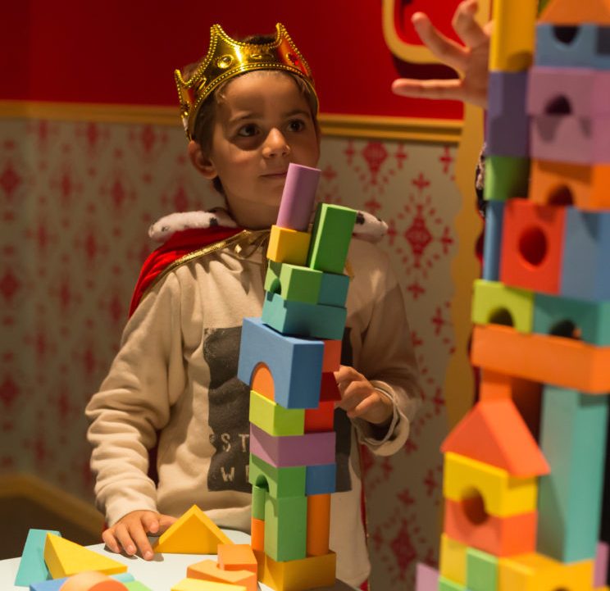
What: This exhibition is interactive and fun! The museum needs our children help to find the lost objects of fairy tales. A quest worthy of "À l'aventure" week! Little Red Riding Hood, Hansel and Gretel, Jack and the Beanstalk, The Little Mermaid and Cinderella; these stories have been reinterpreted in an immersive and fun space, where young visitors can roam a world turned upside down by a spell cast by an evil fairy godmother who has mixed up the characters and objects from different fairy tales—and caused quite a conundrum in the process! The exhibition also includes a dress-up area and space for playing games such as bowling, memory, blocks and bird watching, to name a few. We will have two hours to tour the exhibits and play games. If your child does not usually attend on Mondays, he/she is welcome to attend this great trip. Cost per child is $19.00. We will need parent volunteers so please sign yourself up on the classroom door
When: Monday, March 12. The bus boards at 8:00AM, we need to leave at 8:15 sharp to be on time. We will be back at school for lunch

4 An excursion to The Pointe Claire Aquatic Centre for Swim and Gym (Classrooms 1 and 2 only)
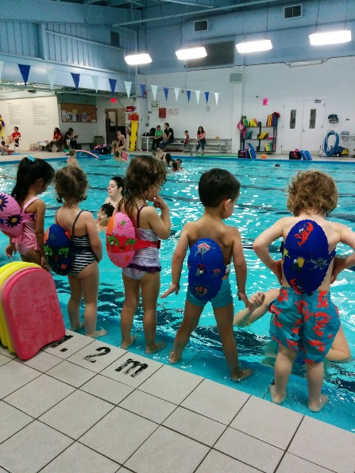
Where: 60 Maywood Ave., Pointe Claire 514-630-1202
What: This excursion takes place in the morning for some fun land and aquatic activities. The Pointe Claire Aquatic centre has a wonderful gymnasium and pool. For 30 minutes, children will explore movement in the gym through structured activities and games. Then comes the “30-minute swim” where qualified and caring instructors provide each child with a swimming lesson and of course some time to play. This is a safe and happy learning experience with the dynamic staff at the Pointe Claire pool. If your child does not usually attend on Thursdays and you would like him/her to come on the trip please see us in the office to confirm availability. Cost is $19.00. Your child needs to wear a bathing suit with t-shirt on top and bring a towel (put names on the towels please).

When: Thursday, March 15. Two groups: Bus leaves at 9:00 and 10:00

5 Turtle Magic Show with Blair Marshall!
Where: At the school, in classroom 4 or 2.
What: The ocean is a magic place! Meet a turtle on the beach and be ready for some magic with Blair Marshall. Blair Marshall has been performing for over 30 years and has come to Montessori many times. We always look forward to his shows! The show is about 40 minutes long. If your child does not usually attend on Mondays you are very welcome to drop by with him/her. The cost is $6.50 for the child.
When: Monday, March 19. Classroom 1 and 2: 10h30am
Classroom 3 and 4: 9h30am
:::: Rescheduled activity :::: Excursion to Cap Saint-Jacques (Classroom 1 and 2 only)
FOR THOSE CHILDREN ALREADY SIGNED UP FOR THIS ACTIVITY LAST MONTH: As the date has changed we need you to “check” the box saying yes but there is no fee (you have already paid).
FOR CHILDREN WHO WERE NOT SIGNED UP LAST MONTH BUT WISH TO PARTICIPATE: This is treated same as any other field trip, check yes and include the field trip fee in your payment.

Where: 215 chemin Cap Saint-Jacques, Pierrefonds 514 280-6743
What: Originally planned for January 23, this activity has been rescheduled for March 27.
Nous participerons à trois activités de plein air durant notre séjour à Cap Saint-Jacques: Fabulosia, Pirate à l'abordage et Kansi. Fabulosia: Transformés en personnages magiques, les participants devront utiliser les voies de l’expression dramatique pour contrer les mauvais sorts jetés sur les animaux de la forêt. Pirate à l'abordage: Suivant un entraînement pour devenir pirates, les participants partiront dans une folle aventure à la recherche d’indices et de cartes dans le but de mettre le grappin sur le mystérieux trésor caché. Kansi: Les animaux du zoo se sont enfuis. Les participants doivent donc partir en Safari à l’aide d’une carte afin de visiter chaque animal et trouver une mystérieuse habitation.The cost per child is $20.00.
When: Tuesday, March 27. The bus leaves at 8:15 am (we will be back at school for lunch)
__________________________________________________________________________________________________
I give permission for my child to participate in the following:
1 Excursion: Stewart Hall (classroom 1 and 2) Yes No Cost: $ 15.00
2 Sportball Fun! Yes No Cost: $ 9.00
3 Excursion: McCord Museum (classroom 1 and 2) Yes No Cost: $ 19.00
4 Excursion: Swim and Gym (classroom 1 and 2) Yes No Cost: $ 19.00
5 Turtle Magic Show with Blair Marshall Yes No Cost: $ 6.50 RESCHEDULED TRIP TO CAP ST JACQUES (Classrooms 1 and 2: Mar 27) Yes No Cost: $ 20.00
For Cap St Jacques pay only if you did not pay last month for this trip

CHILD’S NAME ________________________________________________ Classroom No.________________

PARENT’S SIGNATURE_________________________________________ TOTAL SUBMITTED $_______________
IMPORTANT: PLEASE GIVE THIS FORM AND THE FEE TO THE TEACHER BY Friday, March 2.

