Special Events for April 2018
1 Excursion and lunch La cabane à sucre de la famille Constantin (Classrooms 1 and 2 and 4 -100%toilet trained)
Where: 1054 Boulevard Arthur-Sauvé, Saint-Eustache (450) 473-2374
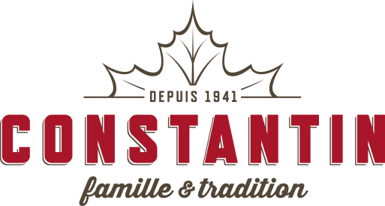
What: This excursion is your typical, wonderful, Quebec fun Sugar Shack event! We will eat taffy on the snow, visit the farm animals, take a horse-drawn sleigh ride and end our visit with an all you can eat sugar-shack lunch! If the weather permits it, we will go collect maple water from the maple trees and walk in the forest. Here’s the lunch menu MENU TRADITIONNEL À VOLONTÉ COMPOSÉ DE: Pain canadien - Soupe aux pois – Cretons - Salade de choux - Saucisses dans le sirop - Marinades maison - Sirop d’érable – Omelettes – Jambon - Grillades de lard - Fèves au sirop d’érable - Pommes de terre bouillies - Oeufs cuits dans le sirop – Crêpes - Pouding au chômeur - Tarte au sucre - Crème glacée molle - lait. https://constantin.ca/cabane-a-sucre/menu-produits-derable/ The cost for this excursion is $25.00
When: Thursday, April 5. Please be at school by 8h45am to leave on time.

2 Excursion to Stewart Hall Cultural Centre: La minuscule (Classrooms 1 and 2 and 4 – 100% toilet trained)
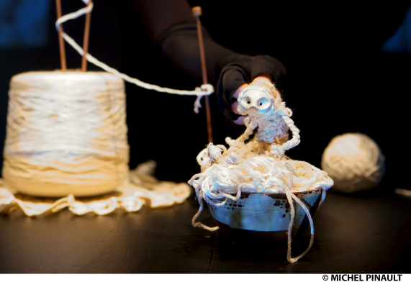
Where: 176 du Bord-du-lac Pointe-Claire 514-630-1220
What: Visual poetry with a puppet, materials and live video. Minuscule has not grown up. Just like a grain of dust, sometimes like a hand or a small piece of bread. She was born on a winter morning, from a storm, inside and out. Surrounded by paper cutouts, crunchy sounds, shadows and lights, objects and materials, she lives in a larger than life world, a reflection of the inner imaginings of an islander. From season to season and from one improbable encounter to the next, she takes care of the lighthouse. The cost for this excursion is $15.00.
When: Monday, April 9. Please be at school by 8:30am to leave on time.

3 Pianist Michael Woytiuk presents a Piano Concert for children: “Out of This World Music”
Where: At the school, in the library area or classroom.
What: It’s "Earth" week at Montessori and Michael has a special piano concert planned for us, where we will have fun with music and stories that get us up and moving to the rhythm. Sun, stars and earth, out of this world. We’ll be entertained with songs like “Mr Sun”, “Hot Hot Hot” and other fun adventurous music. We’ll use our imagination, pretend we are looking at clouds, and see where Michael’s beautiful piano music can take us. Michael performs several times a year at Montessori and his concerts are always a success with the children. If your child does not usually attend on Mondays he/she is welcome to at the time shown. The cost is $5.00.
When: Monday, April 16 Classroom 1: 10:45 am Classroom 2: 10:15 am
Classroom 3: 9:15 am Classroom 4: 9:45 am

4 An Art Workshop with Jenny-Lynn Manzo “Planète Terre”
Where: In the school library or classroom
What: We all love Jenny and her art classes! Here’s the synopsis of this workshop, which takes place during “Earth” week.
"Comme notre rencontre sera près de la date du Jour de la Terre nous ferons un bricolage avec un élément surprise recyclé! Nous parlerons de la Terre, nous observerons sa forme, les couleurs qui la caractérise lorsque qu’on la voit prise en photo dans l’espace, etc…ce sera notre point de départ et inspiration pour créer un chef d’œuvre abstrait la représentant avec une technique inusitée et amusante! "
" As our meeting will be near the date of Earth Day we will do a craft with a surprise recycled element! We will talk about the Earth, we will observe its shape, the colors that characterize it when we see pictures of the Earth taken from space ... it will be our inspiration to create an abstract masterpiece representing Earth using an unusual and fun technique! "
Jenny-Lynn Professeur d’art/ Art teacher
The cost of this great activity is $12.00
When: Friday April 20, in the afternoon
5 "My own moon walk Yoga" with Yogi Doug
Where: At the school in the child’s classroom or in the library
What: Yogi Doug has been part of our Montessori program for several years now. Yogi Doug comes in during the year to teach some very special yoga classes for us. Yogi Doug teaches using the Kripalu Yoga technique which is a form of Hatha Yoga using inner focus, meditation, standard yoga poses, breath work, "development of a quiet mind", and relaxation. Yogi Doug’s specialty is making this connection for young children. The children are extremely enthusiastic about Yogi Doug’s classes. Every class that he teaches has a different focus and goes along with our weekly theme. For “Outer Space” week our minds are going to leave the Earth and follow Yogi Doug's enthusiasm to the moon and beyond.

Whenever Yogi Doug teaches, all the money that he raises (100% of it) is donated to charity. Each time he is here we pick a special charity that will benefit. For our April class with Yogi Doug the donation will be to the Shriners Hospital for Children. (https://www.shrinershospitalsforchildren.org/montreal)

If your child does not normally attend on Mondays he/she is welcome to come to the class-you can join in too-no cost for parents. Cost per child is $5.00
When: Monday, April 23 Classroom 1: 10:45 am Classroom 2: 10:15 am
Classroom 3: 9:15 am Classroom 4: 9:45 am

6 Excursion to the Botanical Gardens (Classrooms 1 and 2 and 4 – 100% toilet trained)
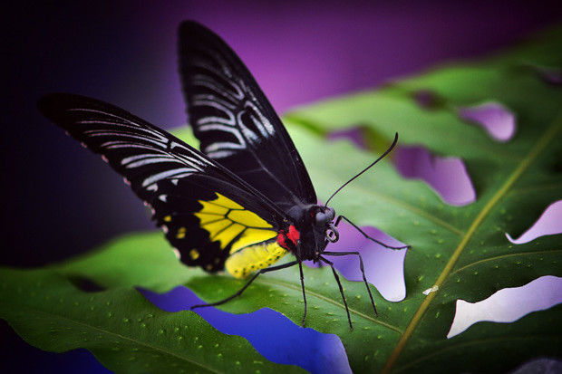
Where: 4101 Sherbrooke, Montréal (514) 868-3000
What: Dans le cadre de la semaine de la préservation, nous visiterons l'exposition Papillon en Liberté et l'insectarium du Jardin Botanique de Montréal. Les papillons et plusieurs insectes perdent de plus en plus leur habitat à cause des activités humaines (industrialisation, étalement urbain et agriculture commerciale) et leur population est aussi affectée par les changements climatiques. Il est important d'en apprendre davantage sur ses espèces afin de s'assurer qu'elles ne deviennent pas éteintes. Les insectes et les papillons sont un pilier des écosystèmes où il nous fait si bon vivre. The cost for this excursion is $19.00
When: Wednesday, May 2. Please be at school by 8:30 am to leave on time.
_______________________________________________________________________________________
I give permission for my child to participate in the following:
1 Excursion and lunch Cabane à sucre(Classrooms 1 and 2 and 4 -100%toilet trained)Yes No Cost: $ 25.00
2 Excursion to Stewart Hall (Classrooms 1 and 2 and 4 – 100% toilet trained) Yes No Cost: $ 15.00
3 A Piano Concert for children: “Out of This World Music” Yes No Cost: $ 5.00
4 An Art Workshop with Jenny-Lynn Manzo “Planète Terre” Yes No Cost: $ 12.00
5 "My own moon walk Yoga" with Yogi Doug Yes No Cost: $ 5.00
6 Excursion - Botanical Gardens (Classrooms 1 and 2 and 4 – 100% toilet trained) Yes No Cost: $ 19.00

CHILD’S NAME ________________________________________________Classroom No.__________________
PARENT’S SIGNATURE______________________________________TOTAL SUBMITTED $_________________
IMPORTANT: PLEASE GIVE THIS FORM AND THE FEE TO THE TEACHER OR OFFICE BY Tuesday, April 3.

