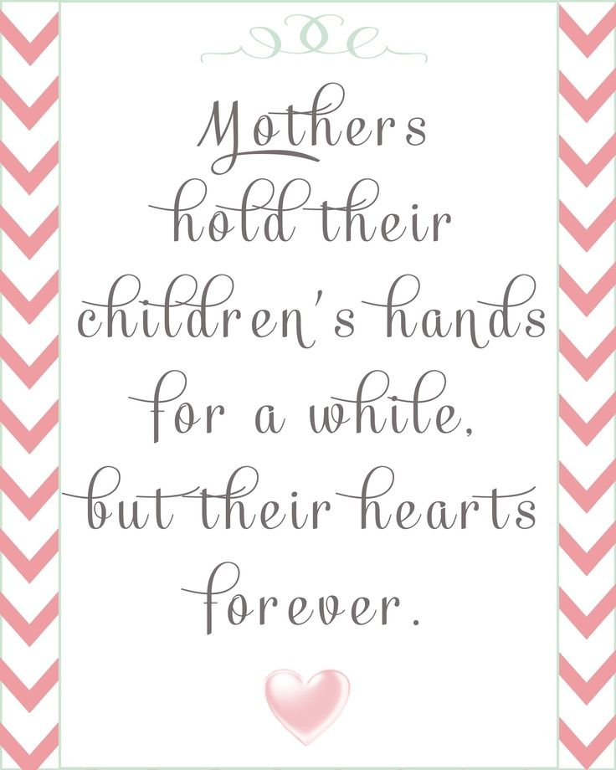MAY 2018 NEWSLETTER

**Happy Mother’s Day to You**

# PARENT WINE AND CHEESE MEETING

Our final parent meeting of the year will be on **Wednesday, May 16th, from 7:30 to 9:00pm.** We invite **all** parents to come and participate. Your input is very valuable and we are sure that you will find our meetings interesting. Wine and cheese are always served and the evening is social as well as informative. Agenda for our upcoming meeting:

1. How to teach your child to be generous – Artemis, Daycare director
2. Pascale Pinette our science specialist will talk about the continuum concept (the idea that in order to achieve optimal physical, mental and emotional development, human beings — especially babies — require the kind of experience to which our species adapted during the long process of our evolution.)
3. Samantha (classroom 4 teacher) will talk about “when is it a good time to stop the pacifier?”
4. Herla (enseignante Prématernelle): Pourquoi c’est important de partager.
5. Open discussion

# END OF YEAR PARTY AND GRADUATION CEREMONY

YOU WILL BE INVITED TO BRING SPECIAL TREATS FOR GRADUATION. A LIST WILL BE POSTED ON THE CLASSROOM DOORS. PLEASE PAY SPECIAL ATTENTION TO INGREDIENTS TO AVOID BRINGING ANYTHING WITH TRACES OF NUTS. IT IS DIFFICULT TO SUPERVISE THE CHILDREN DURING A PARTY, THEREFORE WE COUNT ON YOUR CARE IN BRINGING FOOD THAT EVERYONE CAN EAT AND ENJOY.

THANK YOU.

**Parents are invited to the graduation ceremony of their child**

***Friday June 15:***

Classroom 1: 1:45 pm Classroom 2: 2:15 pm

### Classroom 3: 3:00 pm Classroom 4: 2:45 pm

**Our graduation agenda:**

**--- Presentation of songs by the children**

j0290203**--- Graduation ceremony**

**--- Buffet “lunch” in class**

**--- Outdoor activities: Entertainment, face painting, pony rides**

Our party will take place on the Friday, June 15th, rain or shine. For the children who do not usually attend on Fridays, you are requested to come with your child at the graduation ceremony time. ***All children need to have an adult present*** on graduation day, as the teachers are busy with the ceremony and it is not possible to provide individual supervision once the ceremony has started. If it is impossible for a parent to attend please send a grandparent, aunt etc. Please join us and come enjoy this fun and exciting event.

# KEEP THE SAND OFF THE CARPETS

When you bring your child into the school in the afternoon at pick up, he or she should automatically want to take his/her outdoor shoes off to go into the classroom. If he/she does take his shoes off, we ask that you please be careful that the sand in the child’s shoes is dumped into one of our little “sand buckets” in the cubbies and not on the carpet. We have replaced our vacuum cleaner (again) as the sand chews up the motor, so we are trying hard to avoid having to vacuum up too much sand. It is also a good lesson to teach your child about respecting his environment as the sand from the buckets will go back outdoors. Thank you ☺

# http://c.tadst.com/gfx/stock/fathers-day-canada.jpgREMINDER MOTHER’S DAY AND FATHER’S DAY EVENTS

* Mother’s Day Tea on Friday, May 11 at 2:00pm for classroom 1
* Mother’s Day Snack Time, for classroom 3 on Tuesday, May 8 at 3:00pm.
* Mother’s Day Tea on Thursday, May 10 at 2:30 pm for classroom 2
* Mother’s Day Tea on Wednesday, May 9 at 3:30 pm for classroom 4
* Father’s Day Breakfast on Monday, June 11 for classroom 1 (8:30am)
* Father’s Day Breakfast on Wednesday, June 13 for classroom 2 (8:30am)
* Father’s Day Snack Time, for classroom3, on Wednesday June 13 (3:30pm)
* Father’s Day Breakfast on Tuesday, June 12 for classroom 4 (8:30am)

We do try to make these “ladies” and “gents” events, but if “mom” or “dad” cannot attend please let the

teachers know who will be coming.

PLEASE CHECK YOUR CHILD’S SNACKS TO BE SURE THEY ARE NUT FREE AND ALSO CHECK THAT HE/SHE IS NOT COMING TO SCHOOL WITH PEANUT BUTTER ON HIS CLOTHING. WE HAVE SEVERLY ALLERGIC CHILDREN IN ALL CLASSROOMS. THIS CARE ON YOUR PART IS CRITICAL FOR KEEPING EVERYONE SAFE. THANK YOU.