Special Events for May 2018

- Jenny-Lynn Manzo, art teacher, a special art workshop for children
Where: In the school library or in the classroom
What: Our favourite Art teacher Jenny-Lynn Manzo is here with a wonderful children’s art project that we will all enjoy doing while we learn about different art techniques. In Jenny’s own words:
LES CHOSES QUI POUSSENT / THINGS THAT GROW
Art conceptuel /Process art
Nous réaliserons une œuvre abstraite impressionnante en nous inspirant du thème. Le tout en utilisant des objets amusants, surprenants et inattendus ainsi que des méthodes de créations inusitées.
We will create a totally awesome abstract artwork inspiring ourselves from the theme using fun unexpected, surprising objects and methods of creation.
L’art conceptuel est considéré comme un voyage ou un processus créatif, plutôt que comme un produit livrable ou un produit final.
Process art is viewed as a creative journey or process, rather than as a deliverable or end product.
Jenny-Lynn Professeur d’art/ Art teacher

If your child does not usually attend on Thursdays, you are welcome to bring him/her for the workshop at the time shown below. Cost for the child is $12.00.
When: Thursday, May 17 in the morning. Children will be divided into small groups.

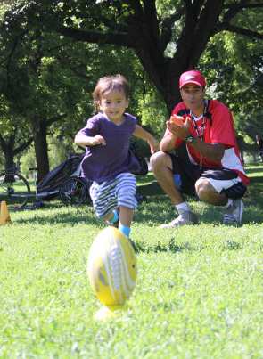
2 Sportball “Football - Fun and Active”
Where: In the child’s classroom (or outdoors if possible)
What: Sportball is a half hour of fun and learning with a physical education animator (“coach”). The program is specifically designed to teach the children the skills of various sports. The sport for this workshop is football, very suitable for our “Sweet treats” week as it is one of the more active sportball classes, and that’s what we need to work off those sweet calories 😊! Sportball’s Football and Flag Football programs for kids introduce children to the fundamental concepts of the game in a fun, supportive, non-competitive environment. Coaches zero in on skills like throwing and catching, field goals, snapping and footwork in fun, exciting skill-focused play. At the same time that we are teaching toddlers, preschoolers and big kids how to reach the endzone, we are also helping children meet developmental milestones and develop physical literacy through our play-based, “coaching with purpose” curriculum. At Montessori, we have had many Sportball workshops over the years and every single one of these workshops have been very successful! We always look forward to our Sportball workshops. If your child does not usually attend on Wednesdays, he/she is welcome to come to the Sportball Workshop at the time shown below. The cost is $9.00. The web site for Sportball is www.sportball.ca
When: Wednesday, May 23 Classroom 1: 11:15am & 11:45am
Classroom 2: 10:15am & 10:45am
Classroom 3: 9:15am Classroom 4: 9:45am

3 Théâtre musical et interactif pour enfants : Pikabelle, la Coccinelle
Where: In classroom 4
What: It’s Insect Week at Montessori and La Théâtre Baluchon Magique, children’s theatre group, presents: Pikabelle, la Coccinelle. You can check out this theatre group on their site http://baluchonmagique.com . Here’s a synopsis of the show we will be seeing: Une pièce de théâtre sur l’alimentation, la bonne forme et ses secrets
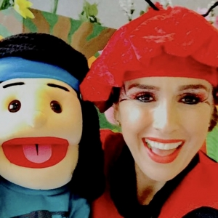
Pikabelle, la coccinelle, invite les amis avec elle au pays des fruits géants. Ils rencontrent là-bas, le raton Rikikouki, qui est malade, car il a trop mangé. Ensemble ils iront trouver le docteur Queue-de-Carotte, qui leur donnera quelques conseils sur l’alimentation et la santé, d’une manière décontractée, adaptée aux enfants. Puis, ce sera au tour le Madame Kroukrou d’ajouter son grain de sel… au sujet de la bonne forme. A travers aventures, dialogues et surprises, des connaissances alimentaires sont données d’une façon à plaire aux tout-petits. Des gestes, des comptines, de l’action et la gigue des légumes.
If your child does not usually attend on Tuesdays, he/she is welcome to come to the show at the time below (you can stay and watch too). Cost is $9.00.
When: Tuesday, May 29 3:00 pm

4 Discover the World of Insects with “Insectia”
Where: At the school, in the classrooms.
What: We will learn about insects in a very interesting way. The educators from the group “Creactions Steven Fraser” will be at the school in the morning with a different type of “workshop” for the children. This workshop is a combination of science fun and gym class! Stations are set up in the classroom with special gym equipment that looks like a giant flower or a giant spider web, for example. The children are given a short presentation describing four different types of insects and what they do (in pre-school language of course!). Then the children rotate through the stations and” pretend” they are insects, in the process learning about such things as how a spider wraps insects in its web (the children actually do this with a toy insect), or how bees pollinate flowers (the children use a dropper to “pollinate” the flowers). If you would like a preview of what will be set up for the children check this link - http://www.bionique.net/creactionsf/video/creaction.mov. If your child does not usually attend on Tuesdays he/she is welcome to come to the workshop. The cost is $8.00
When: Thursday, May 31 Classroom 1: 10:45 am Classroom 2: 10:15 am
Classroom 3: 9:15 am Classroom 4: 9:45 am
________________________________________________________________________________
I give permission for my child to participate in the following:

1 Jenny-Lynn Manzo, a special art workshop for children Yes No Cost: $ 12.00
2 Sportball “Football - Fun and Active” Yes No Cost: $ 9.00
3 Théâtre pour enfants : Pikabelle, la Coccinelle Yes No Cost: $ 9.00
4 Discover the World of Insects with “Insectia” Yes No Cost: $ 9.00
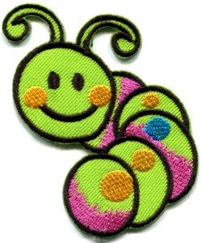
CHILD’S NAME ________________________________________________Classroom No.________________

PARENT’S SIGNATURE______________________________________TOTAL SUBMITTED $_______________
IMPORTANT: PLEASE GIVE THIS FORM AND THE FEE TO THE TEACHER BY Friday, April 11.

