Special Events for June 2018

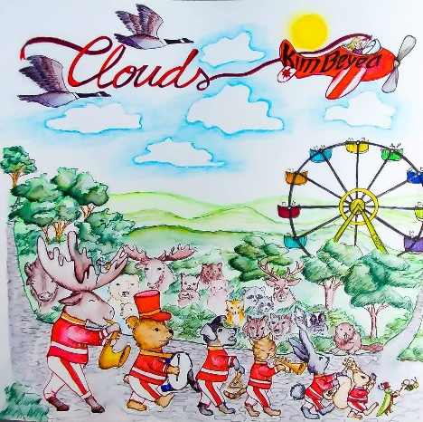
1 The Kim Beyea Band in Concert at Montessori: “Clouds”
Where: At the school, indoors or outdoors depending on weather
What: Join us for this awesome event! On the occasion of the release of her new children’s albumn, our music teacher Kimberly Beyea will be performing with her Jazz Trio at Montessori! “Clouds”, the latest album from the Kim Beyea Band, exposes children to a variety of musical styles, rhythms and instruments. With themes such as animals and nature, the world around us, and positive thinking, this collection of songs is full of catchy tunes and lyrics that will have your whole family singing along. It’s a toe-tapping, hand-clapping, get-up-and-dance good time! Cost is $5.00.
When: Monday, June 18 in the morning

- A special summer Art Workshop with Jenny-Lynn Manzo
Where: In the library or classroom
What: Our favourite art teacher Jenny is back for a final workshop for this year. Cost for the workshop is $12.00. Children will be divided into small groups and as always will get individual attention. The following is a description of the workshop presented to you by Jenny:
PLAISIRS D’ÉTÉ / SUMMER FUN
À la manière de- in the manner of: David Pirrie
David Pirrie’s interest in mountains dates back to his childhood, when he and his brother would scramble around their backyard of British Columbia’s coastal range on Vancouver’s North Shore.
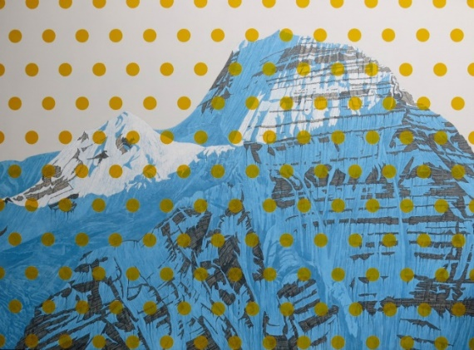
In removing the individual mountain from the surrounding range Pirrie decontextualizes his subject, making it symbolic rather than representational. He treats his mountains like celebrities, fashioning larger than life, unattainable, beautiful and mysterious portrayals.
L'intérêt de David Pirrie pour les montagnes remonte à son enfance, alors que lui et son frère se promenaient dans leur arrière-cour de la chaîne côtière de la Colombie-Britannique sur la côte nord de Vancouver.
En enlevant la montagne individuelle de son environnement, Pirrie décontextualise son sujet, le rendant symbolique plutôt que représentatif. Il traite ses montagnes comme des célébrités, façonnant des représentations plus grandes que nature, inatteignables, belles et mystérieuses.
C’est l’été, amusons-nous, en nous inspirant de la vision unique de cet artiste!
Nous réaliserons un projet coloré au look contemporain et différent à l’aide de plusieurs techniques comme le collage et la peinture. It's summertime let’s have fun, inspiring ourselves from the unique vision of this artist!
We will realize a colorful project, with a contemporary and different look using several techniques such as collage and painting.
When: Tuesday, June 19 in the morning

3 Outdoor “Summer” Yoga with Yogi Doug
Where: At the school, outdoors or in the library area in case of rain.
What: Yogi Doug is just an amazing Yoga teacher and an amazing person to learn from. The children respond enthusiastically to his teaching. The theme for this yoga class is summer so we will have the class outdoors if possible. Even if we need to be inside we will practice visualizing nature during summer and all our “nature” poses

If your child does not normally attend on Fridays he/she is welcome to participate in Yogi Doug’s class at the time shown below. Cost is $5.00.

When: Thursday, June 21
Classroom 3 9:15am
Classroom 4 9:45am
Classroom 2 10:15am
Classroom 1 10:45am

Yogi Doug teaches for charity, so funds raised with his classes at Montessori are always given as a charitable donation. For our June class the donation will go to Parkinson’s Canada for the occasion of Rudy’s Run which takes place August 18th in Pointe Claire at Voyageur park. You will be receiving more information about this family event from Artemis, as Rudy is Artemis’ husband who has had Parkinson’s for the past ten years and this summer they are organizing “Rudy’s Run” to help raise funds and to raise awareness of Parkinson’s in our community.
Artemis invites you to help by making an additional donation to Parkinson’s Canada now, or by signing yourself or your child up for the run/walk at the park in August.

Here is the link for our website for the run: http://donate.parkinson.ca/rudysrun
___________________________________________________________________________________________

I give permission for my child to participate in the following:
3 Kimberley and the Jazz Trio children’s concert Yes  No  Cost: $ 5.00
4 Jenny’s Summer Art project Yes  No  Cost: $ 12.00
7 Summer Yoga with Yogi Doug Yes  No  Cost: $ 5.00
CHILD’S NAME ________________________________________CLASSROOM NUMBER_______
PARENT’S SIGNATURE_______________________________TOTAL SUBMITTED $__________

I would like to add an additional donation to Parkinson’s Canada in support of Artemis and Rudy. Thank you so much from both of us!!!
$Amount ___________ (cash, or cheque made to Parkinsons Canada please)
Name and Address for receipt ($20 and over)________________________________________________
_________________________________________________________________________________

IMPORTANT: PLEASE GIVE THIS FORM AND THE FEE TO THE OFFICE BY Tuesday, June 12.

