Special Events for September 2018

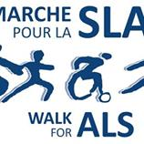Our Office Manager, Cindy Batten is fundraising for Walk for ALS 2018

*I am walking the Walk for ALS Society this year in memory of my husband Mark. Mark fought a very courageous 4-year battle with ALS. During those years the ALS Society helped us by donating equipment to make Mark's quality of life better, giving us money for respite care so I could have a break and helped in so many other ways to make our life easier. Without donations they would not be able to do the important work they do to help families dealing with ALS. Please help by donating for my walk so the ALS Society can continue to help many more families like mine living with ALS.*

**1 “Feel Good” Yoga with Yogi Doug**

**Where:** At the school in the child’s classroom or in the library

### What: Yogi Doug has been part of our Montessori program for many years now. Yogi Doug comes in during the year to teach some very special yoga classes for us. Yogi Doug teaches using the Kripalu Yoga technique which is a form of Hatha Yoga using inner focus, meditation, standard yoga poses, breath work, "development of a quiet mind", and relaxation. Yogi Doug’s specialty is making this connection for young children. The children are extremely enthusiastic about Yogi Doug’s classes. Every class that he teaches has a different focus and goes along with our weekly theme. September at Montessori is all about helping others and feeling good, and what better way to feel good than with a class of Yoga! Whenever Yogi Doug teaches all of the money that he raises (100% of it) is donated to charity. Each time he is here we pick a special charity that will benefit from his, and your, generosity. For our September class with Yogi Doug the donation will be to the ALS Society of Canada in support of our office manager Cindy, whose husband fought a very brave battle with ALS. If your child does not normally attend on Thursdays he/she is welcome to come to the class-you can join in too-no cost for parents. Cost per child is $5.00

**When:** Thursday, September 13 Classroom 1: 10:45 am Classroom 2: 10:15 am

Classroom 3: 9:15 am Classroom 4/5: 9:45 am

1. **[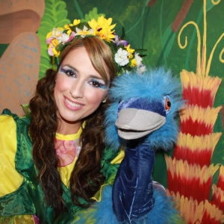](http://baluchonmagique.com/wp-content/uploads/IMG_7248.jpg)A Children’s Concert “I Feel the Music” with Pianist Michael Woytiuk**

**Where:** At the school, in the library area.

**What:** The theme this week is “Feeling Good” and Michael is here for his first concert of this year’s series to show us how we can “feel” the music and feel good at the same time! Michael’s piano concert series at Montessori is a lovely part of our program. The children certainly adore Michael’s approach where he tells them a story and get the children to act the story out as he plays wonderful music on the piano. Michael is a talented classical pianist and plays at concert halls for adults, but he loves his work with the children and the fact that this gives him the opportunity to educate the children about classical and other forms of music. This is a fantastic way for the children to listen to music, to understand the differences in various pieces, and to appreciate and enjoy music. If your child does not usually attend on Wednesdays he/she is welcome to at the time shown. Cost is $5.00.

**When:** Wednesday, September 19 Classroom 1: 10:45 am Classroom 2: 10:15 am

Classroom 3: 9:15 am Classroom 4/5: 9:45 am

**3 Théâtre musical et interactif pour enfants : Capucine au Pays des Rêves**

**Where:** In classroom 4

**What:** It’s Insect Week at Montessori and La Théâtre Baluchon Magique, children’s theatre group, presents: **Capucine au Pays des Rêves**. You can check out this theatre group on their site <http://baluchonmagique.com> . Here’s a synopsis of the show we will be seeing: Une aventure sur l’estime de soi et les differences. La fée des rêves envoie Capucine, la fée des Fleurs, en mission. Elle amène les enfants, par des procédés imaginaires, visiter des pays tout aussi loufoques. Ils rencontrent d’abord l’extravagante autruche Coucoulie, puis après quelques aventures, le trop gourmand dragon bleu Nuage, l’écervelé Froufrou, le dodo (oiseau rare) et finalement le sympathique monstre orange, Bonbon. Chacun donnera aux enfants son secret pour avoir une bonne estime de soi et faire de beaux rêves. Une belle aventure, drôle, légère et captivante, où l’intérêt est continuel. Décor: la forêt magique, invitante et mystérieuse

If your child does not usually attend on Fridays, he/she is welcome to come to the show at the time below (you can stay and watch too). Cost is $9.00.

**When:** Friday, September 21 3:00 pm

**When:** Friday, September 21 3:00PM

1. **An Excursion to Verger Labonté to go Apple Picking (Classrooms 1, 2, 5 and classroom 4-toilet trained-no accidents)**

**Where:** Verger Labonté. 2291 boul Perrot, Notre-Dame-de-L’ile-Perrot 514-453-5379

**What:** We’re off to Verger Labonté, a very popular place for children. About 20 minutes from Montessori by school bus, Verger Labonté is a lovely location to visit on an autumn day. We are hoping for nice weather, however, we will be going on the excursion even if there is rain, so please dress appropriately (adults too!). The bus will leave the school at 8:45 am (back by lunch). At the farm we will go on a hayride to the apple orchard and will pick our own little bag of apples. We will also have a snack of home baked (apple) muffins, and fresh squeezed apple cider (juice). We will see a puppet show animated with the friendly orchard pirate who will teach us all about how apples grow and what the parts of the apple are 😊 There is a petting zoo for the children and a fun corn maize as well as a playground they can explore. We need parent volunteers for this trip so if you can come please sign your name on the sheet posted by or on the classroom door. If your child does not usually attend on Tuesdays and you would like him/her to come to Verger Labonté please check with the office for availability. The cost for the trip is $28.00.

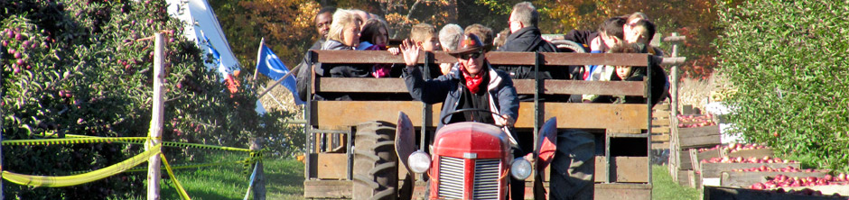**When:** Tuesday, September 25 Bus leaves at 8:30am, back for lunch

**________________________________________________________________________________________**

***I give permission for my child to participate in the following:***

**1 “Feel Good” Yoga with Yogi Doug** Yes  No Cost: $ 5.00 (donated to ALS)

**2 Concert with Pianist Michael Woytiuk**  Yes  No Cost: $ 5.00

**3** **Théâtre musical: Capucine au Pays des Rêves** Yes  No Cost: $ 9.00

**4** **An Excursion to Verger Labonté**  Yes  No Cost: $ 28.00

**CHILD’S NAME ________________________________________CLASSROOM NUMBER_______**

**PARENT’S SIGNATURE_______________________________TOTAL SUBMITTED $__________**

***IMPORTANT:* PLEASE GIVE THIS FORM AND THE FEE TO THE OFFICE BY Wednesday, September 12.**

I would like to add an additional donation to ALS Society in support of Cindy. *Thank you* **so much** from Cindy and everyone at Montessori who values the help Cindy gives us every day.

Amount of donation $___________ (cash, or cheque made to ALS Society please)

Receipts will be issued for $20 and over, but any amount makes us very happy!

Name for receipt___________________________________________________________________________

Address to mail receipt______________________________________________________________________