WIMGYM REGISTRATION for children 3 years and up
(Fully toilet trained-no “accidents”)
September 2018

PLEASE SUBMIT THIS FORM AS SOON AS POSSIBLE TO ENSURE A PLACE FOR YOUR CHILD. REGISTRATION IS ON A FIRST-COME FIRST-SERVE BASIS.
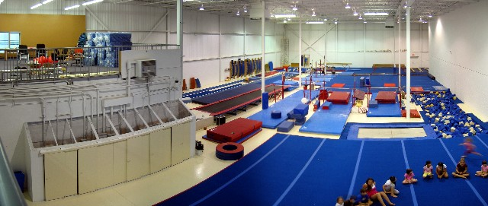
Wimgym will take place on Friday mornings starting September 21, 2018 (last class Nov 23). The Wimgym program is very popular as it is a fun physical activity that helps the child to develop his/her concentration, gross motor coordination and strength. The program is called “Kindergym” and is for children 3 to 5 years old. Children from classrooms 1, 2, 5 and 4 (toilet trained-no accidents) are welcome to register for these classes. The classes start with a 10-minute aerobic warm up (movement and stretching to music). Children are then divided into groups (by age) of 4 to 6 per instructor and take turns using the various gymnastics equipment (beam, parallel bars, trampoline, foam pit, etc.) All equipment is very safe and the supervision and instruction is excellent. The instructors are trained gymnastics coaches.

Each class is 45 minutes long, and the program is ten weeks in total, on Friday mornings. Transportation to and from the gym is by school bus. Wimgym is located at 2100 Trans Canada on the South Service road just east of Sources Blvd (in the same plaza as Ottimo Furniture).

For our last class on November 23rd parents are invited to the Gym to see us “tumbling”!

Cost is $195.00 for the 10-week session, and includes the Wimgym fee, cost of additional supervision, and cost of transportation by school bus. Registration is limited so please register early.
_______________________________________________________________________________________
I WOULD LIKE TO REGISTER MY CHILD FOR THE AUTUMN 2018 WIMGYM PROGRAM:

I ENCLOSE: $ 195.00 Cash
or Cheque (Made out to The Montessori School of Pointe Claire)

CHILD’S NAME________________________________________________ DATE OF BIRTH______________
CLASSROOM NUMBER____________
PARENT’S SIGNATURE_________________________________________________DATE________________

