Ballet with Nina
We are continuing our ballet program this fall with Nina Menon. Nina teaches ballet at Sheila Parkins Dance Academy as well as at several child care centres in Montreal. Nina enjoys her little ballerinas at Montessori and is always happy to be starting a new session here.

Nina is a ballerina herself with many years of experience in dance. Nina joined the Royal Winnipeg Ballet after graduating from The Royal Conservatory of The Hague and The Royal Winnipeg Ballet Professional Division. As a member of the corps de ballet she danced numerous soloist roles. Nina has also choreographed several professional ballets and has coached for The Professional Division students and taught dance at The Royal Winnipeg Ballet’s General Division.

Ballet classes with Nina at Montessori will start on October 15th. Classes take place on Monday afternoons for a total of 8 classes. Parents are invited to the class on December 10th to see their ballerinas “perform”. The dates of the classes are:
October 15, 29
November 5, 12, 19, 26
December 3, 10(parents invited to the last class)

If you wish to register your child for ballet please fill in and return the form below. Cost for the 8 classes is $80.00.

I wish to register my child (child’s name) _______________________________________
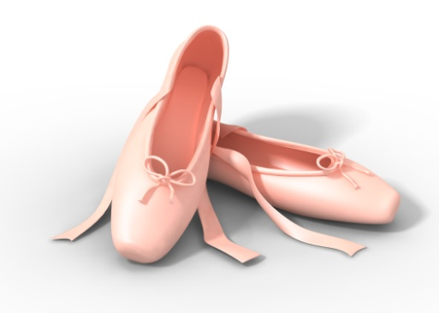
in classroom number ____________ for Ballet classes with Nina (Mondays, October-December 2018).

I enclose $80.00 ________cash ________cheque
Parent’s signature _______________________________________________________

