Special Events for October 2016

- Excursion to Stewart Hall Cultural Centre “The Globetrotting Ball” and “Xylon Outside the Norms”
(Classrooms 1 and 2 only)
Where: 176 du Bord-du-lac Pointe-Claire 514-630-1220
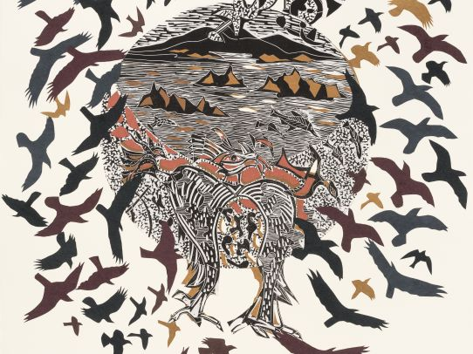
What: This is a “two part” excursion. Part one is an activity presented and animated by Jeunesses Musicales Canada, which is absolutely amazing! Are your suitcases packed? Travel the world and discover local musical styles and dances from South America to Africa. In this dance workshop, children explore cultural diversity through cumbia, African dance and some traditional chants. Part two, is a guided tour for pre-schoolers of the “Xylon Outside the Norms” art exhibition at Stewart Hall Art Gallery. This is a tour developed by qualified guides, and intended to demystify art and encourage dialogue. These tours educate about exhibition themes, artists and the various techniques explored, placing the artworks in their larger context. In addition, the visit is followed by a creative workshop that is adapted to the age group. Xylon Outside the Norms is an exhibition which brings new media into the art of relief printing. It’s actually quite fascinating and wonderful for adults too. For more information you can consult the art gallery web site http://museesmontreal.org/en/museums/stewart-hall-art-gallery. If your child does not usually attend on Wednesdays, please check with the school office if you wish him/her to attend this trip. Cost per child is $15.00.
When: Wednesday, October 12. Bus leaves at 1:45PM and we will return by 5:00PM

2 Sportball have fun with soccer! We will practice our “spatial awareness” since this is Space week
Where: In the child’s classroom
What: Sportball is a half hour of fun and learning with a physical education animator (“coach Matt”). The program is specifically designed to teach the children the skills of various sports; we will have one Sportball workshop per month until the end of the school year. Even if your child participated last year we guarantee you that now that he/she is a year older he/she will appreciate the activity in a different way, and will be more than excited to see his/her “Sportball coach” again. The philosophy of Sportball is to help children develop their confidence with different sports, free from the pressure of competition. The coach reinforces the benefits of teamwork rather than the importance of winning, allowing children to develop socially and physically. The Sportball workshop for October is an all-time favourite sport, soccer! Even our youngest children LOVE the Sportball activity. If your child does not usually attend on Mondays, he/she is welcome to come to the Sportball Workshop at the time shown below. The cost is $8.00. The web site for Sportball is www.sportball.ca
When: Monday, October 17 Classroom 1: 1:00pm or 1:30pm Classroom 3: 3:00pm
Classroom 2: 2:00pm or 2:30pm Classroom 4: 3:30pm

3 An Art Workshop with Jenny-Lynn Manzo “Space week/Semaine sur l’espace” (Classrooms 1, 2 and 4 only)
Where: In the school library
What: For our first encounter of the school year the children will create a space related art work using printing techniques and a fun surprise element! The project will lead them to develop their sense of observation and their sense of spatial organization.

Pour notre première rencontre de l’année scolaire les enfants réaliserons une œuvre sur le thème de l’espace en pratiquant une technique d’impression à l’aide d’un élément surprise! Le projet les amènera à développer leurs sens de l’observation ainsi que leur sens de l’organisation spatiale.
Jenny-Lynn Professeur d’art/ Art teacher
The cost of this great activity is $11.00
When: Tuesday, October 18th in the morning
- Classrooms 1 and 2: An Excursion to Acrosport Barani Trampoline Club
Where: 1365, boul. Dagenais Ouest, Laval 450-622-0077
What: We have been to Acrosport Barani many times and it is a blast! This is a gymnastics club that gives classes specifically for trampoline and trapeze, and they also cater to schools, preschools and parties. Their web site is www.acrosportbarani.com. The children will rotate through different activities including the big trampoline, the trapeze, the Tarzan ropes, and the smaller double trampolines, the foam pits, the ball pits, the tight rope and hoops. Everyone will enjoy this excursion. The supervision is excellent, the monitors at the Club are very funny and good, the equipment is very safe and very clean. If your child does not usually attend on Mondays and you would like him/her to attend, please check with the office as to whether we can accommodate more children. Cost is $20.00. Please note we will not need parent volunteers for this excursion as the gym only permits the teachers to come in and supervise. The children get on the bus at the school and get off the bus right at the door of the gym. The ratio of children to adults at the club with teachers and monitors will be about 3:1. **PLEASE MAKE SURE YOUR CHILD HAS SOCKS ON FOR THIS EXCURSION

AS ACTIVITIES TAKE PLACE IN SOCK FEET. Also, the children are not permitted jewelry or watches on (other than medical alert bracelets) and no belts. The best clothing is sweat pants and a t-shirt. Long hair needs to be attached back with an elastic (no hair clips).
When: Tuesday, October 25. Please arrive by 8:45am, the bus leaves at 9:00am.
We expect to return to the school by 12 noon, in time for lunch

5 Théâtre musical et interactif pour enfants présenté par La Petite Valise Théâtre
Where: In classroom 4
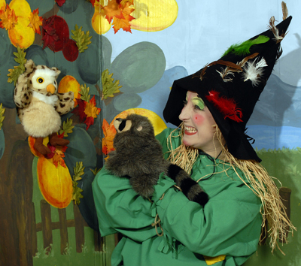
What: La Petite Valise Théâtre is here with a fun Halloween show called “Les malheurs de Grichette”. We’ll see an actress with four puppets who will tell us the story of friendly “Chapidoux” who needs our assistance to help out Grichette the nice witch. “À l’aide! Grichette la sorcière s’affole… De mauvais poil, l’épouvantail Chapidoux se réveille: “Allons aider cette sorcière afin de pouvoir dormir en paix! » Mais les malheurs de Grichette ne s’arrêtent pas là. En plus de son chat, elle s’est aussi fait voler son grand livre de recettes de bonbons. Cela risque de décevoir plusieurs enfants pour la fête de l’Halloween…
We’ll learn two rhythmic songs and get up and dance and develop our imagination! If your child does not usually attend on Tuesdays, he/she is welcome to come to the show at the time below (you can stay and watch too). Cost is $8.00.
When: Thursday, October 27 10:00 am

I give permission for my child to participate in the following:
- Excursion to Stewart Hall “The Globetrotting Ball” and “Xylon Outside the Norms”
(Classrooms 1 and 2 only) Yes  No  Cost: $ 15.00
2 Sportball have fun with soccer! Yes  No  Cost: $ 8.00
3 An Art Workshop with Jenny-Lynn Manzo “Classrooms 1, 2 and 4 only) Yes  No  Cost: $ 11.00
4 Classrooms 1 and 2: An Excursion to Acrosport Barani Trampoline Club Yes  No  Cost: $ 20.00
5 Théâtre musical et interactif pour enfants présenté par La Petite Valise Théâtre Yes  No  Cost: $ 8.00

CHILD’S NAME ______________________________________________CLASSROOM NUMBER___________________
PARENT’S SIGNATURE________________________________________TOTAL SUBMITTED $___________________
IMPORTANT: PLEASE GIVE THIS FORM AND THE FEE TO THE TEACHER BY FRIDAY, OCTOBER 7.
WE ASK THAT YOU RETURN THE PERMISSION FORM EVEN IF YOUR CHILD IS NOT ATTENDING THE EVENTS (INDICATING “NO”) Thank you.

