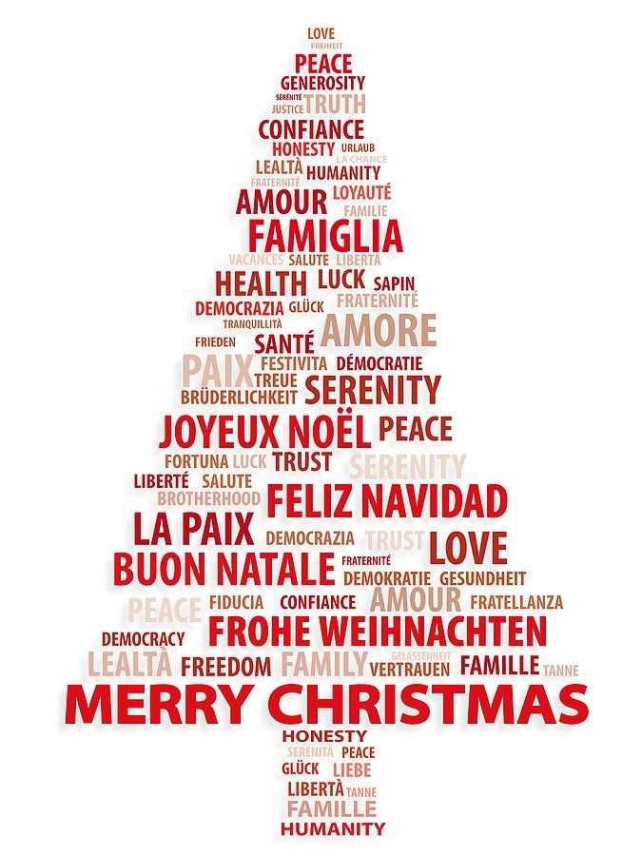
DECEMBER 2018 NEWSLETTER

CHRISTMAS PARTY

We ask you to join us for your child’s Christmas party on the following afternoons: (Children who do not usually attend on these days are requested to join us in the afternoon with their parents/grandparents)
Classroom 1, Thursday, December 13 at 1:45 p.m.
Classroom 2, Wednesday, December 12 at 2:15 p.m.
Classroom 3, Thursday, December 19 at 3:00 p.m.
Classroom 4, Tuesday, December 11 at 2:45 p.m.
Classroom 5, Tuesday, December 11 at 2:45 p.m.

For this occasion you are asked to kindly bring a plate of party snacks (cheese cubes, vegetable sticks, sandwiches, squares, cookies, etc.) for the children and adults at the party. There is a sign-up sheet on the classroom door. PLEASE remember that we cannot allow any food containing nuts or traces of nuts, in the school.

Santa Claus or Mrs Santa (and the Elves!) will be there party day to hand out Christmas gifts. Please remember to bring in your child’s Christmas gift (bring it to his/her classroom) at least one week before the Christmas party – so that the teachers have everything ready for Santa and the Elves.

You are welcome to bring your cameras/video cameras to the party. However—your child may decide to sit on your lap and watch the show instead of participating in it. Please remind yourself, if this happens that you can come back and video your child any time during his music or any other class. (Then relax and have some fun – your child is just thrilled to have you there with him/her.)

PLEASE HELP - REMINDER ABOUT OUR CHRISTMAS GIVING PROJECT

We have selected to help Montreal’s “Share the Warmth” community services and food bank, as well as, The Mision Catolica Latino Americana de Montreal which supports new immigrants and refugees arriving in Canada; many with absolutely no possessions. These two organizations do great work all year round, but they are in dire need of assistance over the holiday period. So please do not hesitate to bring in non-perishable food items, or clothing (any ages for children or adult) and of course any new or used toys. Thank you in advance for your all help!

INTERNATIONAL WEEKS IN JANUARY

We will celebrating International Weeks at Montessori during the weeks of January 7 to January 18. This is the time where we invite you to come in to your child’s class and do a presentation on your “home” country. This event has become a staple at Montessori over the years and one of the reasons why, is because it is a “win-win” for everyone! The children learn about another country, your child LOVES having you in class with him/her and you come away from this experience feeling, well, abosutely great! If you can be available during the day (usually around 10am or 3pm) please let the teacher know. We need your participation to make these weeks work. If you need more information you can speak with your child’s teachers, or with any of us in the office and we will give you all the support you need.

PARENT MEETING

Our second parent meeting was held on November 7, 2018. The following topics were discussed:

- The holiday season and Christmas parties at Montessori are celebrated in honour of all religions and ethnic backgrounds. It is very important to us that the children should be aware of different cultures (which is also the purpose of our international weeks) with the idea being that if the children enjoy learning about these “different” things that people do, then the “differences” will be something that one accepts and enjoys later in life.
- Herla (our Pre-K teacher), covered the topic on the importance of our children making friends and how those relationships change as they continue to grow.
- Tanya ,Classroom 3 Teacher was asked to outline a typical day in Classroom 3 from drop-off to pick up. It was very interesting for the parents to hear how their child spends their day in Classroom 3. Boy those babies are busy!
- Classroom 4 teacher, Samantha, explained the impact of a grand-parent has on a young child. Samantha told the group the story of her own personal experience with her won grand-parents.
- Our Pre-k Spanish Teacher. Gabriella, illustrated to the parents, with many photos, the impression that art makes to a young mind. Exposing children to different mediums, colors, lines and shapes is fundamental to the development of a young mind.
- Artemis, our Director, spoke to the parents about that little word, with so much power, NO! Artemis invited the parents present to share some of their own stories and having raised four children of her own, she equally had her experiences as well! Ultimately, how to curb that little word from becoming a “regular” word in your daily interactions with your child, is to establish respect, for both sides. The secret is to find out WHY, they love that little word so much!
Our next parent meeting will be held on Wednesday, December 5, 2018 We welcome you to attend the meeting. Wine and cheese is served and it is a pleasant and informative evening. Meetings adjourn at 9:00pm.

Agenda for Wednesday, December 5:

- Upcoming events
- Artemis (Daycare Director): Parenting tips on what to do when your child says “no”
- How to make the holidays more fun for children and adults!
- Herla (professeur de la prématernelle): Comment l’enfant se développe globalement
- Samantha (Classroom 4 and 5 teacher): Reducing stress and anxiety in children. Strategies that work.
- Tanya (Classroom 3 teacher): Question and answer period for classroom 3
- Open Discussion

SNOW CLOSING

It is extremely unlikely that the School will close for a snowstorm; however, in the event that we have to close it will be announced on the web site only (no announcements on the radio)

There are many Montessori Schools in the Montreal area, so if the radio announcer says that “ALL the Montessori schools are closed”, don’t believe him! Call us, we will only close if we have no electricity!

If there is a storm during the day while you are at work, please leave work early or make arrangements for someone closer to pick up your child. It is frightening for a child to be left at the school until 7 or 8 p.m. (This has happened and is very upsetting for everyone concerned.)
Please note: We will do our best to stay open, but as is stated in the regulations, there can be no refunds for closure due to the weather, and no switching days if YOU decide to take a snow day .

SOME WINTER REMINDERS

- Please remember to remove your boots or wet shoes on the entryway carpet or put on the “blue booties” to cover your boots (once you have used the booties please discard them into the waste basket). Do not get the tile floor wet as it becomes very slippery and dangerous.
- Remove or shorten all strings on your child’s jackets to avoid entanglement in playground equipment
- Long scarves are not permitted on the playground. The child should have a neck warmer.
- For classrooms 3 and 4 children should have mittens attached to their jackets (classroom 3 they need to be on a
- string through the jacket). For the other classrooms children should have winter clothing that they can put on themselves (we will help with zippers where necessary).
- Label your children’s winter clothing visibly to avoid mix-ups.
- When you leave at the end of the day check that your child has his own boots on (not someone else’s)
- Check your child’s “extra change of clothes” to make sure that the clothing fits and is suitable for the winter season.

HOLIDAYS
Montessori Pointe Claire holiday calendar:

Monday, December 24 to Friday, December 28, 2018....................... closed
Monday, December 31, 2018 to Tuesday, January 1, 2019................ closed
Wednesday, January 2, 2019.............................................................. open

From all of us at Montessori
We wish everyone a joyous holiday and
a very
Happy New Year!

