Week of:  Semaine de: | Monday  lundi | Tuesday  mardi | Wednesday  mercredi | Thursday  jeudi | Friday  vendredi
December  3 to 7 | Vegetable soup  Scrambled eggs with salsa and cheese  Steamed broccoli  Fresh fruit | Vegetable and barley soup  Cod fish cakes  Couscous  Fresh fruit | Minestrone soup  Pasta with tomato sauce  Dinner rolls  Fresh fruit | Sweet potato soup  Chicken with rice  Hummus with pita bread  Fresh fruit | Vegetable soup  Spaghetti with meatballs  Fresh fruit
December  10 to 14 | Tomato and rice soup  Meatloaf with brown sugar sauce  Roasted potatoes  Fresh fruit | Celery soup  Chicken salad and cheese sandwiches  Mixed vegetables  Fresh fruit | Broccoli soup Homemade macaroni and cheese  Corn  Fresh fruit | Pea soup  Crispy crumbly fish  Couscous  Broccoli  Fresh fruit | Vegetable soup  Broccoli and cheese omelet  Carrots  Fresh fruit
December  17 to 21 | Spinach soup Pasta primavera  Fresh bread with butter  Fresh fruit | CHRISTMAS DINNER  Turkey loaf , mashed potato, stuffing, gravy, cranberry sauce  Corn  Holiday dessert | Tomato and zucchini soup  Bagels and cream cheese  Peas  Fresh fruit | Carrot soup  Pancakes with apple sauce  Turkey sausage  Fresh fruit | Vegetable soup  Grilled cheese sandwiches  Peas  Fresh fruit
 |  |  | 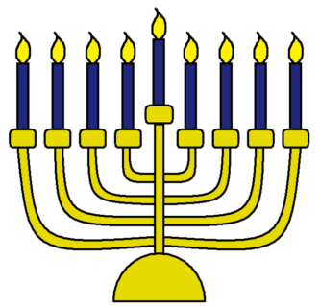 | 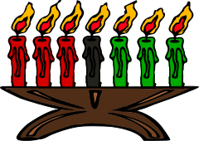
Milk and water are served at lunch and during morning and afternoon snack.
Menu : December 2018 décembre

