Montessori Pointe Claire Summer Camp Programs: The best for everyone!

For all our children Montessori Pointe Claire summer camp is really the best place to be to have fun with your friends! Here’s what the summer program looks like:

Days will be well balanced with many activities and with the emphasis on outdoor fun. Our summer program is amazing with a fun “summertime twist” for everyone!

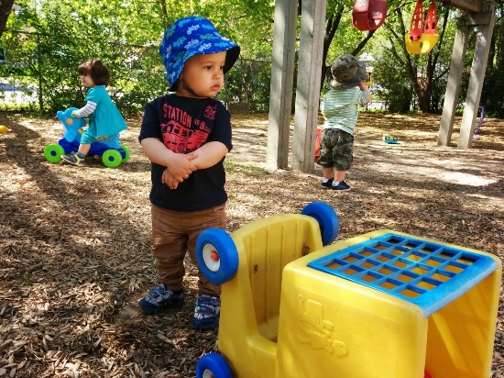
- 1½ to 2½ years: Summertime Toddler-Motor-Skill Development Program with lots of outdoor play (always carefully planned out to balance outdoor play with indoor air-conditioned cooling off!).

Our 1 ½ to 2 ½ years-old group requires very careful care in the summer. Activities take place indoors and out with the children’s teachers being vigilant in keeping everyone well hydrated and protected from too much sun. Our toddler playground is large and well shaded with trees and the ground surface is grass and special playground wood chips so that the environment is both pleasant and safe. There are no artificial surfaces that can overheat. This play area is for the use of our toddlers only, no older children use this space.

The summer program is designed by our specialists to guide the children in developing their gross motor skills, something that they are doing innately at this time in their lives, but need the proper environment to flourish. Teachers create fun, organized “games”, for example this could be walking on a beam (directly on the ground), chasing bubbles (amazing exercise for balance), finding balls and putting them in buckets, and many other activities that change every day. Children are also allowed to “free play” as much as they want outdoors. The goal is to give the child multiple ways in which to exercise his/her gross motor skills but with the child being the guide as to his/her own limits so that the development comes naturally. The child needs to feel comfortable with how fast he can run or how high he can climb, and ultimately this leads to the best individual development in physical skills.

For children who have been with us during the year, the summer program allows them to expand on what they have learnt, to socialize in different ways with the other children (sharing the playground toys, discovering how to play together). For children who are new to Montessori Pointe Claire, starting in the summer is wonderful as the outdoor time is extremely relaxing (as humans we are always more at ease in a natural outdoor environment), and the adjustment period to a new daycare experience becomes shorter and easier for the child.

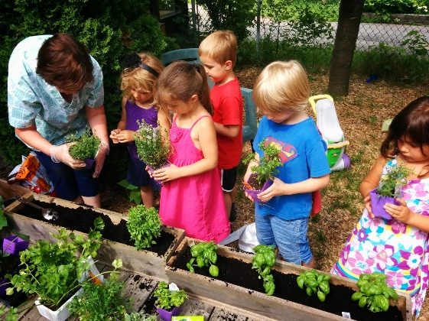
- 2½ to 3½ years: Pre-School Nature Experience Program: Experience the joys of being outdoors with a great program to teach about nature: gardening (planting, weeding, harvesting), recycling, insects, trees, etc.

The majority of the time spent outdoors will be free play, running and jumping and swinging and climbing and sliding, building sand castles, and just having a great time with our friends. We do however have some special activities planned for our pre-school group.

Children of all ages love to be outdoors and to just have the opportunity to interact with the natural environment. Our experience is that the 2 ½ to 3 ½ year olds are at an age where they are taking a special interest in what is around them, being at the age where they are starting to discover the large world around them and they are ready to explore, to find the “bugs” and “leaves” and “flowers” and to learn about the environment. We have created a special summer program just for this Montessori group, where the children are encouraged to free play and at the same time to become involved in their surroundings. We want the children to dig in the sand and the dirt and feel like they are part of nature. At the same time it is the perfect hour to impart some knowledge of the environment to them as their curiosity is at a peak. Our program is “little-kid environmental awareness” and includes understanding that we need to help our environment by recycling, planting, and basically caring for our “outdoor home”. Children will have short, fun lessons on things like planting grass, planting bulbs, making a vegetable garden, understanding how compost works. We know that the children are fascinated by these concepts and that when they learn to love the environment at this young age, this love will continue with them throughout their lives.

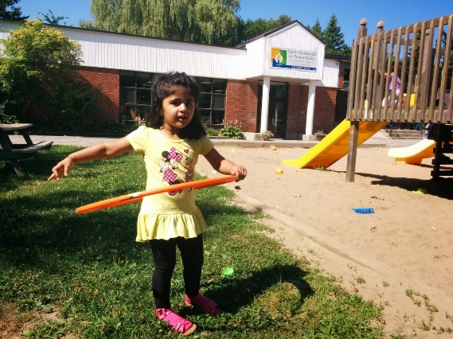
- 3½ to 4½ years: Sports-and-More Program. Start participating in sports! We are old enough to start learning some fun (non-competitive) outdoor games with our Physical Education specialists. We’ll have a variety of team games and introduction to sports activities every day.

By about 3 ½ years of age the child’s gross motor development as well as level of understanding of directions is at a level where the child can really start to enjoy organized games where he/she will act in a cooperative manner with friends. Children at this age start to develop their own outdoor games where they play all sorts of “make believe” activities with their friends. This play is encouraged and also well monitored by the teachers. At the same time the children love having their summer camp monitors guide them in some more organized games.

This age group is perfect to start introducing non-competitive sport activities. The children love using the sports equipment (balls, baseball bats, golf clubs, hockey sticks, etc.). It is really a fun challenge for them. The important part is that they need the help of adults to make these activities enjoyable as the children are just learning about cooperative play. This is the focus of the summer outdoor program for this age group. The children are given plenty of opportunity for free play, but there are also some organized games so that they can get involved in a different way with their friends, and at the same time start to develop the skills they will need later on should they decide to become involved in sports.

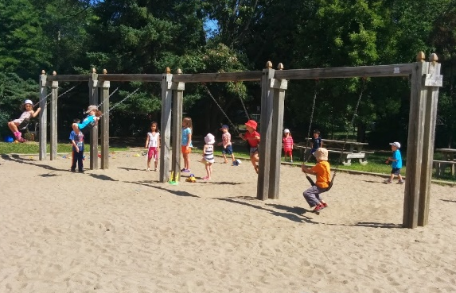
- 4½ to 5½ years: Treasure-the-Summer-with-Our-Friends Program. Spend the day outdoors with all your friends and discover the fun of treasure hunts, crazy team games, picnics, gym games, sports activities, and park play at many of our local parks.

Our prekindergarten group is off to school next year and they are so happy to be together over the summer with their friends and share this time making life-lasting bonds. Our camp counsellors have a special summer program for this age group that encourages these friendships and is entirely different from the regular school year activities. The focus is on outdoor play. New games such as treasure hunts, as well as “crazy, fun” activities (try body painting, being your favourite animal for the day, and much more), make the summer so much fun!

The pre-K group is old enough for excursions to the local parks (within walking distance), and as much as possible activities will be held outdoors. There are so many different activities for this age group that it is difficult to list them all!

- 6 to 8 year-olds: Love-The-Sun Senior-Camper Program. Make new friends, come back and meet up with old friends, and have the best summer ever with our fun, experienced camp monitors! Activities are enjoyable, safe, and totally perfect for our 6 to 8 year olds.
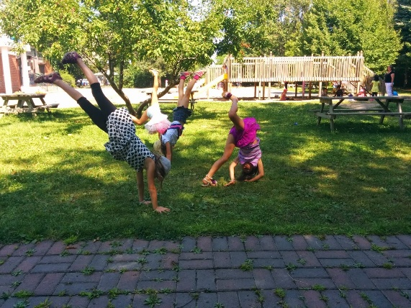
At Montessori Pointe Claire we take a maximum of 30 “Senior” campers who have their own space, their own program, and their own counsellors (ratio is 1:10). This program was initially developed as a fun and safe alternative to the “big” camps and it has become so popular that we fill up quickly and our campers keep returning! The activities are created by our counsellors to keep this group active. We promise that no one ever gets bored! Activities almost always take place outdoors. Our facilities provide more than ample green space to play games, have picnics and in general stay outdoors as much as we are comfortable doing. We have access to soccer fields, a baseball diamond, tennis courts, playgrounds for “bigger” kids, and a great outdoor splash/pool area at Viking Park across the street. We are always within a short walking distance from our building so it’s easy to go in and out as we please.

Our counsellors are mature and fantastic and are picked to work specifically with this age group. The counsellors are in charge of creating a summer program that will appeal to everyone in their group. Our counsellors are very capable of helping with special considerations for individual campers where necessary.

If you are not familiar with Montessori Pointe Claire, before registering, parents are invited to come for a tour of the facilities. Camp photos are accessible, and worth a look, both at the Montessori Pointe Claire Daycare Facebook site, and also the Montessori Pointe Claire Summer Camp Facebook site (new for this summer).

