Special Events for January 2019
- A Children’s Concert “Exploring the World of Music” with pianist Michael Woytiuk

Where: At the school, in the library
What: It’s International week at Montessori! In keeping with the theme of the week, our resident pianist, Michael is here to tell us a pirate story with a twist! It’s all about the young son of a Captain Pirate who is more interested in learning the music of the countries rather than prating! In the end, the pirate ship turns into a “good ship” and tours the world as a musical act! Cost: $6.00
When: Monday, January 14
Classroom 1:10:45 a.m. Classroom 2: 10:15 a.m.
Classroom 3: 9:15 a.m. Classroom 4&5: 9:45 a.m.

- Wooden Craft Workshop with Florent Antona

Where: At the school, in the child’s classroom.
What: This wooden craft is another great workshop taught by Florent Antona, a professional woodworker and artist. “Winter Animals” is our theme this week and Florent will show the children how to make a wooden Polar Bear! The children will pain their creation in their very own unique style. This activity is the perfect blend of woodworking and art! Cost: $13.00
When: Tuesday, January 22 in the morning

- An excursion to Zig Zag Zoo (Classroom 1,2 and 5)

Where: 980 St. Charles Ave., Vaudreuil-Dorion, J7V 8P5 Tel:450-424-3244
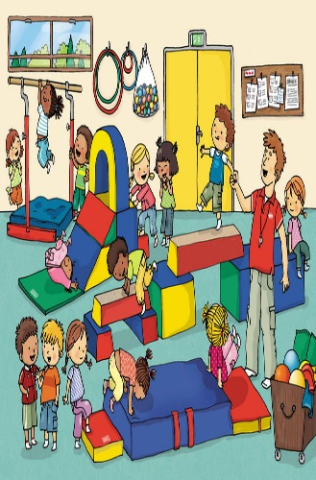
What: We have all been inside far too long this winter, so we have planned a fun morning for the children at Zig Zag Zoo! We will start the morning with a short bus ride to our destination where we will be met one of their animators. Zig Zag Zoo is an immense indoor space where the kids can slide and explore in a clean and safe environment. Activities include the giant tube structure, a climbing wall and even a mini soccer arena. The children will have a wonderful morning exploring and having fun in the center with their friends. Zooky the Zig Zag Zoo mascot will be there too! Cost: $19.00

When: Wednesday, January 31. The bus leaves at 9.00 am. We will back at at school in time for lunch.

________________________________________________
I give permission for my child to participate in the following:

- Concert” Exploring the World of Music” with Michael Woytiuk Yes  No  Cost: $ 6.00
- Wooden Craft Workshop with Florent Antona Yes  No  Cost $13.00
- An excursion to Zig Zag Zoo (Classrooms 1,2 and 5) Yes  No  Cost: $19.00

CHILD’S NAME ___________________________________CLASSROOM NUMBER___________

PARENT’S SIGNATURE__________________________________________

TOTAL SUBMITTED $________________ Please submit this form and payment to the office by Friday, Jan 12.

Note: If your child does not usually attend on the days of the activities, they are welcome to come for the time of the activity. Please see us in the office and we can make the arrangements!

