Special Events for February 2019
1 “Count and Colour Magic Show” with Blair Marshall
Where: In Classroom 2
What: Blair Marshall is a great magician for children and he has a fun show that is perfect for younger children and also perfect for our “colour & shapes week” theme! Blair has been to Montessori on numerous occasions and the children always love his shows. If your child does not usually attend on Tuesdays, he/she is welcome to come to the show at the time below (you can stay and watch too). Cost per child is $6.00.
When: Tuesday, February 5 Show starts at 3:15 p.m.

- Excursion to Stewart Hall Cultural Centre “Owl at Home” – Puppet show presented by
Rag and Bone Puppet Theatre (Classrooms 1,2,4, and 5)
Where: 176 du Bord-du-lac Pointe-Claire
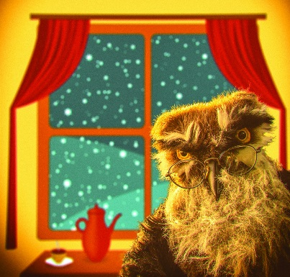
514-630-1220
What: Whether he's inviting Winter to sit by the fire or finding strange bumps in his bedroom, Owl is a hoot! Rag and Bone's puppets, accompanied by live music, make these delightful stories about soft-hearted Owl irresistible. Watch as Owl tries to be in two places at once, or thinks of sad things in order to make a perfect cup of tea. If your child does not usually attend on Thursdays, he/she is welcome to attend this trip. Cost per child is $15.00.
When: Thursday, February 7 The bus leaves at 8:30 a.m.

- Jenny-Lynn Manzo, Art teacher, a “Valentine Art Workshop”
Where: In the school library or in the classroom
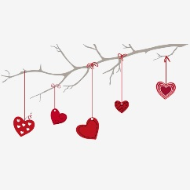
What: Our favourite Art teacher Jenny-Lynn Manzo is here with a wonderful children’s art project that we will all enjoy doing while we learn about different art techniques. In Jenny’s own words:

St-Valentin / Valentine’s Day

Comme toujours nous nous amuserons en explorant le monde magique de l'art!
Je serai brève, me gardant un élément de surprise bien sûr… puisque la création de votre
enfant deviendra votre cadeau. En fait, toutes les créations artistiques d'un enfant
sont de merveilleux cadeaux.

As always we will have fun exploring the magical world of art!
I will be brief, keeping an element of surprise of course… since you child's creation will
become your gift. In fact, every child's art creations are always beautiful gifts.

Jenny-Lynn / professeur d’art – art teacher

If your child does not usually attend on Thursdays, you are welcome to bring him/her for the workshop at the time shown below. Cost per child is $12.00.
When: Thursday, February 14. Classroom 1: 11:00 a.m. Classroom 2: 10:30 a.m.
Classroom 3: 9:30 a.m. Classroom 4: 10:00 a.m.
Classroom 5: 10:00 a.m.

4 It’s the Winter Olympics with Sportball!
Where: In the school library or in the classroom
What: Sportball is a half hour of fun and learning with a physical education animator (“Coach”). The Coaches at Sportball are passionate about what they do, and they work with the kids and develop their confidence in the different sports they present each time they are here. The Coach reinforces the benefits of teamwork rather than the importance of winning, allowing children to develop socially and physically. The Sportball workshop for February is based on this week’s theme of Winter Olympics. Our Sportball Coach will be here to guide the children through a series of it Even our youngest children LOVE the Sportball activity. If your child does not usually attend on Tuesdays, he/she is welcome to come to the Sportball Workshop at the time shown below. Cost per child is $9.00. The web site for Sportball is www.sportball.ca
When: Tuesday, February 19 Classroom 1: 11:30 a.m. & 12:00 p.m.
Classroom 2: 10:30 a.m. & 11:00 a.m.
Classroom 3: 9:30 a.m. Classroom 4: 10:00 a.m.
Classroom 5: 11:30 a.m.

5 En Mode Fitness – Zumba for Children
Where: In the school library or in the classroom
What: Zumba is an exercise fitness program created by Colombian dancer and choreographer Alberto "Beto" Perez during the 1990s. Zumba involves dance and aerobic movements performed to energetic music, and this week we have invited Miss Barbara to “Zumba” things up with the children during Healthy, Fit and Fun week. It is a well=know fact that fitness is an essential part of children’s health and what a perfect way to do this than with Zumba. Cost per child is $9.00.
When: Monday, February 25 Classroom 1: 2:00 p.m. Classroom 3: 3:30 p.m.
Classroom 2: 2:30 p.m. Classroom 4: 3:00 p.m.
Classroom 5: 2:00 p.m.

6 The Dentist visits our Class
Where: At the school, in the child’s classroom.
What: Dr. Gita Mehrabani is a dentist who we know well as her daughters attended Montessori and many of our students are her patients. Dr. Mehrabani visits our school once often to speak to the children about keeping their teeth healthy, and about being a dentist. Dr. Mehrabani comes with her funny dog puppet (which has huge teeth) and she is great at helping the children understand what their teeth do and how to care for them. The children love to ask questions about all the things that Dr. Mehrabani shows them. Dr. Mehrabani’s visit always ends with a great story time where she reads them a book about going to the dentist. If your child does not usually attend on Wednesdays, you may bring him/her for this event.
When: Wednesday, February 27 Classroom 1: 10:45 am Classroom 2: 10:15 am
Classroom 3: 9:30 am Classroom 4 &5: 9:45 am
______________________________________________________________________________
I give permission for my child to participate in the following:
1. ”Count and Colour” Magic Show with Blair Marshall Yes  No  Cost: $ 6.00
2. Excursion to Stewart Hall Cultural Centre “Owl at Home” – Puppet Show Yes  No  Cost: $ 15.00
3. Jenny –Lynn Manzo, art teacher – “Valentine Art Workshop” Yes  No  Cost: $ 12.00
4. Winter Olympics with Sportball! Yes  No  Cost: $ 9.00
5. EnMode Fitness - Zumba for Children Yes  No  Cost: $ 9.00
6. The Dentist Visits our Class Yes  No  Cost: $ free

CHILD’S NAME ___________________________________CLASSROOM NUMBER___________________
PARENT’S SIGNATURE_____________________________TOTAL SUBMITTED $___________________
IMPORTANT: PLEASE GIVE THIS FORM AND THE FEE TO THE OFFICE BY MONDAY, FEBRUARY 4.
WE ASK THAT YOU RETURN THE PERMISSION FORM EVEN IF YOUR CHILD IS
NOT ATTENDING THE EVENTS (INDICATING “NO”)

