March 2019

Special Events

1 Excursion to Stewart Hall Cultural Centre: Le Grenier de Molinari (Classrooms 1,2 4 and 5)
Where: 176 du Bord-du-lac Pointe-Claire 514-630-1220
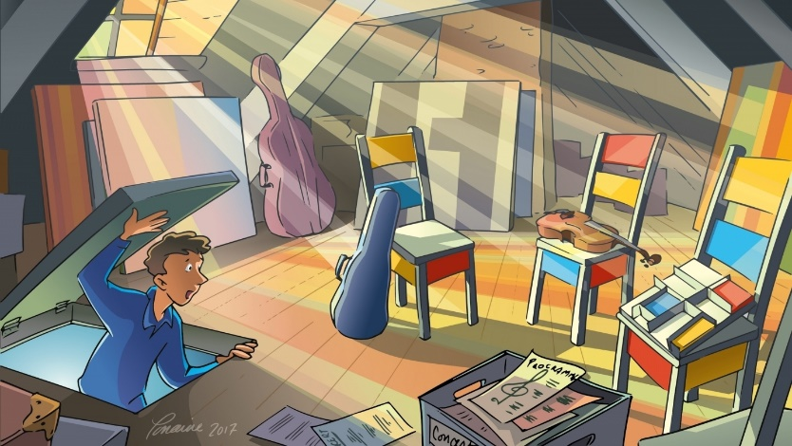
What: Sebastian lives with his grandfather, who is a great admirer of Québec artist Guido Molinari. He has collected so many of Molinari’s paintings that the whole house is bursting, right up to the attic! Afraid that as he ages, his grandfather won’t be able to see Molinari’s bright colors, Sebastian decides to invite three musicians to join him in the attic to help translate Molinari’s paintings into music. The show will be 35 minutes long, followed by a workshop for the children. The show will be in French. Cost: $15.00
When: Tuesday, March 5. The bus leaves at 10:00 a.m. and we will be back at school for lunch.

2 Excursion to the Pointe Claire Aquatic Centre for Swim and Gym (Classrooms 1,2,4 and 5)
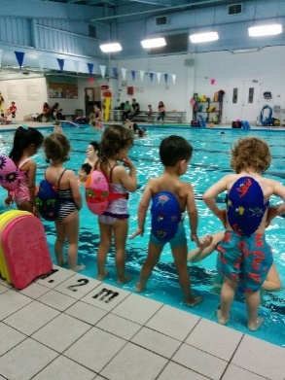
Where: 60 Maywood Ave., Pointe Claire 514-630-1202
What: This excursion takes place in the morning for some fun land and aquatic activities. The Pointe Claire Aquatic centre has a wonderful gymnasium and pool. For 30 minutes, children will explore movement in the gym through structured activities and games and then they have a wonderful ‘’30-minute swim”. The qualified and caring instructors provide each child with a swimming lesson and of course some time to play. The Pointe Claire Aquatic Centre provides a safe and happy learning experience with the dynamic staff at the Pointe Claire pool. If your child does not usually attend on Thursdays and you would like him/her to come on the trip please see us in the office to confirm availability. Your child needs to wear a bathing suit with t-shirt on top and bring a towel (put names on the towels please).
Cost is $20.00.

When: Thursday, March 14. Two groups: Bus leaves at 9:00 and 10:00

3 A Spring Puppet Show ‘’Le Petit Chuchoti vert’’
Where: At the school, in classroom 2.
What: Chlorophylle Productions is here with a great puppet show to kick off Spring!!
(one of our favourites). The children will enjoy the story and there are sure to be lots of laughs! Here’s a synopsis of the show : Au pays du centre de la Terre, vivent de petits lutins, le peuple des Chuchotis.
L'un deux, le Petit Chuchoti Vert, a comme travail de s'occuper des fleurs et des arbres. Chaque année, il confie les fleurs à Grand-Mère Terre durant la saison froide. Il attend ensuite que Lorine, la licorne, annonce la douce saison pour ramener les fleurs sur la Terre. Mais voilà que Lorine est toute enrhumée et ne peux pas étendre le tapis arc-en-ciel, annonciateur du retour de la végétation.
If your child does not usually attend on Tuesdays, he/she is welcome to come to this performance from
Cost is $9.00
When: Tuesday, February 19 at 3:00 p.m.

4 Yogi Doug: Spring Spirit Yoga for a cause
Where: At the school, in the classroom or library.
What: Yogi Doug is a master of Kripalu style yoga (Kripalu Yoga works on unblocking energy channels in the body and promoting health) and he is a wonder working with children. According to Yogi Doug children have a special energy with the changing of the seasons. What a beautiful activity for all of us in order to welcome in the new Spring! As is the case with our resident yogi, his intentions are always for the greater good and he chooses a well-deserved organization to donate the funds collected. For Spring, all funds collected will be going to the Welcome Hall Mission. If your child does not normally attend on Thursdays, he/she is welcome to. Cost is $5.00.
When: Thursday, March 28 Classroom 1&5: 10:45 am Classroom 2: 10:15 am
Classroom 3: 9:15 am Classroom 4: 9:45 am

__________________________________________________________________________________________________

I give permission for my child to participate in the following:

1 Excursion: Stewart Hall (classroom 1,2,4 and 5) Yes No Cost: $ 15.00
2 Excursion: Swim and Gym (classroom 1,2,4 and 5) Yes No Cost: $ 20.00
3 A Spring Puppet Show ‘’Le Petit Chuchoti Vert’’ Yes No Cost: $ 9.00
4 Yogi Doug: Spring Spirit Yoga for a cause Yes No Cost: $ 5.00

CHILD’S NAME ________________________________ Classroom No.________________

PARENT’S SIGNATURE___________________________ TOTAL SUBMITTED $_____________

IMPORTANT: PLEASE GIVE THIS FORM AND THE FEE TO THE OFFICE BY Friday, March 1.

