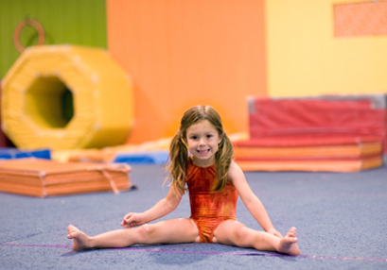
WIMGYM REGISTRATION

April to June 2019 Session

PLEASE SUBMIT THIS FORM AS SOON AS POSSIBLE TO ENSURE A PLACE FOR YOUR CHILD. REGISTRATION IS ON A FIRST-COME FIRST-SERVE BASIS.

Our spring session of Wimgym will take place on Friday mornings starting April 5, 2019. The Wimgym program is very popular as it is a fun physical activity that helps the child to develop his/her concentration, gross motor coordination and strength. The program is called “Kindergym” and is for children 3 to 5 years old (child must be completely toilet trained). The classes start with a 10-minute aerobic warm up (movement and stretching to music). Children are then divided into groups of 4 to 6 per instructor and take turns using the various gymnastics equipment (beam, parallel bars, trampoline, foam pit, etc.) All equipment is very safe and the supervision and instruction is excellent. The instructors are trained gymnastics coaches.

Each class is 45 minutes long, and we will have a total of 10 Wimgym classes on Friday mornings. Transportation to and from the gym is by school bus. Wimgym is located at 2100 Trans Canada on the South Service road just east of Sources Blvd (just past Ottimo Furniture).

Parents are invited to the Gym to attend a demonstration Wimgym class (at the regular class time for your child) on Friday, June 21 (our final class). Note there is no class on April 19 and June 14 (graduation day).

Cost is $195.00 for the 10-week session, and includes the Wimgym fee, cost of additional supervision, and cost of transportation by school bus.



I WOULD LIKE TO REGISTER MY CHILD FOR THE APRIL-JUNE 2019 WIMGYM PROGRAM:

I ENCLOSE: $_195.00__ Cash
or Cheque (made out to Montessori Pointe Claire)

CHILD’S NAME_________________________________ DATE OF BIRTH______________

CLASSROOM NUMBER____________

PARENT’S SIGNATURE___________________________________DATE________________

