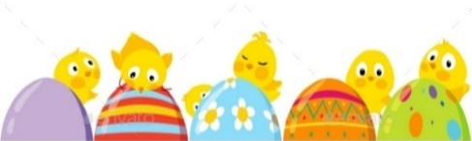
3__
April /Avril 2019
MONDAY  Classroom  Classe  LUNDI | TUESDAY  MARDI | WEDNESDAY  MERCREDI | THURSDAY  JEUDI | FRIDAY  VENDREDI
1 Theme: Beach Party  Show & Tell:  Bring in something you  Bring to the beach  Yoga with Nathalie | 2  Beach music dance party! | 3  A la plage sable kinetic  Music: Ukulele | 4  L’heure de racontre à  la plage  Music: Ukulele | 5  Sarah the Science Gal:  Ocean Currents  Paint a round beach ball  3:30 pm - A special class for yoga month with yoga teacher Josey ($6.00)
8 Theme: What goes up must come down  Sing the zoom  zoom song  Yoga with Nathalie | 9  Emilie the Science Gal:  Inverted Balloon in a Bottle  Catch a floating bubble! | 10  9:30 am: Sportball: Basketball-gravity in action ($9.00)  Play catch with different balls  Music: Rain Stick | 11  Build a rocket ship  Music: Rain Stick | 12 Final day to bring scholastic book orders  Sarah the Science Gal:  Parachutes  Jeux parachute  Josh
15 Theme: Everything Bunnies & Eggs!  Storytime:  Easter Egg Hunt  Yoga with Nathalie  (Last Class Parents Invited) | 16  Bring in your favorite bunny thing  Emilie the Science Gal:  Marshmallow Peep Slime | 17  Bake Easter cookies  Music: Egg Shaker fun & games | 18 Waffle Bunny Pyjama Day Breakfast - wear your “cuddly” pj’s  Easter Egg and Matza Hunt!  Music: Egg Shaker fun & games | 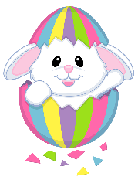  19  CLOSED-FERMÉE  Good Friday  Le vendredi Saint
22 Easter Monday (Open)  Theme: Earth Week  Show & Tell:  Bring in something you  recycle | 23  Sauvons la mer | 24 7:30PM Parent Wine and Cheese meeting. All welcome!  Les balienes  Music: Drums | 25  Emilie the Science Gal:  Earth Skittles  Recycle Robots  Music: Drums | 26  Sarah the Science Gal:  Volcano Eruption  Storytime:  Why should I save water?
29 Theme: Under the Big Top  9:15 am - - Pianist Michael Woytiuk -Circus music from the big top ($6.00)  We will play with our  circus animals  Bianca | 30  Pin the nose on the clown | May 1  Paint a caramel apple  Music: Accordion | May 2  Emilie the Science Gal:  Static with Balloons  Taste some cotton candy  Music: Accordion | May 3  Sarah the Science Gal:  Jumping Popcorn  Playing ring toss

