Special Events for April 2019

1 A special yoga class in celebration for Yoga Month with yoga teacher Josey
Where: At the school, in the library or the classroom
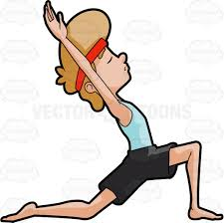
What: Did you know that there are over 900 yoga poses? As many of the yoga studios around town are promoting April as a great month to start yoga, we decided this would be a good time to add more yoga too! We are pleased to introduce Josey! Josey is a yoga specialist with East to West yoga since 2002, and a certified instructor with the YMCA since 1998. Josey will guide the children through a series of poses and breathing exercises. As they love to laugh and have tremendous imagination, they will create an adventure out of the funny stories told.
What a wonderful way to end the week after a morning at Wimgym! Cost: $6.00
When: Friday, April 6 Classroom 1: 2:00 p.m. Classroom 3: 3:30 p.m.
Classroom 2: 2:30 p.m. Classroom 4: 3:00 p.m.
Classroom 5: 2:00 p.m.

2 Sportball: “Basketball” is gravity in action!
Where: In the child’s classroom
What: Sportball is a half hour of fun and learning with a physical education animator (“coach”). For
the "What goes up must come down" week, the children will take part in the game of basketball. The
coaches at Sportball always use creative techniques to stimulate the imagination of the children and get
everyone into the action! If your child does not usually attend on Wednesdays, he/she is welcome to come
to the Sportball Workshop at the time shown below. Cost: $9.00.
When: Wednesday, April 10 Classroom 1: 11:30a.m. & 12:00 a.m.
Classroom 2: 10:30 a.m. & 11:00 a.m.
Classroom 3: 9:30 a.m. Classroom 4: 10:00 a.m.
Classroom 5: 11:30 a.m.

3 Excursion to Stewart Hall Cultural Centre: Les visites du Renard. Puppet Show and Dance Workshop
Where: 176 du Bord-du-lac Pointe-Claire 514-630-1220
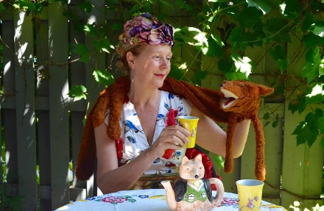
What: Lady Grey (Jacqueline van de Geer) loves, teatime, especially because it is the time of the day that her special fox keeps her company. While thy are having their teach Fritz Foxhill tells Lady Grey all about the parks and the forest around the small town where they live. It seems that very day the parks and the forests are getting more and more dirty since lots of people love to have picnics but simply seem to forget to take their garbage with them. Lady Grey and Fritz Foxhill decide together to make a plan to take action and clean up the parts and forest forever! The is a 45-minute show, followed by a 30-minute dance workshop! It will be in French. Cost: $15.00.
When: Thursday, April 11. Please be at school by 8:15 am to leave on time.

4 Cooking Class Field Trip to Provigo’s Kitchen
Where: 16900 Trans-Canada, Kirkland 514-426-3005
What: Provigo has a great program to teach the fundamentals of cooking skills to children and to promote good nutrition. It’s actually a really great set-up where the children spend an hour cooking in the Provigo kitchen with their chefs and then do a tour through the grocery store to get an understanding of nutrition while seeing all of the different foods. For our excursion, we will be making pizza cupcakes! If your child does not usually attend on Thursdays, he/she is welcome to at the time shown. The cost is $19.00.
When: Thursday, April 25. Please be at school by 8:15 am to leave on time.

5 A Children’s Concert “Under the Big Top” with pianist Michael Woytiuk
Where: At the school, in the library
What: Michael takes the kids under big top to explore all of the wonders of the Circus! Michael is going to introduce the children to various types of music by having them listen while moving so that they
can really fell the beat of the music. Michael perform several times a year at Montessori and his concerts are always a success with the children (and the Teachers too!) If your child does not attend on Mondays, he/she is welcome to attend at the time shown. Cost: $6.00
When: Monday, April 29 Classroom 1: 10:45 a.m. Classroom 2: 10:15 a.m.
Classroom 3: 9:15 a.m. Classroom 4&5: 9:45 a.m.

_______________________________________________________________________________________

I give permission for my child to participate in the following:

1 A special yoga class in celebration of Yoga Month Yes No Cost: $ 6.00
2 Sportball “Basketball” is gravity in action! Yes No Cost: $ 9.00
3 Excursion to Stewart Hall (Classrooms 1,2,4 and 5 – 100% toilet trained!) Yes No Cost: $ 15.00
4 Cooking class Field Trip to Provigo’s kitchen(Classrooms 1,2 and 5) Yes No Cost: $ 19.00
5 “A Children’s Concert “Under the Big Top” with pianist Michael Woytiuk Yes No Cost: $ 6.00

CHILD’S NAME ________________________________________________Classroom No.__________________

PARENT’S SIGNATURE______________________________________TOTAL SUBMITTED $_________________

IMPORTANT: PLEASE GIVE THIS FORM AND THE FEE TO THE TEACHER OR OFFICE BY
Wednesday, April 3

