Theatre and Movement Classes with Barbara

We have our first of the year wonderful session of dramatic movement this spring with teacher Barbara Diabo. Barbara has been teaching theatre at Montessori for 12 years and we are always thrilled by how much the children enjoy and learn from this activity. Barbara has a BFA in Theatre from Concordia University and has worked as a professional actor and dancer. Barbara has been teaching pre-school age children in Montreal since 1989 and her aspiration is to teach children the love of movement. Her program combines theatre and creative movement for a unique combination. Each of her classes has a theme (and during each school year the themes will not repeat); for example:
- castle adventure
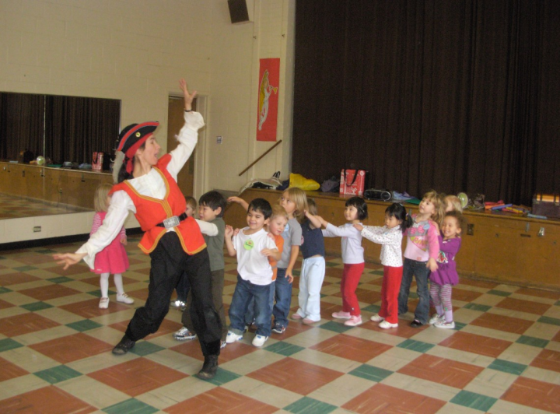
- seasons
- in space
- dreams
- dinosaurs
- international games and dances
- camping
- pirate adventure
- sports
- the Old West
- the 5 senses
- insects
- air
- art
- cooperation
- snow
- Native Americans
- holiday themes
- beach
In each class the children will act out various scenarios according to the theme. The objective is to have the children learn acting skills while getting plenty of exercise and learning about the theme. Barbara’s mission is to “inspire the children to get up and move while they improve their locomotive skills, balance, co-ordination, creativity, memory and team work”. This program is excellent for all age groups including our youngest students!

Barbara’s classes will be on Monday mornings
(6 classes) on the following dates:
May 6, 13, 27
June 3, 10, 17
(Parents are invited to watch our class on June 17)

To register your child, please complete the form below and return to the office with your payment by Friday, April 19.

_________________________________________________________________________________________________

I wish to register my child (child’s name) ______________________________________

in classroom number _____________ for the May/June 2019 Theatre and Movement classes with Barbara.
I enclose $60.00 _________cash ________cheque

Parent’s signature _______________________________________________________

