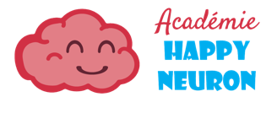
A science discovery program this spring with Emilie!
Mini-Astronauts program
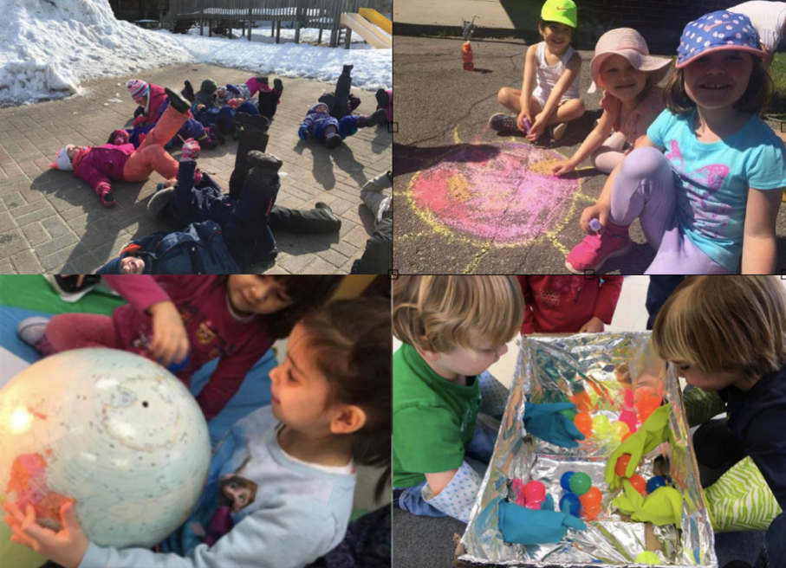

We are adventurous Mini-Astronauts. We look up at the sky and wonder.
What is out there? Will I ever reach the stars?

This spring, Académie Happy Neuron, is pleased to bring back Mini-Astronauts and we will turn our focus to the sky once again! We believe that learning more about the planets and the universe reveals why the Earth is so precious. It is also a very humble adventure, as you look further and further into the sky, you realize how small you are and how big you can dream. The Mini-Astronauts will go on a journey they will never forget!
Académie Happy Neuron is a social enterprise that aims to prepare today’s children to be part of a prosperous and healthy humanity. Please note that by registering your child, this permits us to post pictures of your child on the Académie Facebook page. This will allow you to see what your Mini-Astronaut has discover that day and it will help us grow our new endeavour. You can find us on Facebook, ( https://www.facebook.com/academiehappyneuron/ ) and on our website ( http://happyneuron.ca/ )

Look up! Learn how to use a telescope, observe the moon and familiarize themselves with constellations
Explore the planets of the solar system. Learn about their characteristics in a fun and engaging way
Feel and observe gravity and its effects on the universe
Understand the enormity of the big bang and the scale of the universe!

The Mini-Astronauts program will be held on Wednesday mornings (8:45 a.m. – 11:45 a.m.), on the following dates:

April 17, 24 May 1, 8, 15, 22

Each class lasts 3 hours, includes activities outdoors, and is held by Emilie (aka Leader Astronaut!).
____________________________________________________________________________________________
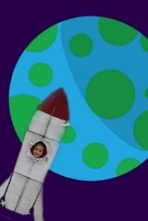
Registration
Places are limited to 10 Mini-Astronauts so please return your registration to the office to reserve your spot.
I understand that by registering for the Mini-Astronaut program I agree that the pictures of my child will be posted on the Académie Happy Neuron Facebook page, Website and promotional material.
I wish to register my child (Child’s name) __________________________________________
For the Mini-Astronauts program from April 17th to May 22nd 2019
I enclose $110___Cash or ___ Cheque (Made to Montessori Point Claire)

