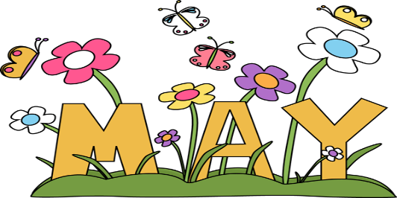
Special Events

May 2019

- Jenny-Lynn Manzo, art teacher, a special Spring art workshop

Where: In the school library or in the classroom
What: Our favourite Art teacher Jenny-Lynn Manzo is here with a wonderful children’s art project that we will all enjoy doing while we learn about different art techniques. In Jenny’s own words:

FLEURS DE MAI – MAY FLOWERS
Art conceptuel /Process art
Les averses d’avril apportent des fleurs en mai. Bourgeon après bourgeon, le printemps arrive, le plus bel
atout du printemps : les fleurs! Quelles soient fraiche ou artificielles…Les enfants ramèneront à la maison un magnifique mini bouquet du printemps qui durera toute l’ainée! Tout en apprenant chaque partie qui composent
une fleur: pétales, pistil, étamine, feuille, tige, racine, réceptacle.

April showers bring May flowers. Blossom by blossom the spring begins, the best thing about
spring: flowers! Whether fresh or faux…The children will bring home gorgeous botanical beauty consisting
of a mini faux spring bouquet that will last all year! While learning each part of the flower: petals,
pistil, stamen, leaf, stem, roots receptacle.

L’art conceptuel est considéré comme un voyage ou un processus créatif, plutôt que comme un produit
Livrable ou un produit final.

Process art is viewed as a creative journey or process, rather than as a deliverable or end product.
Jenny-Lynn Professeur d’art/ Art teacher

If your child does not usually attend on Thursdays, you are welcome to bring him/her for the workshop at the time shown below. Cost: $12.00.
When: Thursday, May 16 in the morning. Children will be divided into small groups.

2 Welcome to the Desert with Reptizoo
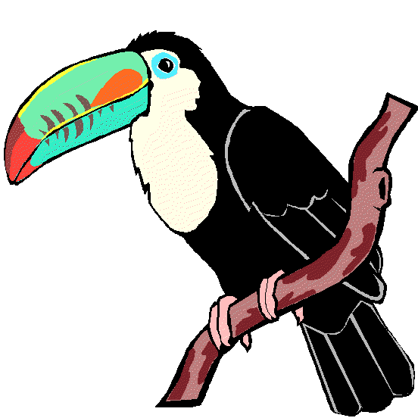
Where: In the child’s classroom
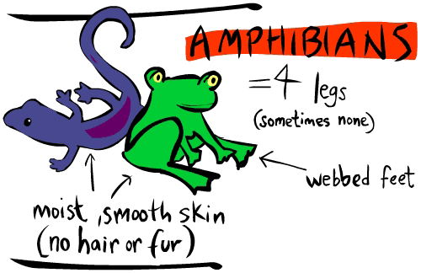
What: The educators at Reptizoo will be here with a wonderful
collection of special birds and amphibians from different parts of the world. This demonstration is suitable (and totally fun) for all age groups. The explanations about the various animals are geared for each child’s age group, and it thrills the children to be able to touch some of the animals. If your child does not usually attend on Wednesdays, you are welcome to bring him/her for the animals’ visit at the time below. Cost: $10.00
When: Wednesday, May 29 Classroom 1: 2:00 pm Classroom 2: 2:30 pm
Classroom 3: 3:30 pm Classroom 4: 3:00 pm
Classroom 5: 2:00 pm

- A trip to the Ostrich Farm – A safari to Discover! (Classrooms 1,2,4-toilet trained only- and 5)

Where: 825 Chemin Fresnière, St. Eustache J7R 0E9 450-623-5258
What: We will begin our visit to the Ostrich Farm in an African setting, where the host will introduce the children to the characteristics of this prehistoric bird. Watch out! Africa always has surprises! In guided groups, the children (and volunteers, Moms and Dads sign up!) will discover the baby ostrich in the maternity ward, encounter the young ostrich and may even be able to touch them and even learn how ostrich communicate. After lunch, we wrap up our visit with a visit to the petting zoo and playground, where the children will see the chickens, rabbits, pigs and lamas and will have the opportunity to feed them and learn some tricks (like how to put a chicken to sleep!). After a full day in the Safari, we will prepare for our return back to the school.
If your child does not usually attend on Thursdays, he/she is welcome to come to the field trip.
Cost: $26.00
When: Thursday, May 30. Bus leaves at 8:30 a.m.
________________________________________________________________________________
I give permission for my child to participate in the following:

1 Jenny-Lynn Manzo, a special art workshop for children Yes No Cost: $ 12.00
2 Welcome to the Desert with Reptizoo Yes No Cost: $ 10.00
3 A trip to the Ostrich Farm – (Class 1,2,4 toilet trained and 5) Yes No Cost: $ 26.00

CHILD’S NAME _____________________________________Classroom No.________________

PARENT’S SIGNATURE_______________________________TOTAL SUBMITTED $____________

IMPORTANT: PLEASE GIVE THIS FORM AND THE FEE TO THE TEACHER BY Wednesday, May 8

