May /Mai 2019
222-___
Classroom
Classe

GABRIELA’S  SPANISH | MONDAY  LUNDI | TUESDAY  MARDI | WEDNESDAY  MERCREDI | THURSDAY  JEUDI | FRIDAY  VENDREDI
 |  |  | 1  Activity:  Clown face painting  Maria  a.m. – Mini Astronauts | 2 Emilie the Science Gal:  Static with Balloons  Discussion:  What animals do we see under the big top? | 3  Sarah the Science Gal:  Jumping Popcorn  Let’s pretend we’re acrobats on a tight rope  a.m. - Wimgym
Canción :  Feliz día mamá  Chanson :  Bonne fête  Maman | 6 Theme: Happy Moms &Grandmas  Craft:  Make a picture of Mom!  a.m. - Theatre | 7 Emilie the Science Gal:  How to make a bath bomb!  Apprenons une jolie chanson pour Maman  a.m. – Swimming  p.m. – Ballet | 8  Show & Tell:  Bring a picture of Mommy and Grandma  p.m. - Music with Pascale  a.m. – Mini Astronauts | 9 Storytime:  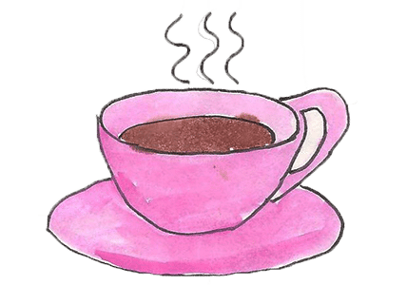  Mrs. Pepper’s Mother’s Day  2:30 PM  Moms and grand moms, you are invited to our class Mother’s Day Tea Party | 10 Final day to bring scholastic book orders  Discussion:  What I love about Mommy  a.m. - Wimgym
Floración : Las flores de mayo  Floraison :  Les fleurs de Mai | 13 Theme: May flowers  Emilie the Science Gal:  Colorful flowers  Activity:  Plant your own flower!  a.m. - Theatre | 14  Discussion:  We’ll learn the names of different types of flowers  a.m. – Swimming  p.m. – Ballet | 15  L’heure du conte :  J’aime pas les bisous  Bricolage:  Faisons une jolie fleur  a.m. – Mini Astronauts  p.m. - Music with Pascale | 16 AM Atelier Jenny Lynn Arts and Crafts: April showers bring May flowers! ($12.00)  PM A presentation: Children and Ramadan, with our teacher Reham. Learn about feeding the poor and charity (sadaqa) to other families, and about cleansing our bodies. Learn some Arabic words and talk about how we celebrate. Thank you Reham. | 17  Game:  Richie  Finley  Pin the bee  on the flower  p.m. Italian language lesson with Samantha  Charlotte S  a.m. - Wimgym
Receta de cocina.  Recette de cuisine. | 20  CLOSED-FERMÉE  Victoria Day  Journée nationale des patriotes | 21 Theme: We love to bake  We are making  cupcakes today!  a.m. – Swimming  p.m. – Ballet | 22  Emilie the Science Gal:  The science behind baking  Let’s make a pizza!  a.m. – Mini Astronauts  p.m. - Music with Pascale | 23 AM – Baking Sweet treats with Chef Pina  Storytime:  Maisy makes  Micah  Gingerbread  Xavier  p.m. - Music with Pascale | 24  Sarah the Science Gal:  Baking Soda Cookies  Making rice  crispy squares  Zack  a. m. - Wimgym
La migración :  Las aves de América  Migration : les oiseaux d’Amérique | 27 Theme: Birds  Emilie the Science Gal:  Let’s make a Brid feeder  Art:  Let’s make a bird.  a.m. - Theatre | 28  Game:  Guess what type of bird I am  a.m. – Swimming  p.m. – Ballet | 29 Wear your PJ’s today for Pyjama Day Breakfast  Bird Egg Special! Yum!  2:30 PM We have a visit from Reptizoo to show us some special birds, exciting! ($10.00)  Jeu de devinette:  Quel est ce bruit? | 30 8:30 am – A trip to the Ostrich Farm. A Safari of discovery – so cool! ($26.00)  Story:  Be happy little penguin | 31  Sarah the Science Gal:  Flying Birds  Discussion:  Different types of birds  a.m. - Wimgym

