Classroom
Classe

Ella

May /Mai 2019
3___
GABRIELA’S  SPANISH | MONDAY  LUNDI | TUESDAY  MARDI | WEDNESDAY  MERCREDI | THURSDAY  JEUDI | FRIDAY  VENDREDI
 |  |  | 1  Paint a caramel apple | 2  Emilie the Science Gal:  Static with Balloons  Taste some cotton candy | 3  Sarah the Science Gal:  Jumping Popcorn  Playing ring toss
Canción :  Feliz día mamá  Chanson :  Bonne fête  Maman | 6 Theme: Happy Moms &Grandmas  Bring in a photo of  you and Mom!  a.m. - Theatre | 7  Emilie the Science Gal:  How to make a bath bomb!  Storytime:  I’ll love you forever  p.m. – Ballet | 8  Histoire:  Je t’aime Maman  p.m. - Music with Pascale | 9  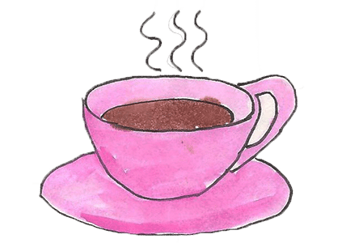  We will decorate our class  3:30 PM  Moms and grand moms, you are invited to our class Mother’s Day Tea Party | 10 Final day to bring scholastic book orders  Histoire:  Je t’aime Maman
Floración : Las flores de mayo  Floraison :  Les fleurs de Mai | 13 Theme: May flowers  Emilie the Science Gal:  Colorful flowers  The letter ‘’F’’ is for Flower  a.m. - Theatre | 14  How many petals do you see?  p.m. – Ballet | 15  We will plant wildflowers  Paint a sunflower with Tanya  p.m. - Music with Pascale | 16 AM Atelier Jenny Lynn Arts and Crafts: April showers bring May flowers! ($12.00)  PM A presentation: Children and Ramadan, with our teacher Reham. Learn about feeding the poor and charity (sadaqa) to other families, and about cleansing our bodies. Learn some Arabic words and talk about how we celebrate. Thank you Reham. | 17  Storytime:  April showers bring May flowers  p.m. Italian language lesson with Samantha
Receta de cocina.  Recette de cuisine. | 20  CLOSED-FERMÉE  Victoria Day  Journée nationale des patriotes | 21 Theme: We love to bake  Play with our kitchen and pretend we are bakers!  p.m. – Ballet | 22  Emilie the Science Gal:  The science behind baking  We will bake cupcakes  p.m. - Music with Pascale | 23  AM – Baking Sweet treats with  Chef Pina  Gâteaux a sable  p.m. - Music with Pascale | 24  Sarah the Science Gal:  Baking Soda Cookies  Make cookies with play dough
La migración :  Las aves de América  Migration : les oiseaux d’Amérique | 27 Theme: Birds  Emilie the Science Gal:  Let’s make a Brid feeder  Go for a walk and look for birds  a.m. - Theatre | 28  Colour a bird  p.m. – Ballet | 29 Wear your PJ’s today for Pyjama Day Breakfast  Bird Egg Special! Yum!  3:30 PM We have a visit from Reptizoo to show us some special birds, exciting! ($10.00)  Chercher les oiseaux de hors | 30  Observation activity: Match the birds by color  Number game: Count the birds  we see around our school | 31  Sarah the Science Gal:  Flying Birds  Meet Stanley – the eclectus parrot!  Carina

