May /Mai 2019
4___
Classroom
Classe

GABRIELA’S  SPANISH | MONDAY  LUNDI | TUESDAY  MARDI | WEDNESDAY  MERCREDI | THURSDAY  JEUDI | FRIDAY  VENDREDI
 |  |  | 1  Circle time:  Under the parachute | 2Emilie the Science Gal:  Static with Balloons  Storytime:  The day the circus came to town | 3 Sarah the Science Gal:  Jumping Popcorn  Color a clown!  a.m. - Wimgym
1Canción :  Feliz día mamá  Chanson :  Bonne fête  Maman | 6 Theme: Happy Moms &Grandmas  Craft:  Something for Mom!  a.m. - Theatre | 7  Emilie the Science Gal:  How to make a bath bomb!  Storytime:  Grandma and me!  a.m. – Swimming  p.m. – Ballet | 8  Emilie the Science Gal:  How to make a bath bomb!  Why I love my Mommy!  p.m. - Music with Pascale | 9  Chanson:  J’aime Maman  J’aime Papa  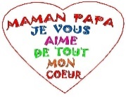 | 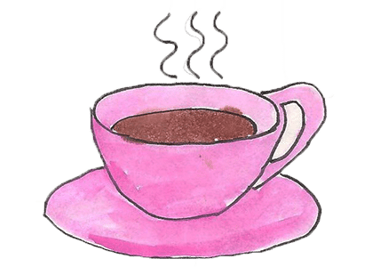  10 Final day to bring scholastic book orders  3:00 PM  Moms and grand moms, you are invited to our class Mother’s Day Tea Party  a.m. - Wimgym
Floración : Las flores de mayo  Floraison :  Les fleurs de Mai | 13 Theme: May flowers  Emilie the Science Gal:  Colorful flowers  Flower craft with Samantha  Storytime:  April Showers bring May flowers  a.m. - Theatre | 14  Songs:  Rain, Rain & Mr. Sun  a.m. – Swimming  p.m. – Ballet | 15  Craft:  Celery stamped flowers  p.m. - Music with Pascale | 16 AM Atelier Jenny Lynn Arts and Crafts: April showers bring May flowers! ($12.00)  PM A presentation: Children and Ramadan, with our teacher Reham. Learn about feeding the poor and charity (sadaqa) to other families, and about cleansing our bodies. Learn some Arabic words and talk about how we celebrate. Thank you Reham. | 17  Art:  On dessine une fleur!  p.m. Italian language lesson with Samantha  a.m. - Wimgym
Receta de cocina.  Recette de cuisine. | 20  CLOSED-FERMÉE  Victoria Day  Journée nationale des patriotes | 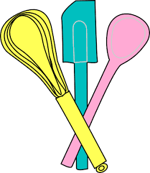  21 Theme: We love to bake  Baking with  Laurie  a.m. – Swimming  p.m. – Ballet | 22  Emilie the Science Gal:  The science behind baking  Color a cupcake!  p.m. - Music with Pascale | 23  AM – Baking Sweet treats with  Chef Pina  Discussion  Quelle saveur de gâteaux  Est-ce que tu préfère  p.m. - Music with Pascale | 24  AM – Baking Sweet treats with  Chef Pina  Sarah the Science Gal:  Baking Soda Cookies  Fun with playdough cookies  a.m. - Wimgym
La migración :  Las aves de América  Migration : les oiseaux d’Amérique | 27 Theme: Birds  Emilie the Science Gal:  Let’s make a Brid feeder  Color a cardinal!  a.m. - Theatre | 28  Bird Watching  a.m. – Swimming  p.m. – Ballet | 29 Wear your PJ’s today for Pyjama Day Breakfast  Bird Egg Special! Yum!  3 p.m. - We have a visit from Reptizoo to show us some special birds, exciting! ($10.00)  Bring in a picture of a bird or your pet bird! | 30 8:30 am – A trip to the Ostrich Farm. A Safari of discovery – so cool! ($26.00)  Histoire:  La forêt enchantée | 31  Sarah the Science Gal:  Flying Birds  Art:  Paint a bird!  a.m. - Wimgym

