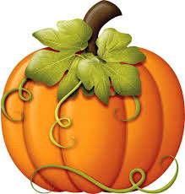
OCTOBER 2019

NEWSLETTER

PARENT WINE AND CHEESE MEETINGS
We will have four or five very informative meetings during the course of the school year. All parents are invited to attend. You may come to one or to all of the meetings. The purpose of these meetings is to encourage the parents to come out and be part of Montessori Pointe Claire, to voice opinions and make suggestions as to what activities they would like the children to participate in, as well as to help us by giving us the “parents’ point of view” on life at Montessori. The meetings are always fun and a nice evening out for everyone. Meetings are actually “a fun night out” with wine and cheese and the parents of your child’s classmates and friends. There is an agenda prepared for each meeting. If you would like to have a special topic discussed at the meeting you are encouraged to call the office and have that topic added to our agenda.

The first parent “Wine and Cheese” meeting will be held on Thursday, October 10th at
7:30 pm. (Meetings adjourn at 9:00pm)

Agenda for our first meeting:
  - Upcoming events
  - Herla (professeur de la prématernelle): - Apprentissage de l’écriture chez les enfants
  - Artemis (our Daycare director) will speak about “Modern parenting, do parents feel guilty for not spending enough time or money on their children?”
  - Tanya, (Classroom 5 teacher): Q & A for Class 5
  - Discussion

SCHOOL PHOTOS

On Wednesday, October 16 and Thursday, October 17 the School Photographer from Kreative Memories Photography Studio will be at Montessori in the morning to take individual and class p photos of the children. Classrooms 3 and 4 will have photos taken on the Thursday and classrooms 1 and 2 on the Wednesday. Your child may have his photo taken on the alternate day if necessary. Class photos will be taken on BOTH days for all four classrooms. You will be given a proof of the photos and can order photos if you desire (there is absolutely no obligation).

If your child does not normally attend on the photography day you may bring him/her to the school for the pictures in the morning. It is preferable that you drop the child off around 8:30am and pick him/her up after the photography is over (we can call you) as the children seem to find it more relaxing to do the “photo shoot” with just their friends and teachers present

REPORT CARDS

Your children will be receiving their first “report card” towards the end of October. This is a basic evaluation on how the child has adjusted to his/her new class, and how he/she is doing socially. A child development report will be given to you in February and an academic report in June. If you have questions or you would like to discuss your child’s report with his/her teacher, please call the office to arrange an interview.

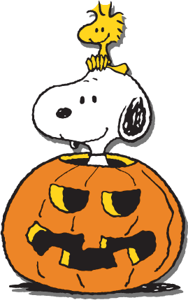
HALLOWEEN PARTY

On Thursday, October 31 we will be trick or treating at Montessori with the children. On that day children are invited to bring a costume in a plastic bag with the child’s name on the bag please. We will dress up in the afternoon. At afternoon snack time we will trick or treat inside the school. We will go to each of the classrooms, the office and the kitchen and receive treats in our halloween bags. If your child does not usually come on Thursday, you may bring him on Thursday afteroon but please check with your child’s teacher to find out the details!

FIRE DRILLS

We will have a minimum of two drills this month. The dates will be determined depending on the weather. (We will not hold a fire drill in bad weather as the children do have to go outside without putting on any extra clothing.) We will only be outdoors for a few minutes, not long enough for anyone to get cold The drills are designed so that the staff has practice assisting the children to leave the building and follows our evacuation procedure correctly, but also for the children to understand and become familiar with the sound of the fire bell (which is quite loud). Our experience with the drills is that the children are cooperative but also that after the first trial, the second and third go very smoothly so this is a drill worth repeating. The main thing to convince the children is that during a fire drill they do not go into the cubbies to change into their outside shoes! Each of our classrooms has it’s own exit for a fire drill, so the children may also exit from a door which is not their usual one.

*******************************************

NO NUTS PLEASE
PLEASE READ THE LABELS VERY CAREFULLY ON YOUR CHILD’S SNACK ITEMS. THERE ARE SEVERAL CHILDREN IN THE SCHOOL WITH VERY SEVERE, LIFE THREATENING NUT ALLERGIES. FOR THEIR SAFETY WE DO NOT ALLOW ANY NUTS OR NUT PRODUCTS TO BE BROUGHT INTO THE SCHOOL.
THANK YOU FOR YOUR COOPERATION.

NO NUTS PLEASE
PLEASE READ THE LABELS VERY CAREFULLY ON YOUR CHILD’S SNACK ITEMS. THERE ARE SEVERAL CHILDREN IN THE SCHOOL WITH VERY SEVERE, LIFE THREATENING NUT ALLERGIES. FOR THEIR SAFETY WE DO NOT ALLOW ANY NUTS OR NUT PRODUCTS TO BE BROUGHT INTO THE SCHOOL.
THANK YOU FOR YOUR COOPERATION.

