Mandarin with Yue Shan | MONDAY  LUNDI | TUESDAY  MARDI | WEDNESDAY  MERCREDI | THURSDAY  JEUDI | FRIDAY  VENDREDI
We will learn the colours | Theme: Pumpkins  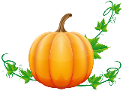 | 1 We will celebrate  Rosh Hashanah  (Jewish New Year)  Histoire : Aventure des citrouilles | 2 AM Morgan the Science Gal: Will pumpkins float?  Song: Five Little Pumpkins  Music with Kimberley: Instrument of the week – Bongos | 3  Bricolage: Couleurs de citrouille  Music with Kimberley: Bongos | 4  Counting pumpkins
We will learn to count to 5 | 7 Theme: What Time Is It?  AM Morgan the Science Gal: Homemade water clock  Contez avec l’horloge  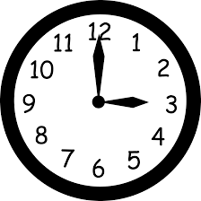  PM Karate with Sensei Meghan | 8 3PM Spectacle « La bernache a perdu sa boussole! » par La petite valise ($9.00)  Hickory Dickory Doc – Nursery Rhymes | 9  Simon Says:  It’s time to play!  Music with Kimberley: Metronome | 10 7:30PM Parent Wine and Cheese Meeting. Everyone welcome for an evening of interesting discussion.  Histoire: Tic Toc  Tessa  Music with Kimberley: Metronome | 11 Final day to bring scholastic book orders.  Paint a turkey!  PM Kim the Science Gal:  Skittle Experiment
We will learn to greet | 14  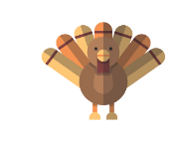  CLOSED-FERMÉE  Thanksgiving  Action de Grâces | 15 Theme: Fire Safety  (We will do fire drills this week)  Story: The Fire Engine Book | 16 School photographer  Dress up time:  Be a fireman  Music with Kimberley: Voice | 17 School photographer  La sécurité en cas de feu  Music with Kimberley: Voice | 18 We will celebrate Sukkot  (Jewish Thanksgiving)  L’heure du conte:  Jackson  Les pompiers  PM Kim the Science Gal:  Fire Extinguisher
We will learn to name animals | 21 Theme: Forest Animals  AM Morgan the Science Gal: Bird feeder  Nos amis dans la forêt  PM Karate with Sensei Meghan | 22 Wear your Halloween pyjamas for a spooky breakfast at school (spooky spice muffins and fruit salad)  Craft: Little Owl | 23 AM Morgan the Science Gal: Bird nest  Which animals live in the forest?  Music with Kimberley:  Tin whistle & slide flute | 24  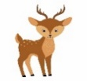  Colour a deer  Music with Kimberley:  Tin whistle & slide flute | 25  Histoire:  Mr. Renard  PM Kim the Science Gal:  How clouds hold water
We will learn words to describe nature | 28 Theme: Halloween  AM Morgan the Science Gal: Bubbling witches cauldron  Paint bats!  PM Karate with Sensei Meghan | 29 3PM Blair Marshall’s Mysterious Magic Show ($6.00)  Les chauves-souris en vol | 30 AM Art workshop with Jenny-Lynn: We will create a mysterious and spooky paper Halloween craft ($11.00)  Scary wheels on the bus  Music with Kimberley: Piano | 31 Happy Halloween!  Apporte ton costume  PM Trick or Treat at School!  L’heure du conte :  Mon premier halloween  (No music) | Nov 1  Make Halloween cookies  PM Kim the Science Gal:  Dancing worms and spider foam
4__
Classe
Classroom

Octobre 2019 October

