Mandarin with  Yue Shan | MONDAY  LUNDI | TUESDAY  MARDI | WEDNESDAY  MERCREDI | THURSDAY  JEUDI | FRIDAY  VENDREDI
We will learn the colours | Theme: Pumpkins  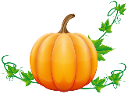 | 1 We will celebrate  Rosh Hashanah  (Jewish New Year)  Graines et Lettres | 2 AM Morgan the Science Gal: Will pumpkins float?  Follow the pumpkin pattern  Music with Kimberley: Instrument of the week – Bongos | 3  Pumpkin dot painting  Music with Kimberley: Bongos | 4  Pumpkins with  playdoh and shapes
We will learn to count to 5 | 7 Theme: What Time Is It?  AM Morgan the Science Gal: Homemade water clock  Hickory Dickory Dock tell the time on the rock clock  PM Karate with Sensei Meghan | 8 3PM Spectacle « La bernache a perdu sa boussole! » par La petite valise ($9.00)  Find the numbers on the clock | 9  Read a story about the hands of time  Music with Kimberley: Metronome | 10 7:30PM Parent Wine and Cheese Meeting. Everyone welcomes for an evening of interesting discussion.  Play with our hands on the clock  Music with Kimberley: Metronome | 11 Final day to bring scholastic book orders.  Make a chalk clock outside  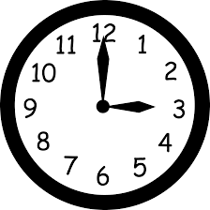  PM Kim the Science Gal:  Skittle Experiment
We will learn to greet | 14  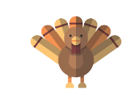  CLOSED-FERMÉE  Thanksgiving  Action de Grâces | 15 Theme: Fire Safety  (We will do fire drills this week)  Hot and cold sorting | 16 School photographer  Show & Tell:  Your favourite fire truck  or fireman hat  Music with Kimberley: Voice | 17 School photographer  Makes flames in a bag  Music with Kimberley: Voice | 18 We will celebrate Sukkot  (Jewish Thanksgiving)  Sing our song about fire trucks  PM Kim the Science Gal: Fire Extinguisher
We will learn to name animals | 21 Theme: Forest Animals  AM Morgan the Science Gal: Bird feeder  Sponge paint animal tracks  PM Karate with Sensei Meghan | 22 Wear your Halloween pyjamas for a spooky breakfast at school (spooky spice muffins and fruit salad)  Nature in the block center with our animals | 23  AM Morgan the Science Gal: Bird nest  Squirrel craft  Music with Kimberley:  Tin whistle & slide flute | 24  Special snack for bears  Music with Kimberley:  Tin whistle & slide flute | 25  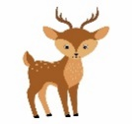  Autumn squirrel sensory  PM Kim the Science Gal:  How clouds hold water
We will learn words to describe nature | 28 Theme: Halloween  AM Morgan the Science Gal: Bubbling witches cauldron  Make a black cat  PM Karate with Sensei Meghan | 29 3PM Blair Marshall’s Mysterious Magic Show ($6.00)  Carve our pumpkin | 30  Sensory bin hide and seek: Halloween find  Music with Kimberley: Piano | 31 Happy Halloween!  Apporte ton costume  PM Trick or Treat at School!  Dance to the spooky music  (No music) | Nov 1  Memory game of  witches and goblins  PM Kim the Science Gal:  Dancing worms and spider foam
5__
Classe
Classroom

Octobre 2019 October

