Special Events for November 2019

- The Dentist visits our Class
Where: At the school, in the child’s classroom.
What: We welcome, Dr. Lilianne Malczewski to Montessori. She is the Mom of Lucas and Evelyne who also attend Montessori. Dr Liliane Malczewski & Dr Matthew Healy are Children & Family dentists based in the West Island. Dr. Malczewski has very generously donated her time to visit our school and each class. She will be checking each child for overall oral health (this is a screening and nothing invasive, Dr Malczewski will be giving a report to each parent). The children will be learning that it is so important to keep our teeth healthy and if we get into good habits from when we are young, our teeth and mouth are going to be healthy for a long long time! What Dr Malczewski has planned for the children is a "Happy tooth, Sad tooth" dentist activity with what foods are healthy and which ones cause cavities, a dental brushing demo, as well as a little dental activity sheet to keep the little ones busy while their peers get their screenings done. They will read the book "Caillou Goes to the Dentist" It will be lots of fun and the children will receive new toothbrushes. A lucky parent will also receive (by draw), a Paw Patrol spinbrush (electric toothbrush).
If your child does not usually attend on Tuesdays, you may bring him/her for this event. Cost: Free
When: In the morning on the following dates: Tuesday, November 5 Classrooms 1 and 3 Tuesday, November 12 Classrooms 2, 4 & 5

- Philippe, the Water Specialist visits our Class
Did you know that only 3% of the Earth’s water is fresh water? And of that 3%, 2/3rds is frozen in glaciers and polar ice caps. That means only 1% of the Earth’s freshwater supply is accessible for use! This is why it is so important to conserve the limited amount of water that we do have. We are so happy to bring back our water specialist Phillippe! Phillipe will visit each classroom and explain why our rivers are important and explain to the children the different things that we can do every day in order to keep our rivers clean. We will learn that we have to be very careful what we do with plastics as they can choke marine life. We need to keep the fish and turtles and seals (etc) safe and the water clean for them! Cost: Free
When: Wednesday, November 13 Classroom 1: 10:45 am Classroom 2: 10:15 am
Classroom 3: 9:30 am Classroom 4 & 5: 9:45 am

- Excursion to Stewart Hall Cultural Centre: L’Echo de L’Ecume (for classrooms 1,2, and 3)
Where: 176 du Bord-du-lac Pointe-Claire 514-630-1220
What: This is a 25-minute show (In French), followed by a 30-minute painting workshop
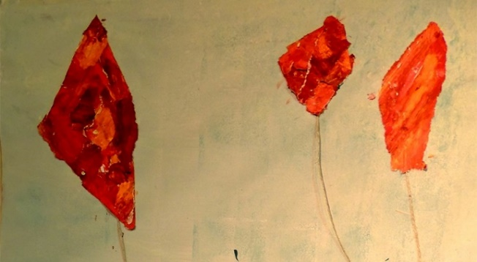
About the show: L’echo de l’echume is a bold show bringing together theatre and visual arts. This small living art gallery, which features dance, a revisited repertoire of a cappella sailor songs and specks of poetry, is an ode to joy. Yes, joy…thanks to its light dress, its impertinence, its bare feet and the charm of its skin, golden by the sea breeze. Even if your child does not usually attend on Thursdays, the child is welcome to attend this trip.
Cost per child is $15.00.
When: Thursday, November 14. Bus leaves at 8:15 a.m.

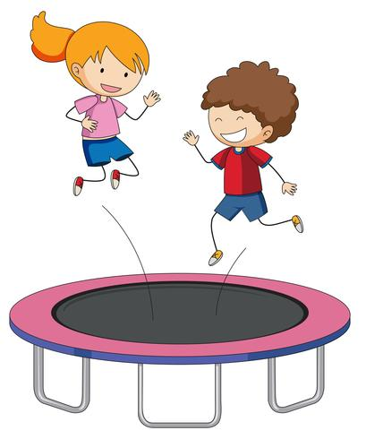
- Field Trip to Le Club de Trampoline Acrosport Barani (Classrooms 1,2 and 3)
Where: 1365 Boul. Dagenais O., Laval, QC. H7L 5Z9, 450-622-0077
What: The Trampoline Club Acrosport Barani is a family business, established in Laval for over 35 years. We have been to Acrosport Barani many times and it is a blast! This is a gymnastics club that gives classes specifically for trampoline and trapeze, and they also cater to schools, preschools and parties. Their web site is www.acrosportbarani.com. The children will rotate through different activities including the big trampoline, the trapeze, the Tarzan ropes, and the smaller double trampolines, the foam pits, the ball pits, the tight rope and hoops and the very fun rock wall. Everyone will enjoy this excursion. The supervision is excellent, the monitors at the Club are very funny and good, the equipment is very safe and very clean. If your child does not usually attend on Mondays and you would like him/her to attend, please check with the office as to whether we can accommodate more children. Please note we will not need parent volunteers for this excursion as the gym only permits the teachers to come in and supervise. The children get on the bus at the school and get off the bus right at the door of the gym. The ratio of children to adults at the club with teachers and monitors will be about 3:1. **PLEASE MAKE SURE YOUR CHILD HAS SOCKS ON FOR THIS EXCURSION AS ACTIVITIES TAKE PLACE IN SOCK FEET. Also, the children are not permitted jewelry or watches on (other than medical alert bracelets) and no belts. The best clothing is sweat pants and a t-shirt. Long hair needs to be attached back with an elastic (no hair clips).
Cost per child is $23.00
When: Monday, November 25. Bus leaves at 8:00 a.m.
We will back by lunchtime. (No Volunteers required for this Field Trip)

- A Face Painting workshop with Louna
Where: In the school library
What: Face painting is always a huge hit with children. Even the younger children find it fascinating that they can have a picture on their arms (we won’t do faces with children under 2 normally). This workshop is different from just having a face painter come and do face painting for us. Louna works with a small group of children and as they watch each other being painted she describes the process of how she starts (making a basic outline, etc.) and the techniques so that we then end up with the lovely finished product. This workshop is a fun art lesson! The children will have the opportunity to “practice” (on paper) doing some fun face painting themselves. Louna’s web site is http://www.louna.ca/ (she’s great for birthday parties too!)
Cost per child: $10.00
When: Wednesday, December 4 (children will be divided into small groups)
_______________________________________________________________________________________________________

I give permission for my child to participate in the following:

- The Dentist visits our Class Yes  No  Cost: Free
- Phillipe, the Water Specialist Visits our Class Yes  No  Cost: Free
- Stewart Hall excursion Theatre and art: classrooms 1,2 and 3 Yes  No  Cost: $ 15.00
- Le Club de Trampoline Acrosport Barani: classrooms 1, 2 and 3 Yes  No  Cost: $ 23.00
- A Face Painting workshop with Louna Yes  No Cost: $ 10.00

CHILD’S NAME ___________________________CLASSROOM NUMBER____________________

PARENT’S SIGNATURE_______________________TOTAL SUBMITTED $___________________

IMPORTANT:
PLEASE GIVE THIS FORM AND THE FEE TO THE OFFICE
(OR DROP IN THE OFFICE DEPOSIT BOX) by Tuesday morning, November 5.

