November  1 | 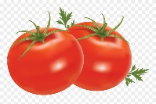 | 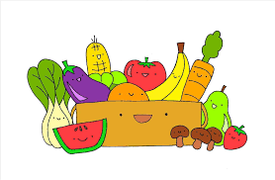 | 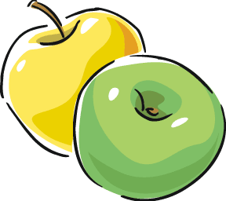 |  | Vegetable soup  Chicken salad and cream cheese  roll up sandwiches  Fresh fruit
November  5 to 9 | Celery soup  Scrambled eggs with cheddar cheese  Roasted potatoes  Fresh fruit | Carrot soup  Mustard apricot fish fillets  Couscous  Fresh fruit | Creamy tomato basil soup  Baked French toast  Corn  Fresh fruit | Vegetables and dip  Spaghetti with meatballs  Garlic bread  Fresh fruit | Lentil soup  Turkey and cheese sandwiches  Corn  Fresh fruit
November  12 to 16 | Chicken noodle soup  Tortellini with rosé sauce  Broccoli  Fresh fruit | Minestrone soup  Meatloaf  Garlic mashed potatoes  Corn  Fresh fruit | Broccoli and cheddar soup  Grilled cheese sandwiches  Mixed vegetables  Fresh fruit | Vegetable soup  Pineapple chicken  with noodles  Carrots  Fresh fruit | Tomato and rice soup  Cheese and broccoli omelet  Roast potatoes  Fresh fruit
November  19 to 23 | Potato and leek soup  Vegetarian pizza with mozzarella cheese  Fresh fruit | Cauliflower soup  Pancakes with apple sauce  Vegetarian sausage  Fresh fruit | Garden salad  Chicken breast with honey glaze  Rice pilaf  Peas  Fresh fruit | Broccoli soup  Homemade Vegetarian burgers  Mixed vegetables  Fresh fruit | Celery soup  Egg salad sandwiches on brown bread  Corn  Fresh fruit
November  25 to 29 | Sweet potato, carrot and apple soup  Steak and cheese subs  Broccoli  Fresh fruit | Vegetable soup  Tuna loaf  Rice pilaf  Mixed vegetables  Fresh fruit | Caesar salad  Vegetarian lasagna  Soft rolls  Fresh fruit | Spinach soup  Crispy baked fish  Couscous  Peas and carrots  Fresh fruit | Chicken noodle soup  Sloppy Joes  Butterscotch pudding
A fresh fruit desert is served after each lunch.
Milk and water are served at lunch and during morning and afternoon snack.
Menu : November 2019 novembre

