Novembre 2019 November
4__
Classe
Classroom

Mandarin with  Yue Shan | MONDAY  LUNDI | TUESDAY  MARDI | WEDNESDAY  MERCREDI | THURSDAY  JEUDI | FRIDAY  VENDREDI
We will learn words to describe nature |  |  |  |  | 1  Make Halloween cookies  PM Kim the Science Gal:  Dancing worms and spider foam
We will learn the names of the fruits | 4 Theme: Healthy Habits  La fée  Ariel  des dents  PM Karate with Sensei Meghan | 5  Veggie guessing game | 6 AM Morgan the Science Gal: Why do we use soap?  AM Baking healthy granola bars with Chef Pina  On mange pour la santé  Music with Kimberly: Accordion | 7 *** Photo Retakes ***  Food collage  Music with Kimberley: Accordion | 8  What good foods go in our grocery basket?  PM Kim the Science Gal: How to get rid of germs
We will learn to count to 5 | 11 Special Theme Today: Remembrance Day  AM Morgan the Science Gal: Canadian flag experiment  Bring a photo of someone special  PM Karate with Sensei Meghan – Last class – Parents invited | 12 Theme: The World of Art  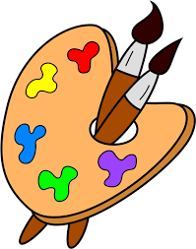  AM Dentist Lilianne will tell us about teeth health and check our teeth  Celery rose art | 13 Final day to bring scholastic book orders  AM Water Specialist Philippe will speak to us about saving the rivers  Create your own rainbow  Music with Kimberley: Trumpet | 14 7:30PM Parent Wine and Cheese Meeting. Everyone welcome for an evening of interesting discussion.  Abstract  Samantha  painting  Music with Kimberley: Trumpet | 15  Histoire:  Mes grand-parents  PM Kim the Science Gal: Food coloring art
We will learn to greet | 18 Theme: Bodies of Water  AM Morgan the Science Gal: Ocean in a bottle  What lives under the ocean? | 19  Colour a picture of the beach! | 20  Les coquilles de la mer  Music with Kimberley: Didjeridu | 21 AM Gardening with Zoe  Way down deep in the deep blue sea  Music with Kimberley: Didjeridu | 22  L’heure du conte:  Neil  La mer  PM Kim the Science Gal: Shark buoyancy
We will learn about my family members | 25 Theme: We Are Family  Things we do with our family | 26  Song:  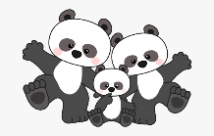  I love you! | 27 AM Morgan the Science Gal: Diversity with playdough  Jeu: Trouve ma famille  Music with Kimberley:  Electric Bass | 28 Wear your warm PJ’s for a  Family style “eggs and sausage” breakfast at school  Storytime:  My Family  Music with Kimberley:  Electric Bass | 29  Apporte une photo de ta famille  PM Kim the Science Gal: Citrus experiment

