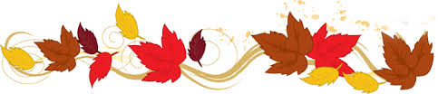
Novembre 2019 November
5__
Classe
Classroom

Mandarin with  Yue Shan | MONDAY  LUNDI | TUESDAY  MARDI | WEDNESDAY  MERCREDI | THURSDAY  JEUDI | FRIDAY  VENDREDI
We will learn words to describe nature |  |  |  |  | 1  Memory game of  witches and goblins  PM Kim the Science Gal:  Dancing worms and spider foam
We will learn the names of the fruits | 4 Theme: Healthy Habits  Let’s make a vegetable alphabet and vegetable soup  PM Karate with Sensei Meghan | 5  Have a healthy snack –  bring an apple | 6 AM Morgan the Science Gal: Why do we use soap?  AM Baking healthy granola bars with Chef Pina  Let’s count the teeth on  Mr. Potato Head  Music with Kimberly:Accordion | 7 *** Photo Retakes ***  We will wash our hands while using a timer  Music with Kimberley: Accordion | 8  We will brush our apple with our toothbrush  PM Kim the Science Gal: How to get rid of germs
We will learn to count to 5 | 11 Special Theme Today: Remembrance Day  AM Morgan the Science Gal: Canadian flag experiment  Make a poppy  PM Karate with Sensei Meghan – Last class – Parents invited | 12 Theme: The World of Art  AM Dentist Lilianne will tell us about teeth health and check our teeth  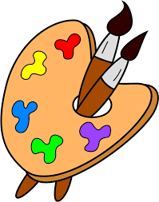  Colour your own world | 13 Final day to bring scholastic book orders  AM Water Specialist Philippe will speak to us about saving the rivers  We will mix colors in our bubbles  Music with Kimberley: Trumpet | 14 7:30PM Parent Wine and Cheese Meeting. Everyone  welcome for an evening of interesting discussion.  Talk about the colors in the coloring box  Music with Kimberley: Trumpet | 15  We will make colored rice for our sensory bin  PM Kim the Science Gal: Food coloring art
We will learn to greet | 18 Theme: Bodies of Water  AM Morgan the Science Gal: Ocean in a bottle  How many drops does it take to fill a cup? | 19  What sinks? What floats? | 20  Paint with water  Lucas  Music with Kimberley: Didjeridu | 21 AM Gardening with Zoe  Water sensory  activities  Music with Kimberley: Didjeridu | 22  Music with water  PM Kim the Science Gal: Shark buoyancy
We will learn about my family members | 25 Theme: We Are Family  Read a story: “My Family” | 26  Paint your family  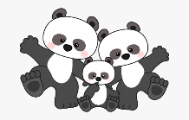 | 27 AM Morgan the Science Gal: Diversity with playdough  Show & Tell: Bring in a picture of your family  Music with Kimberley:  Electric Bass | 28 Wear your warm PJ’s for a  Family style “eggs and sausage” breakfast at school  Make a family flower  Music with Kimberley:  Electric Bass | 29  We will make family patterns using different people  PM Kim the Science Gal: Citrus experiment

