December  2 to 6 | Vegetable soup  Scrambled eggs with spinach and feta cheese  Roasted herb potatoes  Fresh fruit | Vegetable and barley soup  Cod fish cakes  Couscous  Fresh fruit | Minestrone soup  Pasta with tomato sauce  Dinner rolls  Fresh fruit | Sweet potato soup  Chicken with rice  Hummus with pita bread  Fresh fruit | Vegetable soup  Spaghetti with meatballs  Fresh fruit
December  9 to 13 | Tomato and rice soup  Meatloaf with brown sugar sauce  Roasted potatoes  Fresh fruit | Celery soup  Chicken salad and cheese sandwiches  Mixed vegetables  Fresh fruit | Split pea soup  Salmon and potato croquettes  Rice Pilaf  Fresh fruit | Carrot soup  Pancakes with apple sauce  Turkey sausage  Fresh fruit | Mediterranean style lentil soup  Broccoli and cheese omelet  Carrots  Fresh fruit
December  16 to 20 | Leek and potato soup  Pasta Primavera  Cauliflower  Fresh fruit | CHRISTMAS Lunch  Turkey loaf, mashed potato, stuffing, gravy, cranberry sauce  Corn  Holiday dessert | Broccoli soup  Homemade macaroni and cheese  Mixed vegetables  Fresh fruit | Pea soup  Crispy crumbly fish  Couscous  Broccoli  Fresh fruit | Tomato Soup  Grilled cheese sandwiches  Peas  Fresh fruit
December 23 | Vegetable soup  Homemade pizza  Fresh fruit |  | 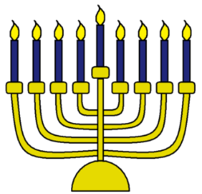
A fresh fruit dessert is served after lunch every day.
Milk and water are served at lunch and during morning and afternoon snack.
Menu
December 2019 décembre

