Ballet with Nina
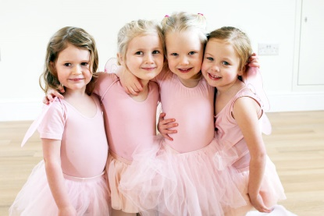
We are very happy to have Nina back at Montessori this winter for another excellent series of ballet lessons. Nina has been teaching ballet at Montessori (as well as at many other schools on the West Island) for years and we just love her classes. Nina’s little ballerina’s at Montessori always look forward to their classes as Nina makes everyone feel happy and enthusiastic about practicing ballet.

Nina is a very talented ballerina herself with many years of experience in dance. Nina joined the Royal Winnipeg Ballet after graduating from The Royal Conservatory of The Hague and The Royal Winnipeg Ballet Professional Division. As a member of the corps de ballet she danced numerous soloist roles. Nina has also choreographed several professional ballets and has coached for The Professional Division students and taught dance at The Royal Winnipeg Ballet’s General Division.

Ballet classes with Nina at Montessori will start on January 21st. Classes will take place on Tuesday afternoons for a total of 6 classes. Parents are invited to the last class on Tuesday, February 25th to see their ballerinas “perform”.

The dates of the classes are:
January 21, 28
February 4, 11, 18. 25
(parents invited to the last class but if you can’t make the last class please let us know and you are welcome to come to any of the other classes to observe)
If you wish to register your child for ballet, please fill in and return the form below. Cost for the 6 classes is $65.00.

I wish to register my child (child’s name) __________________________________
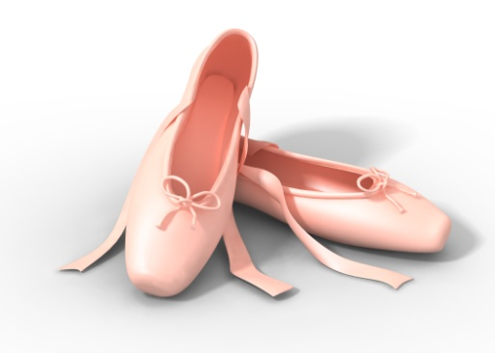
in classroom number ______for Ballet classes with Nina (Tuesdays, January-February 2020).
I enclose $65.00 _____cash _____cheque _____etransfer
(please note child’s name, etransfer@montessoripc.com)
Parent’s signature ______________________________________________

