

**Newsletter for**

**January 2020**

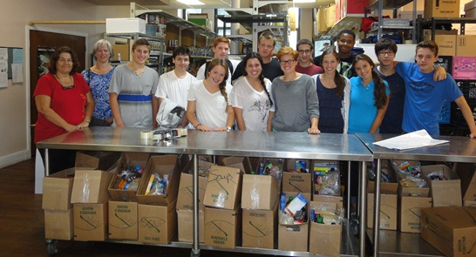**THANK YOU TO ALL OUR PARENTS**

**Thank you** to all our parents who brought in treats for our Christmas party buffets and all your donations to Share the Warmth (Food donations), Chez Doris (adult clothing) and to the Mission Cattolica Latino Americana de Montreal (toys and clothing). Once again, thanks to your grand generosity, all three organizations received huge donations from Montessori.

**Thank you to Montessori Pointe Claire from the team at Share the Warmth Food Bank**

**Our Christmas Drive was a huge success because of all of you!!**

**INTERNATIONAL WEEKS**

Every year one of the events we look forward to at Montessori are our International weeks. This year we have our “International weeks” from January 8 to 19. During this time we introduce “the world” to the children in fun ways (including an amazing lunch menu). Our very special guests are our parents who are invited to come and speak about “their country of origin”. This is a lot easier than you might think. The children love having the parents in class. The presentation is about 20-30 minutes long and normally takes place during big circle time either in the morning or afternoon during big circle time. You will see some parents who have volunteered already indicated on your child’s calendar, however, that does not mean that you cannot participate. We welcome more parents to come and be part of these incredible two weeks. Just speak to your child’s teacher or to the office and we will fit you in!

SKATING

***\*There are a few places still available to register for skating.***

***Please let us know asap.***

**SO00549_Skating starts on Friday, January 10.**

**Your child should be at the school for 9:00 a.m.**

**We are asking that you please:**

* send a **backpack** (not a gym bag) for your child’s skating equipment, as the backpack is much easier for the child to carry.
* send a **helmet**. If the helmet does not fit inside just snap it on to the backpack on the outside, although we much prefer if the helmet can fit in the backpack as there is less risk of it getting “hooked” on anything when the child is walking or getting in and out of the bus. Your child needs a hockey helmet with a cage or visor for the skating lessons. Please **check the helmet at home and adjust the straps to fit correctly**. Children do not need a hat under the helmet (they will be way too hot that way).
* children will also **need their snow pants and mittens or gloves for skating.** The children should not be wearing other hockey equipment; snow pants are sufficient for protection and allow more flexibility of movement.
* please check that your child’s skates are sharpened and that they fit well (if the skates are too large the child will not be able to skate properly).
* parents are invited to the final skating class on **Friday, March 27**. If you wish to come before that class this is perfectly fine as long as your child is happy to participate in the lessons with you there. However, if your child is clinging to you or asking to get off the ice to see you then we need to you to not be present please. The one thing we can guarantee is that your child will be fine at lessons with just his teachers (it always works this way!). The list of children registered for skating is posted by the classroom door.
* please check that your **child’s name appears on the list if he/she is registered.**  It is still possible to register your child for skating if you wish. Please pick up a registration form at the office.
* **skating lessons** are for children aged 3 and up, fully toilet trained: classrooms 1, 2 & 3.

**PARENT MEETING**

Our next parent meeting will be held on **Thursday, January 23 at 7:30 p.m.** We welcome everyone to attend the meeting. Wine and cheese are served and it is a pleasant and informative evening.

Meetings adjourn at 9:00pm.

The agenda will be published 10 days prior to the meeting. We hope that you will be able to attend!

**INCOME TAX RECEIPTS**

Income tax receipts (Relevé 24) will be issued at the end of February. You will find the receipt in the “mailboxes” by the classroom door. Once you receive it, if any corrections are needed please bring your Relevé 24 to the office and we will email you the corrected copy.

**POLICY ON ILLNESS**

* If your child has a mild cold or cough but is happy and lively, yes, he/she can come to school.
* If your child has a fever and needs to rest, then he/she needs to stay at home (the teachers are not allowed to accept a child with a fever into the classroom, even if the child has had medication that morning)
* If your child develops a fever or contagious illness while at school, you will be called and must make arrangements to have your child picked up. We can administer Tylenol or Tempra if you have filled in the medical forms and we have your child’s weight (taken within the last three months). Any other medication-over the counter drugs too-requires a doctor’s prescription.
* If your child is being treated with antibiotics, in most cases, he/she may return to school after 24 hours (as long as the child is feeling well).
* If your child is not well enough to go outside, he/she needs to stay at home

If you are not sure when your child should come back, ask your doctor, or give us a call in the office.