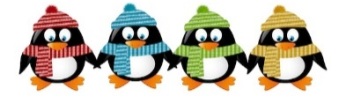
Janvier 2020 January
3__
Classe
Classroom
Italian Program | MONDAY  LUNDI | TUESDAY  MARDI | WEDNESDAY  MERCREDI | THURSDAY  JEUDI | FRIDAY  VENDREDI
Parliamo delle nostre risoluzioni per i nuovi anni |  |  | 1  Bonne Année!  Happy New Year! | 2 Theme: Happy New Year!  Discussion:  New year’s resolutions  Elias U. | 3  Starting our dream board for 2020  PM Kim the Science Gal:  New Year’s Fizz!
Leggiamo "il libro della terra" | 6 Theme: Protect the Earth  Histoire:  La terre, le soleil, le vent | 7  Give a hoot don’t pollute!  PM Mandarin with Maureen: Education into Action! | 8  Discussion: Comment je peux protéger l’environnement  Music with Kimberley: Flute | 9 AM Educational waste management workshop  Garbage or compost game  Music: Flute | 10 AM – Skating  Final day to bring Scholastic  book orders  The 3 R’s:  Reduce, reuse, recycle  PM Kim the Science Gal:  Water volcanoes
Quale diversa cultura celebriamo il mondo | 13 Theme: International week  AM We will play football games with Sportball($11.00)  PM Maureen will tell us about Chinese games, fruits and fans!  Color a Canada flag | 14  Histoire :  Benjamin prend le train  Zoe S.  Olivia  PM Mandarin with Maureen:  Get to know the World | 15  Taste Irish Soda bread  Music: Accordion | 16 AM Djembé with Kuimba Ngoma ($6.00)  Story time:  Around the World  Music: Accordion | 17AM – Skating  Histoire:  Le voyage enchanté  PM Kim the Science Gal:  Travelling water experiment
Diversi cibi culturali in tutto il mondo | 20 Theme: International week  AM Morgan the Science Gal:  Our World  Taste of Italy: “S” cookies  Theater Movement with Barbara | 21  Dis-moi ton met préféré  PM Mandarin with Maureen:  Getting to know YOU!  Ballet with Nina | 22  Bricolage: Avion  Music: Bells | 23 7:30PM Parent Wine and Cheese Meeting. Everyone welcome for an evening of interesting discussion.  Dance to international music  PM Barbara Diabo Hoop Dance ($6.00)/(No Music) | 24 (No skating)  France  Cheese and bread tasting  PM Kim the Science Gal:  What color is light?
Nome animali da circo animali in italiano | 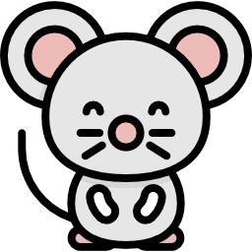  27 Special Theme:  We will celebrate the Chinese New Year – It’s the year of the rat!  Siena  PM Chinese New Year with Maureen  Theater Movement with Barbara | 28 Theme: Circus  PJ DAY!!! Wear your colorful PJ’s for a breakfast at school.  Let’s all juggle  PM Mandarin with Maureen:  A Performing Arts Movement at  A Big Top/Ballet with Nina | 29 AM Morgan the Science Gal: Elephant Toothpaste  Porte un drôle chapeau ou coiffure  Music: Slide whistle | 30 10AM Magic Show by The Amazing Todsky! ($6.00)  On dessine un clown  Music: Slide whistle | 31 AM - Skating  Circus animal Storytime  PM Kim the Science Gal:  Red and blue cabbage

